Torona Pakiakatia

Torona Pakiakatia – Stretching Deep
Māori & Pacific Conservators & Curators Workforce Development Plan

Table of Contents
Te kano ki te rau/Summary 1
Tirohanga whānui/Overview 2
Mātāpuna māramatanga/Data 2
Te hōkai wao/Scope 6
Ngā kaupeka matua/Themes 7
Ko ngā tirohanga a te iwi taketake te tūāpapa o te mana me te tiakina o ngā taonga, ā, me whai whakaaro ki te rauhī me te whāomo i ngā mahi katoa/Indigenous perspectives underpin the value and protection of taonga and need to be considered in all curatorial and conservation work 8
He mariu ake nā ētahi ki ngā tohu Tauiwi tērā i te pūkenga ā-ahurea, kua iti iho te whai pānga o te mātauranga Māori me Ngāi Moana anō hoki./Because Western qualifications are favoured over cultural expertise, Māori and Pacific knowledge is given less importance. 9
E ārai ana ngā utu me ngā wāhi i a Ngāi Māori me Ngāi Moana i tāna tōmene i te wao o te rauhī me te whāomo./Cost and location of training are barriers for Māori and Pacific to choose curatorial and conservation careers. 10
Ki te kore e haumi ki te whakangungutanga tonutanga o te rāngaimahi taketake, kāore kau he ka kairauhī Māori, Ngāi Moana rānei ki a Aotearoa ā tōna wā./Without investing in ongoing and long-term indigenous workforce training, Aotearoa risks having no trained Māori or Pacific conservators. 11
Kua uruparengia e ngā iwi te mimititanga ihotanga o te rāngaimahi ki ngā tohu mō te iwi, nā te iwi./Iwi have responded to the decline in workforce numbers with indigenous- designed and centred qualifications. 13
Kua whakatō kē te ahumahi i ōna anō kākano, e tupu mai ai te uru kahikatea o āpōpō./Industry has sought to address lack of workforce through its own training programmes to increase indigenous conservator technicians. 14
Mō te tiaki taonga, kāore he painga I te kōmitimiti i ngā tirohanga Tauiwi me ngā iwi taketake./Combining indigenous and Western worldviews can produce the best outcomes for preserving taonga. 15
Mā te mahi tahi a te rāngaimahi me ngā iwi e manahua ai te wao. /Strategic iwi and sector partnerships can help grow indigenous workforces. 16
Kia pua i te hua/Actions and recommendations 17
Āpitihanga/Appendix 18
Ngā whakamānawatanga/Acknowledgements 19
Te Rua Ngārehu/Contributors 20
Kuputaka/Glossary of terms 23

Te kano ki te rau/Summary

This workforce development plan has been developed to address the need for more Māori and Pacific conservators and curators.

Training for conservators and curators in Aotearoa is fundamentally based in Western practices – an approach that means Māori and Pacific peoples’ taonga are not always preserved, treated or cared for in ways that honour tikanga, mātauranga and indigenous whakapapa.

With low numbers of indigenous people working in the culture and heritage sector, culturally appropriate conservation practices are often not applied when handling taonga.

Serious attention needs to be paid to training pathways to mitigate the risk of further loss of cultural knowledge when current Māori and Pacific practitioners retire or leave the sector.

In the past, Aotearoa performed well when applying culturally appropriate practices to taonga, most significantly due to the landmark exhibition, Te Māori, which opened at New York’s Metropolitan Museum of Art on 10 September 1984 and showcased taonga on the international stage. This exhibition came at a critical time, raised the mana of the cultural value for iwi and taonga in Aotearoa and positively changed the approach to strategies involving indigenous conservation and curatorial roles.

However, since then, the way taonga is treated in Aotearoa has regressed, and the number of Māori and Pacific people working in the sector has declined. At the same time, with thousands of taonga held in public and private collections in Aotearoa, the demand for indigenous curatorial and conservation services far outstrips the labour workforce supply.

We heard what it means for Māori and Pacific peoples to value and protect taonga, yet we also heard of the constraints that impact cultural identity and mana, reliance on overseas workers, and Eurocentric views embedded in the sector.

The response from iwi has been to exercise mana motuhake (Māori self-determination/autonomy), mobilised through indigenising tohu (qualifications) and delivering by wānanga, growing the workforce skills for future kaitiaki of taonga collections. The power shift of iwi becoming the mātanga (expert) is immense. However, tohu can’t currently meet all required skills the sector needs outside of an iwi and hapū environment. One implication is that ākonga continue to experience limited employment opportunities in Aotearoa and globally.

Institutions recognise the importance of cultural workforce growth, but as they seek their own training models, they face different barriers. Other community groups are hampered by uncoordinated, fragmented and siloed efforts, including lack of resources, funding or influence.

The solution may be found in unifying iwi, the wider sector, providers and government for a collective workforce development strategy to build capability and meet sector needs. The research here attempts to support this by describing why taonga fulfils the lives of Māori and Pacific peoples, what upholds their indigenous perspectives and the cultural conditions they aspire to, where cultural workforces can be planted, and how they can be nurtured to thrive.

Tirohanga whānui/Overview
Torona Pakiakatia/Stretching deep.

For this workforce development plan, a sibling of the Libraries and Archives Workforce Development Plan, we use the element of seeding new growth in the forest.

When you plant a seed in the ground,it requires nutrients to survive
in the environment it is placed.This is likened to the Māori and Pacific conservation and curatorial workforces, looking for sustenance and nutrients in a climate prone to drought.

Naked to the eye, the evidence of life from the seed is only seen when its fragile shoot emerges out of the soil where – unseen beneath the earth – it has firstly built a deep root structure despite the forces of nature. With the help of rain, shelter and sunlight, the young plant is made resilient as it starts to slowly unfurl, establish and mature.

The ground where this seed is planted must therefore be cultivated with fertiliser and the soil dug over, which will take some time to develop – just like the recommendations of this workforce plan. But if we do this well enough, the Māori and Pacific conservation and curatorial workforces will eventually manifest like a towering strong tree, branching and bearing abundant fruit because of its strong roots.

Mātāpuna māramatanga/Data

No Māori nor Pacific identified or were recorded as conservators in Census 2023.

According to Census 2023, there were 69 conservators in Aotearoa. There was about a 17.86% drop compared with the Census 2018 and a 4.17% drop compared with the 2013 Census.

However, while not necessarily primarily identifying as conservators, there is anecdotal evidence to support that at least 10 Māori trained as conservators and still work in the sector across Aotearoa and Australia.

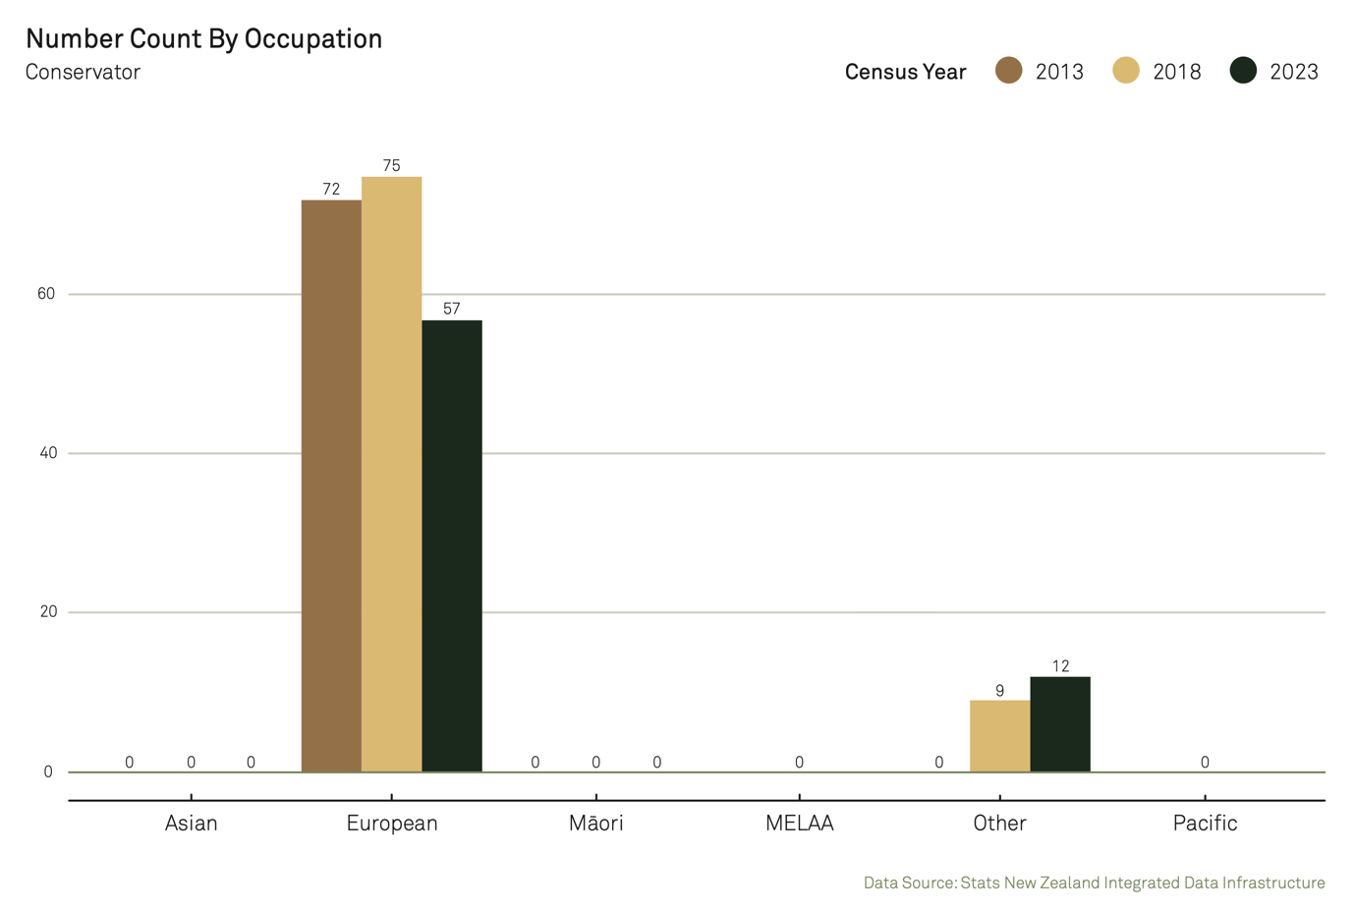

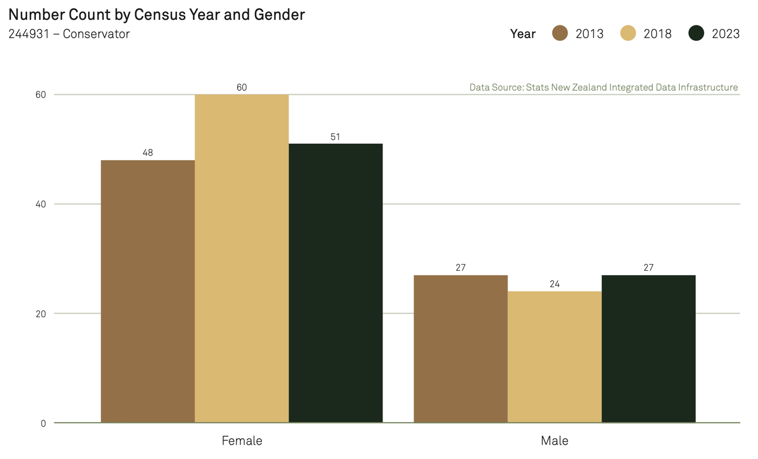

Out of a workforce of 597, there were 60 Māori and 18 Pacific Gallery or Museum Curators
There were 597 Gallery or Museum Curators reported in Census 2023. There was a 32.67% increase on Census 2018’s level. And 63.11% boosted on the Census 2013’s level. Specifically, 60 Māori filled themselves as Gallery or Museum Curators, while there were 18 Pacific people.

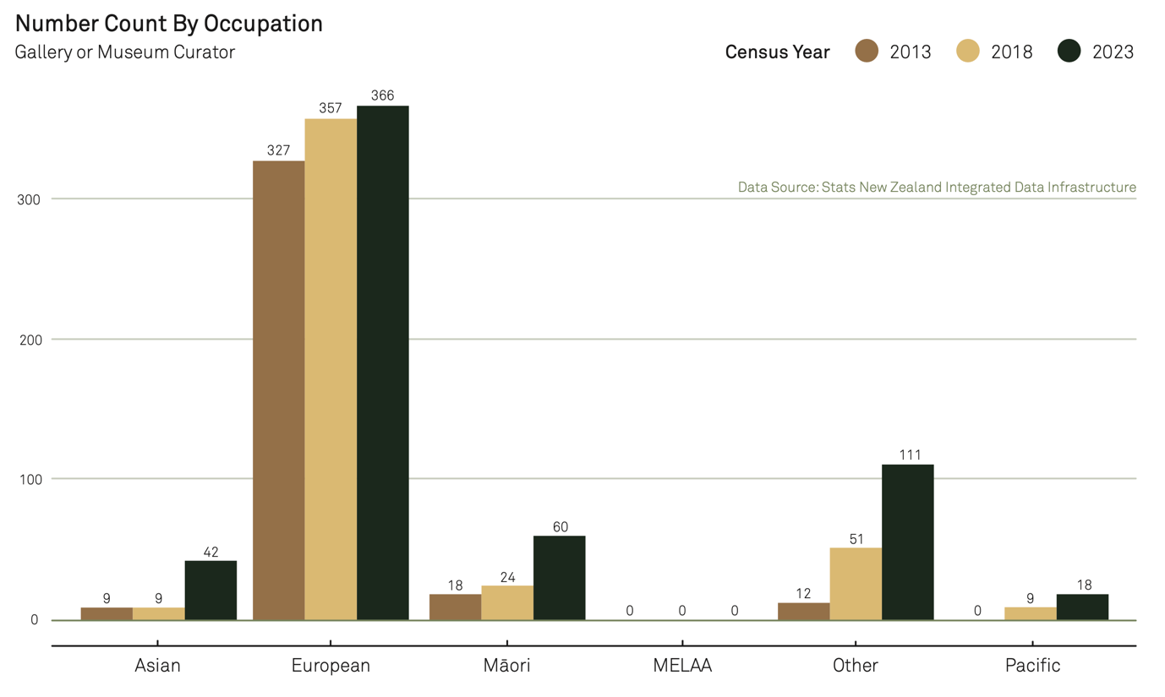

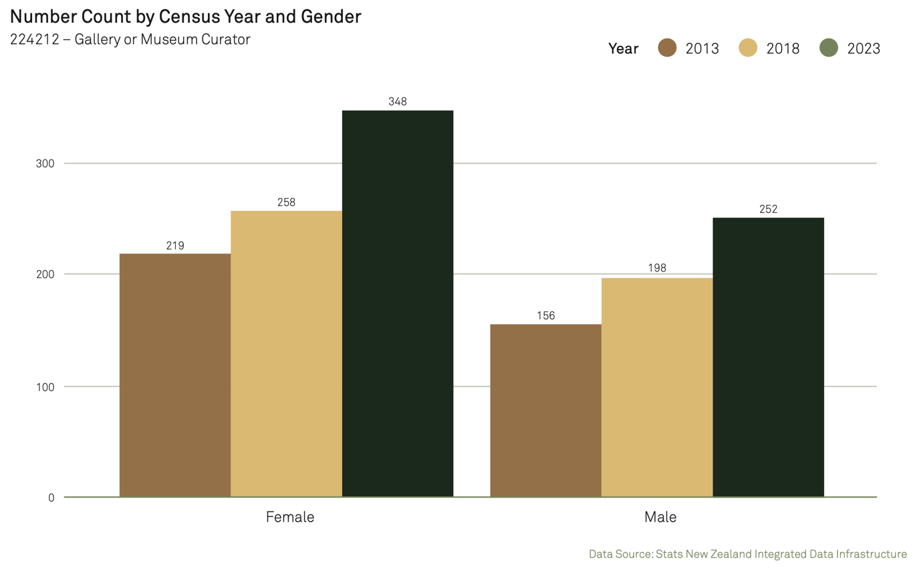

The culture and heritage sector is dominated by a European workforce
In 2022, 69.19% of the workforce for Museum Operation industry was European, with 13.94% Māori and 4.61% Pacific – both below population parity.

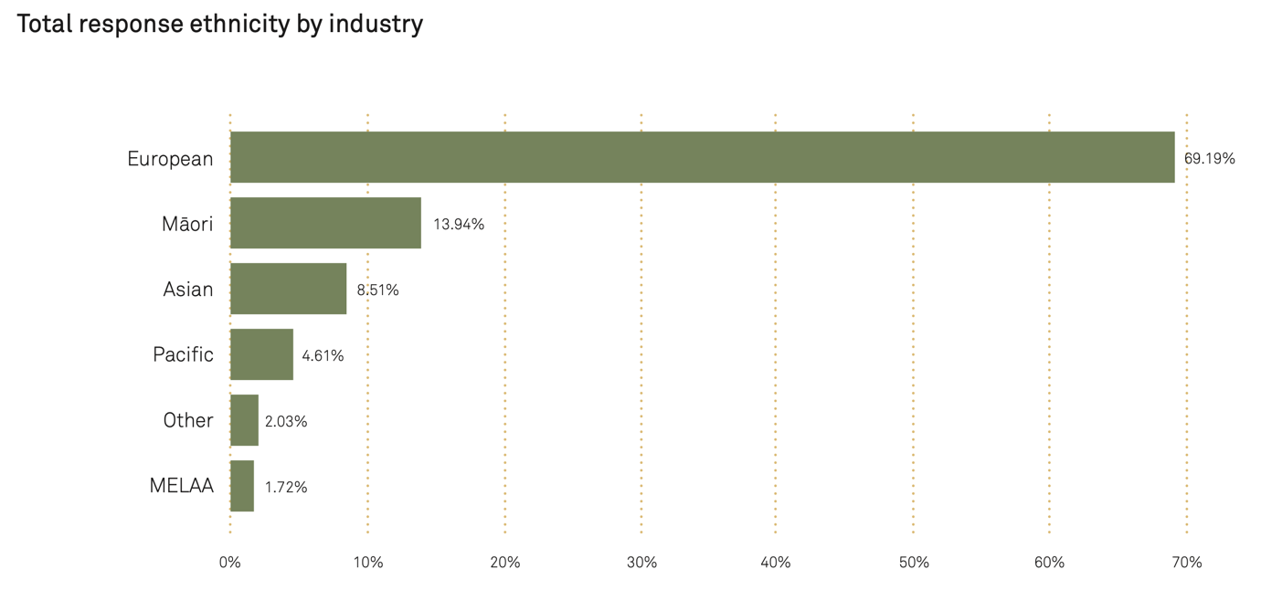

The number of ākonga per reporting year has declined from 2010 to 2025. The majority of these ākonga are non-Māori and non-Pacific, predominantly female, and mostly aged between 25 and 39 years.
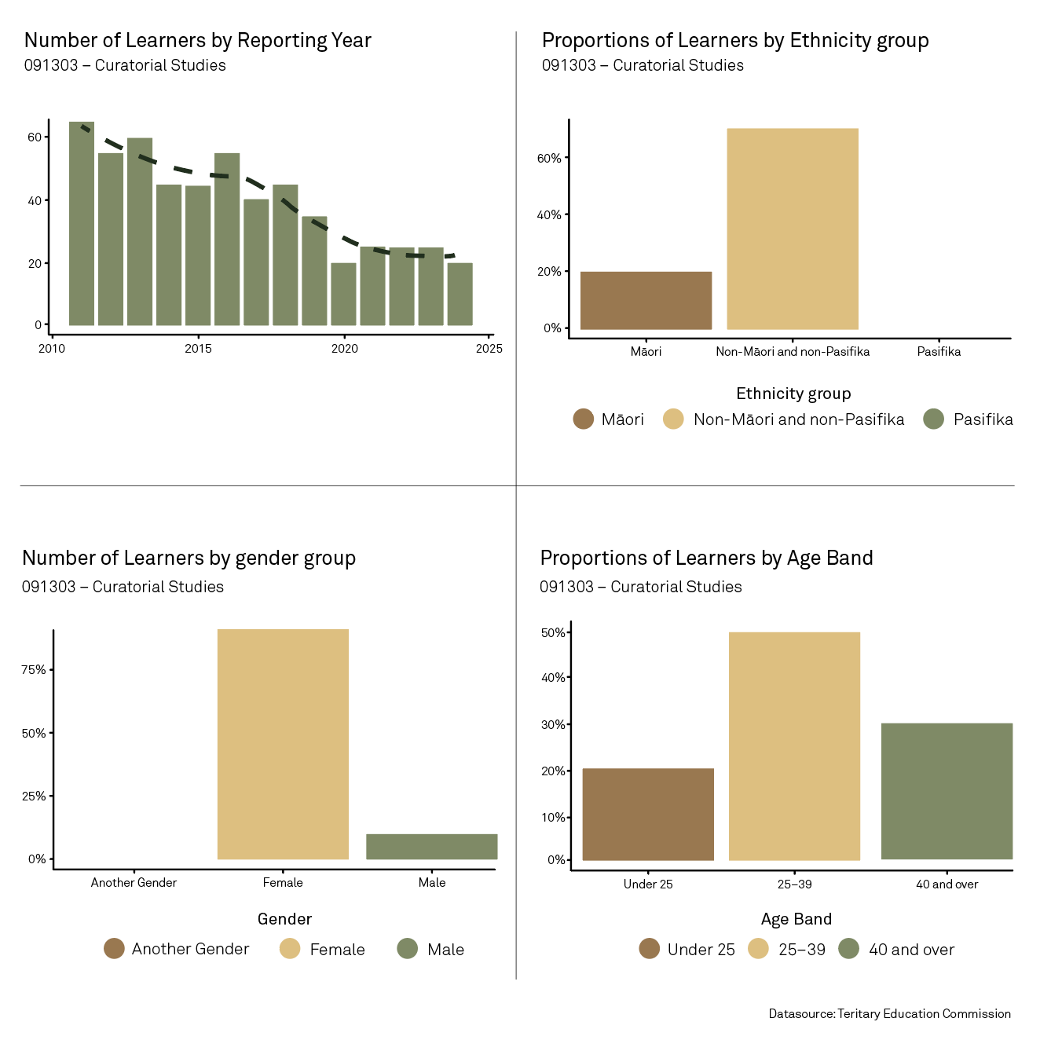

Te hōkai wao/Scope

The focus for this workforce development plan is on Māori and Pacific people who directly work or are associated with conservation and curatorial roles located in the community, culture and heritage institutions and/or as independent sole traders.

The definition of a conservatoris someone who works to preserve, protect and care for taonga using science and technical expertise, research, and cultural understandings. Fields of speciality include taonga objects, paintings, paper and material specialties, such as textiles, metals, wood (including wet organic materialsarchaeological materials), frames and so on.

A curator is someone who researches and develops exhibitions including concept/kaupapa, uses collection objects, contacts artists to loan or commission works for exhibitions, and writes text, labels and essay catalogues to accompany exhibitions.

In undertaking the research informing this workforce development plan, engagements were conducted with interviewees, using a semi-structured interview process. Insights gathered from those conversations informed and support the actions and recommendations outlined in this plan.

Insights from the research have been supported by the use of Artificial Intelligence transcription software with prior approval from all interviewees.

Ngā kaupeka matua/Themes
Ko tā te wāhanga nei he tōmene i ngā kiko i hua ake i ā mātou whakahohenga. Ko tāna he whakatūāpapangia ngā mahinga, ngā marohitanga me ngā whāinga ā-rautaki i whakatakotoria.
This section explores themes that arose during our engagements. It offers a context for the actions, recommendations and strategic objectives proposed.

Ko ngā tirohanga a te iwi taketake te tūāpapa o te mana me te tiakina o ngā taonga, ā, me whai whakaaro ki te rauhī me te whāomo i ngā mahi katoa.
Indigenous perspectives underpin the value and protection of taonga and need to be considered in all curatorial and conservation work.

He mariu ake nā ētahi ki ngā tohu Tauiwi tērā i te pūkenga ā-ahurea, kua iti iho te whai pānga o te mātauranga Māori me Ngāi Moana anō hoki.
Because Western qualifications are favoured over cultural expertise, Māori and Pacific knowledge is given less importance.

E ārai ana ngā utu me ngā wāhi i a Ngāi Māori me Ngāi Moana i tāna tōmene i te wao o te rauhī me te whāomo.
Cost and location of training are barriers for Māori and Pacific to choose curatorial and conservation careers.

Ki te kore e haumi ki te whakangungutanga tonutanga o te rāngaimahi taketake, kāore kau he ka kairauhī Māori, Ngāi Moana rānei ki a Aotearoa ā tōna wā.
Without investing in ongoing and long-term indigenous workforce training, Aotearoa risks having no trained Māori or Pacific conservators.

Kua uruparengia e ngā iwi te mimititanga ihotanga o te rāngaimahi ki ngā tohu mō te iwi, nā te iwi.
Iwi have responded to the decline in workforce numbers with indigenous- designed and centred qualifications.

Kua whakatō kē te ahumahi i ōna anō kākano, e tupu mai ai te uru kahikatea o āpōpō.
Industry has sought to address lack of workforce through its own training programmes to increase indigenous conservator technicians.

Mō te tiaki taonga, kāore he painga I te kōmitimiti i ngā tirohanga Tauiwi me ngā iwi taketake.
Combining indigenous and Western worldviews can produce the best outcomes for preserving taonga.

Mā te mahi tahi a te rāngaimahi me ngā iwi e manahua ai te wao.
Strategic iwi and sector partnerships can help grow indigenous workforces.

Ko ngā tirohanga a te iwi taketake te tūāpapa o te mana me te tiakina o ngā taonga, ā, me whai whakaaro ki te rauhī me te whāomo i ngā mahi katoa/Indigenous perspectives underpin the value and protection of taonga and need to be considered in all curatorial and conservation work

In te ao Māori, taonga are considered as tupuna, or ancestors. This belief informs cultural knowledge of how taonga should be preserved, housed and displayed, and has implications for cultural practitioners in the culture and heritage sector, including conservation and curatorial practice. Because the relationship between Māori and taonga is intertwined spiritually and physically, it can be adversely affected when this cultural knowledge is compromised for any reason.

Similarly, the strong emotive connection of taonga to whakapapa is emphasised. This is not diluted down the generations but grows stronger because of its significance to heritage and genealogy. When separated, efforts are prioritised to bring taonga home to their iwi and hapū, which is seen in repatriation, unearthed finds and stolen returns.

Mātauranga informs how to approach the care and preservation of taonga, based on its acquisition or what it represents among other factors. In this way, appropriate cultural practice or tikanga is applied. This knowledge is valid for maintaining the mauri of taonga.

These concepts are at the core of Māori and Pacific conservation and curatorial practice and need to be embedded as fundamental tenets of museum training.

“Taonga is at the centre of what we do. So, these physical manifestations of thought, of aspiration and hope from our ancestors we get to interact, handle, uplift and care for them. That’s the privilege I’m talking about.” – Curator

He mariu ake nā ētahi ki ngā tohu Tauiwi tērā i te pūkenga ā-ahurea, kua iti iho te whai pānga o te mātauranga Māori me Ngāi Moana anō hoki./Because Western qualifications are favoured over cultural expertise, Māori and Pacific knowledge is given less importance.

“A lot of talented Pasifika and Māori are not able to get into these professions because they don’t have that piece of paper.”– Conservator

Some participants expressed Māori and Pacific peoples are marginalised and developing career pathways are more difficult because the sector prioritises those with a Western-style background in academia over indigenous mātauranga, whakapapa or other connections to taonga.

Recruitment for roles in the sector tends to value an academic approach that privileges this knowledge over what is valued by Māori and Pacific peoples and embedded into their practices. Doing so can misalign what was described as the Eurocentric (Western academic) views of what others think the sector needs and therefore, in turn, look to recruit.

In support of museology, one participant described that a PhD is not needed, but it is helpful given the museum sector’s particularly high standard for formalised education. Reinforcing this, another participant stated that getting a paid role today requires having a degree, and that having a formal qualification, such as a degree, makes a big difference in securing paid work. An undergraduate degree is often required for an entry-level role in a museum.

Eurocentric recruitment practices understand and value formal qualifications but struggle to recognise other forms of knowledge, such as lived and cultural knowledge held by Māori and Pacific experts. A general view expressed was that to underscore the value of knowledge in a way that institutions will understand is to term it as a “qualification”.This would then enable the sector to recognise an applicant’s skills, expertise and training, which would then be supported.

Participants understood there are competing worldviews between museology and mātauranga Māori. One participant felt that despite museology being valued by the sector, it is not prioritised by some Māori, because of long-held views about how Māori perceive museums. For example, they explained the two views can be different about what taonga should be kept or discarded in collections, especially when Māori would probably hide away, bury or burn taonga, particularly where there’s not much providence around them.

Some participants considered an academic background not relevant to the needs of the cultural practitioner role – that Māori and Pacific bring instead an incredible depth of experience and knowledge, which they respected because in their view it was greater than any bachelor’s degree they had personally acquired.

Some institutions advocate for cultural knowledge over qualifications, but even then, they still find recruitment of Māori and Pacific workforces difficult. For example, an entry-level position was advertised where applications were encouraged from anyone with knowledge of taonga Māori or te ao Māori. 240 applications were received, yet only one applicant had whakapapa to iwi.

As part of efforts to upskill entry-level employees through work-based learning, one institution funded the New Zealand Certificate in Museum Practice (Level 4) for new hires within their first three years of employment. However, this initiative saw minimal participation, including among Māori and Pacific people.

Working as a volunteer was mentioned as another option to enter into the sector, including front-of-house or visitor roles. However, many participants did not agree that career development and progression was clear for them and time, opportunity and having a relevant qualification were factors in influencing their career trajectory.

While some in the culture and heritage sector advocate for the formal education system to offer cultural practitioner work-based learning, the current models and support for institutions and iwi are limited and inflexible. To overcome this issue, one participant recommended there are workplace training partnerships developed between institutions and iwi through creating specialised Centres of Excellence (CoE) hubs located in regional museums (see page 16).

“So, I think I’d start by quite clearly saying that I do believe that Māori and Pasifika encouragement to work in the museum sector is a special case. I don’t think it’s as easy to bring Māori and Pasifika workers into our workforces as others.” – Collections kaimahi

E ārai ana ngā utu me ngā wāhi i a Ngāi Māori me Ngāi Moana i tāna tōmene i te wao o te rauhī me te whāomo./Cost and location of training are barriers for Māori and Pacific to choose curatorial and conservation careers.

“The course here is quite elitist. There are currently two Māori studying here part-time, and they can only do it part-time because they work around it.” – Conservator

Many participants highlighted the significant financial investment for conservation training, which makes this choice of career unaffordable formost Māori and Pacific.

The lack of local conservation training opportunities in Aotearoa means there is a need to study overseas. The closest conservation qualifications are offered in Australia: a Bachelor of Arts (Culture and Heritage) degree at the University of Canberra and a Master of Cultural Materials Conservation degree at the University of Melbourne. The typical length of training required is at least five years, including work experience. This may involve site visits, online project work, field trips, internships, professional experience and mentorships.

Even within Aotearoa, geographical barriers can limit Māori and Pacificpeople’s engagement with academic learning, unless they’re prepared to move from regions into larger metropolitan areas, such as Tāmaki Makaurau or Tauranga. The financial implications of this can compound expensive study costs. There are no in-person programmes offered in Te Waipounamu the South Island, and while the New Zealand Certificate in Museum Practice (Level 4) is available online, it is limited to those that are already working in the museum sector, so there are significant barriers to those considering domestic training in the sector.

A further concern expressed was that there is no formal curatorial specific training in Aotearoa although aspects of curation are taught within museology. One view is: while it is good to have an understanding of Western art history, Māori-specific art history is not widely taught – particularly contemporary Māori art. Traditional training for a curator is through the study of art history at tertiary level, although this is not always relevant for Māori curators. In general, many curators start out as art practitioners and gain experience from internships and independent curatorial projects.

Museology was also viewed as delivering learning content about museums, rather than how cultural practice fits within a museum environment. Some participants voiced that relevant tertiary qualifications contain compulsory courses that include content about Māori but were aimed at those who do not come from Māori nor Pacific backgrounds. One participant claimed that there is no tertiary paper that addresses Pacific communities. The inference is the available academic learning in Aotearoa is often at a basic level, teaching others how to engage with Māori rather than strengthening Māori and Pacific peoples themselves.

Ki te kore e haumi ki te whakangungutanga tonutanga o te rāngaimahi taketake, kāore kau he ka kairauhī Māori, Ngāi Moana rānei ki a Aotearoa ā tōna wā./Without investing in ongoing and long-term indigenous workforce training, Aotearoa risks having no trained Māori or Pacific conservators.

Aotearoa does not currently invest in local qualifications and training in conservation, which contributes to an overall domestic workforce skills shortage that also has implications for Māori and Pacific people. This being Māori and Pacific people are underrepresented in the conservation workforce. One response from the domestic culture and heritage sector is to therefore recruit for these skillsfrom an overseas workforce, where across 2014 to 2022, there were a total of 24 conservators employed on a work visa and in the same period a total of 15 Gallery or Museum Curators.

One participant expressed if Māori and Pacific people are to hold cultural practitioner roles, then it must be acknowledged that those with higher academic education and vast experience – including from overseas – don’t have an understanding of tikanga, kaupapa Māori or Aotearoa, and that those that do have a greater knowledge of indigenous culture. The implications are that by recruiting an overseas workforce, they are benefiting from the unique features of Māori and Pacific culture. The flipside is that filling roles with overseas practitioners then makes it even harder for the domestic conservators of Aotearoa to acquire roles.

Poor diversity in the workforce delivers outcomes that continue to perpetuate Western worldviews and approaches to taonga practice. Doing so dominates the sector and suppresses other forms of skills and knowledge. According to Census 2023, there were 69 conservators in Aotearoa. The data shows there were no Māori nor Pacific people who identified or were recorded as conservators. Yet there is anecdotal evidence to support that at least 10 Māori trained as conservators who still work in the sector across Aotearoa and Australia. Conversely, there were 597 Gallery or Museum Curators reported in Census 2023. Specifically, 60 Māori (10%) recorded themselves as Gallery or Museum Curators, while there were 18 (3%) Pacific people.

“Our museum brings in conservation specialists from places like the UK, Canada, Germany and Australia – people who are highly skilled but who come here to learn how to operate in a culturally safe and sensitive space.” – Collections kaimahi

“Back in the day, the CCAC supported students to do that training. That’s why I think it’s significant that those of us who did get the opportunity to do that are mostly still working in the profession because they sent us away.” – Conservator

The evidence is a significant and sustained cultural practitioner workforce shortage that is disproportionate against the backdrop of the thousands of nationally significant taonga in Aotearoa requiring cultural care and preservation.

As the workforce ages and retires, the shortage of Māori and Pacific conservators is amplified further, posing a culturally significant risk. For example, there are currently only two practising Māori textile conservators in Aotearoa yet there is no current workforce succession planning for conservators.

On the other hand, the value of investing in cultural practitioner workforces has proven successful in the past. The few Māori conservators working in Aotearoa today were mostly recipients of a fund administered by the Department of Internal Affairs via the Cultural Conservation Advisory Council (CCAC), which was established in the 1990s and is no longer in operation. The CCAC allowed those conservators the opportunity to study conservation in Australia and,when qualified, return to Aotearoa to work in an institution throughbonded positions or for an institution that decided they needed to fill and grow a conservation role. The CCACserved as an example of long-term investment in workforce planning that has since provided a generation of Māori conservators in Aotearoa.

Kua uruparengia e ngā iwi te mimititanga ihotanga o te rāngaimahi ki ngā tohu mō te iwi, nā te iwi./Iwi have responded to the decline in workforce numbers with indigenous- designed and centred qualifications.

Iwi have exercised mana motuhake over their taonga collections (which includes repatriation), instead of these taonga being stored or displayed in museums. One example is the hapū of Ngāti Kurī opening a Whare Taonga, housing and displaying over 400 taonga at Takahanga Marae, Kaikōura in October 2022. One participant considers such reclamations as decentralising the power of institutions like museums by reframing taonga to be more accessible and visible within the community. With this trend comes an emerging need to grow the capability of Māori and Pacific people.

“The intent was to develop . . . a qualification that was relevant across all iwi, all hapū, marae and whānau to be able to learn to preserve . . . both the physical and digital taonga.“ – Collections kaimahi

Wānanga across Aotearoa (of which there are three: Te Wānanga o Aotearoa, Te Wānanga o Raukawa and Te Whare Wānanga o Awanuiārangi) have looked or are looking to respond to iwi needs through the development of indigenous tohu. For example, Te Wānanga o Aotearoa has established Te Tohu Tiaki Taonga (Kaupae 5) to “learn how to preserve and protect the taonga of your whānau, marae, hapū and iwi in a way that honours their mana and protects their legacy.” Suggested employment pathways post-study includes options for either working in the museum sector context including as an assistant curator and assistant conservator, but also as a cultural practitioner in an iwi-based role.

Core learning content in relation to taonga care, housing and preservation includes but is not limited to the application of tikanga, traditional and contemporary technical skills, understanding the nature of relationships including rights, data sovereignty and environmental factors.

Some participants we spoke to indicated that providers in the tertiary sector are also looking to design cultural practitioner course content by moving towards more indigenous approaches. The aim is to attract ākonga without hindering access because of university entrance criteria and to enable outcomes of applying tikanga, legislation, technical skills and environmental management among others.

Wānanga have been described as learning environments that help build confidence, mentorship and support. In other words, the cultural environment for learning is seen as more important, and wānanga have indigenous cultural values at their centre.

National Services Te Paerangi (NSTP) is a national unit of the Museum of New Zealand | Te Papa Tongarewa that works in partnership with the sector, including iwi, and delivers a range of practical and strategic culture- and heritage-related programmes. In the past, NSTP have delivered regional marae-based training, which focuses on putting communities at the heart of caring for their collections. One participant expressed that this type of training becomes more critical to employ as Treaty claims are settled including outcomes when taonga is returned to iwi ownership, and it is vital there is an understanding of appropriate tikanga for the taonga returned to these places.

Kua whakatō kē te ahumahi i ōna anō kākano, e tupu mai ai te uru kahikatea o āpōpō./Industry has sought to address lack of workforce through its own training programmes to increase indigenous conservator technicians.

To address the Māori conservation workforce shortage, the Auckland War Memorial Museum (AWMM) has developed a proposed ‘Indigenous Conservator Technician’ qualification.

Strategically, AWMM has sought to ensure that there is a sustainable pipeline in place, that cultural safety and protection is prioritised, and that it is training people in conservation techniques – not solely on theory but also ensuring that the mahi is carried out with deep cultural integrity and understanding. In recognising the challenge, AWMM’s He Ara Whaowhia Taumata-ā-Iwi Strategy 2020 – 2025 offers Māori professional development, which also includes a targeted Māori recruitment programme.

The ‘Indigenous Conservator Technician’ qualification is for ākonga Māori and is entirely immersive with taonga and in a museum environment in order to understand how the whole institution operates, where there are multiple layers of navigation, prioritisation and negotiation that need to happen. Trainees will not just learn about the care of taonga but also develop critical skills first hand.

AWMM’s vision on workforce development is to build a pathway over the next decade where AWMM develops indigenous conservation training with a career approach that does not just focus on entry level – which is important to pathway people into industry – but ultimately develops qualifications from vocational through to master’s level, so Māori are able to stay in Aotearoa for all their training needs.

The overall hope is that the qualification will be NZQA approved, although this is constrained by AWMM not being an NZQA-approved provider and struggling to find a suitable one willing to deliver this qualification. Because AWMM’s preference is to select a low cohort of Māori ākonga to complete the qualification, it raises challenges for both the provider and ākonga to attract the necessary funding from the Tertiary Education Commission. For example, StudyLink requires an NZQA-approved qualification (not a micro-credential) to be a minimum of 40 credits.

A key feature of the vocational and education training system in Aotearoa is its volume-based funding. Government funding for providers remains largely based on how manyākonga they support and the nature of the subject such as conservation and curatorial studies, while funding is higher for longer courses.

This means qualifications critical to cultural practitioner growth and success may not be offered if they don’t attract enough funding for providers to offer them.

Alternatively, AWMM could deliver the qualification, but it would have to be as a work-based learning programme in partnership with a provider (such as wānanga) that has a work-based learning programme, and their ākonga would sign into a training agreement with the provider to deliver it. However, one key advantage of keeping numbers limited is AWMM has agreements in place with museum directors across Aotearoa to create employment pathways for graduates of the programme. Doing so ensures there is an available employment role once graduates complete training, and the national quota for a cultural practitioner workforce is not overfilled.

AWMM’s strategic governance partnerships extends to the Pacific Advisory Group where Taumata-ā-Iwi have long articulated workforcedevelopment is a key priority. AWMM’s Pacific Matafatafa Aho Delivery Plan focuses on staff development and career pathways, designed to give visibility to an ākonga career path – including in conservation.

Due to having strong relationships with other museums in the Pacific, AWMM is being looked to to provide conservation training for Pacific people. This interest means AWMM needs to ensure it has the capacity to support not just its own workforce but also the Pacific neighbours of Aotearoa.

Mō te tiaki taonga, kāore he painga I te kōmitimiti i ngā tirohanga Tauiwi me ngā iwi taketake./Combining indigenous and Western worldviews can produce the best outcomes for preserving taonga.

“Chemistry is crucial. You have to understand the chemical degradation processes of the diverse materials of which cultural material is made from to actually inhibit it and prevent it from happening further.” – Conservator

“So, we have conservation values and then we have indigenous values . . . And that’s where the conflict arises . . . You do need to understand where conservation is coming from, but that two-way communication needs to be developed further . . .” – Conservator

Many participants stressed the vital role of combining indigenous knowledge with Western conservation methods to create practices that honour indigenous cultural values and intelligence. Combining the best techniques from both disciplines will ensure taonga is given the best care. There is evidence the sector is shifting towards this approach, primarily because indigenous conservators and curators have made efforts towards that end. For example, these efforts are seen through the establishment of the cross-government rōpū Te Ara Taonga, Kāhui Kaitiaki, the MāoriCuratorial Network and the Pacific led group, Aotearoa Indigenous GLAM Association, among others.

Several participants strongly agreedthat conservation needs to be underpinned by Western knowledge and highlighted the importance of applied science understanding of cultural materials in order to make informed decisions. For example, conservators need to know how different environments, techniques and substances can affect taonga chemically, so it is critical for mātanga to provide their expertise and knowledge. However, in order for that to occur, and despite current wānanga and AWMM’s offerings on cultural practitioner learning content, there are still no centres of training for this applied science in Aotearoa, and the closest places are still Canberra and Melbourne in Australia.

Mā te mahi tahi a te rāngaimahi me ngā iwi e manahua ai te wao. /Strategic iwi and sector partnerships can help grow indigenous workforces.

“It’s not classroom stuff, because our people hate being stuck in classrooms. So, you’re going to have to have something overwhelmingly practical, pragmatic, meeting the need and driven from community perspectives.”– Cultural Practitioner

The challenges that Pacific peoples face mirror those of Māori, notably issues around formal qualifications and the necessity for tailored culturally appropriate pathways and community-driven training. One participant outlined her vision for fair representation of Pacific peoples in the sector, arguing there is a need to include more Pacific professionals across various organisations to engage in workforce development for Pacific conservators and curators, to help grow workforce size and capability. Cultural collaborations led by the sector will result in the increased uptake of museum qualifications and training by Pacific people.

Other participants agreed that developing local training programmes led by the sector that incorporate applied science understanding and cultural knowledge can attract and foster Māori and Pacific people’s workforce growth. Some examples included workplace training partnerships between institutions and iwi through creating specialised Centres of Excellence (CoE) hubs located in regional museums.

This approach is a key action Manatū Taonga | Ministry of Culture & Heritage set out in their draft strategy, Amplify. For example, one textile CoE might be located in one rohe and another CoE for manuscripts and photographs may be in another.

There are Māori conservators who have those specialisms that work alongside and in the regional CoE.

In this way, regional growth of the cultural practitioner workforce could begin to flourish and is potentially a concept that can also be exported internationally. For example, strengthening and growing CoE with Pacific institutions with exposure to international experience can lead to workforce capability frameworks, support and pathways for other indigenous groups with similar issues.

Another participant suggested establishing partnerships between tertiary sector chemistry departments and wānanga or iwi institutions for specialised (and internship) training. In this example, Māori and Pacific people who commit upfront to training may see their investment come to fruition through being linked in some way to participating institutions to secure employment post study. Alternatively, larger institutions may create or grow positions such as internships for Māori and Pacific people as part of the benefits to study.

Kia pua i te hua/Actions and recommendations

Actions

Toi Mai to undertake a review of the NZQA Level 4 New Zealand Certificate in Museum Practice with a goal of strengthening indigenous knowledge and skills within the qualification.

- Toi Mai to consider developing a strand/specialisation for indigenous conservator technician.
- Toi Mai to investigate further options for work-based learning at a sub-degree level in the museum sector.
- Toi Mai to explore apprenticeships, internships, traineeships and vocational qualifications.
Toi Mai to continue to provide advice to the Tertiary Education Commission around the need to invest in vocational training for curators and conservators.
- Toi Mai to continue gathering data about workforce needs.

Recommendations

Toi Mai recommends that if conservators and curators transition to an Industry Skills Board (ISB), the ISB should partner with ManatūTaonga | Ministry for Culture & Heritage and other stakeholders – including iwi, Māori, Pacific and sector groups, and education providers – to address mutually agreed priorities from the draftAmplify strategy.

Make cultural education accessible: Develop a systematic approach to culture and heritage education by potentially offering secondary schools’ vocational pathways, such as developing culture and heritage practice at NZQA levels 2 and 3.

Integrate or consolidate current training programmes: The proposed ISB should undertake a critical assessment of existing cultural practitioner programme offerings to determine how learning content and outcomes can be better marketed, integrated or consolidated. This assessment should aim to:
  - deliver programmes that directly address the strategic cultural priorities of all stakeholders
  - identify critical workforce skills and training gaps that still need addressing to meet iwi and sector needs for vocational education and training.

Further research into Pacific peoples working in the culture and heritage sector: The findings from this research are limited about the provision of equitable workforce development and training pathways for Pacific people in cultural practitionerroles, including conservation and curatorial roles. To explore and understand this through further research is likely to inform effective and strategic planning for Pacific peoples’ workforce growth.

Āpitihanga/Appendix

In the 2025 reporting year, a total of 915 ākonga were enrolled in qualifications that may lead to pathways into conservation and/or curatorial roles, as outlined below:

Provider name | Qualification | Level of qualification | No. of ākonga
Auckland University of Technology | Master of Visual Arts | 9 | 35
University of Auckland | Bachelor of Fine Arts | 7 | 165
 | Master of Fine Arts | 9 | 30
 | Postgraduate Diploma in Fine Arts | 8 | 5
 | Master of Heritage Conservation | 9 | 5
 | Master of Architecture (Professional) and Heritage Conservation | 9 | 5
 | Master of Urban Planning (Professional) and Heritage Conservation | 9 | 0
University of Canterbury | Master of Fine Arts | 9 | 15
 | Bachelor of Fine Arts | 7 | 165
 | Postgraduate Diploma in Fine Arts | 8 | 5
 | Bachelor of Fine Arts with Honours (4 year) | 8 | 30
Massey University | Bachelor of Fine Arts | 7 | 0
 | Bachelor of Fine Arts with Honours | 8 | 175
 | Postgraduate Diploma in Museum Studies | 8 | 5
 | Master of Fine Arts | 9 | 20
 | Postgraduate Diploma in Fine Arts | 8 | 5
 | Graduate Diploma in Fine Arts | 7 | 0
University of Otago | Master of Archaeological Practice | 9 | 10
Te Pūkenga – New Zealand Institute of Technology, Trading as Otago Polytechnic | Master of Fine Arts | 9 | 10
 | Master of Visual Arts | 9 | 5
Whitecliffe Enterprises Limited | Master of Fine Arts | 9 | 20
 | Bachelor of Fine Arts | 7 | 115
 | Bachelor of Fine Arts (Honours) | 8 | 5
Victoria University of Wellington | Master of Museum and Heritage Practice | 9 | 30
 | Postgraduate Diploma in Museum and Heritage Practice | 8 | 5
 | Postgraduate Certificate in Museum and Heritage Practice | 8 | 0
Te Pūkenga Work Based Learning Limited trading as ServiceIQ | NZ Certificate in Museum Practice Level 4 18 Months V2 | 4 | 45
 | NZ Certificate in Museum Practice Level 4 15 Months V2 | 4 | 5
Te Wānanga o Aotearoa | New Zealand Diploma in Tiaki Taonga | 5 | Unknown

Ngā whakamānawatanga/Acknowledgements

This plan is mahi tahi in action.

The research, facilitation, analysis, writing and
documentation of this workforce development plan has been completed by the workforce development team at Toi Mai.

Also, thanks to Anton Matthews for his metaphor that brought this plan to life.

But mostly we would like to thank all the people across the motu whose honest and open feedback enabled us to gain compelling insights so that together we can shape a better future for Māori and Pacific cultural practitioners including conservators and curators and the people of Aotearoa.

Te Rua Ngārehu/Contributors

Toi Mai would like to acknowledge the time and contribution of the following people:

Contributors

Alexander Turnball Library
Vicki-Anne Heikell

Auckland War Memorial Museum
Ahlia-Mei Ta’ala
Amiria Taumata
Chantelle Urguhart
David Reeves
David Tuipulotu
Edward Howell
Ena Manuireva
Esther Stone
Evelyn Kawiti
Gabriel Tongaawhikau
Hannah Temara
Jacqueline Snee
Jami Williams
Janine (Tangimai) Fitzgerald
Kara Wallace
Kath McGhie
Leilani Walker
Maara Maeva
Maia Faddy
Maraea Henare
Mason Lawlor
Matarini Ngari
Nafiza Pilkington
Natasha Fitzgerald
Nicola Railton
Olivia Taouma
Parai Parai
Rachpal (Polly) Atari
Robert (Bob) Newson
Talei Tu’inukuafe
Tanya Matthews
Te Arepa Morehu
Tiare Pito
Vasiti Palavi
Zoe Richardson

Canterbury Museum
Hatesa Seumanutafa
Sarah Murray

Central City Library | Tāmaki Pātaka Kōrero
Atonia (Nia) Vavao
Pamata Toleafoa

Depot Artspace
Amy Saunders
Heather Galbraith
Lily Eketone

Heritage New Zealand Pouhere Taonga
Dean Whiting
Makere Rika-Heke
Tharron Bloomfield

National Library of New Zealand |Te Puna Mātauranga o Aotearoa
Tim Kong

Tūhura Otago Museum
Jonika Edgecombe
Lana Arun
Leota Meredith
Te Rauparaha Horomona

Penapena Taonga Ltd
Kararaina Te Ira

Te Awamutu Museum
Henriata Nicholas

Museum of New Zealand |Te Papa Tongarewa
Migoto Eria
Nirmala Balram
Sean Mallon

Te Tuhi Contemporary Art Trust
Hiraani Himona

Te Wānanga o Aotearoa
Amiria O’Malley
Margaret Aull
Rebecca Pennington

Tiaki Objects Conservation
Erina McCann

University of Canterbury |Te Whare Wānanga o Waitaha
Emily Rosevear
Terri Elder

Victoria University of Wellington |Te Herenga Waka
Awhina Tamarapa

Te Whare Taonga o Waikato Museum & Gallery
Gina Matchitt
Maree Mills

Māori and Pacific Conservators and Curators Workforce Development Project team

Maria Aka
Mata Herehere | Relationship Manager

Tinaka Birch (Tūhoe)
Te Kahu Ahurea ā-Tāngata Rite Tahi | Diversity & Inclusion Partnership Lead

Caitlin Dever
Te Pā Auaha | Graphic Designer

Graeme Cowie
Te Pā Hōtaka | Workforce Planning Advisor

Tim Croft
Mata-Tika | Workforce Lead

Toi Mai Workforce Development
Council Contributors

Hinepounamu Apanui-Barr (Ngāi Tahu, Ngāti Porou)
Te Whatu Ohooho | Senior Advisor

Josh Bowen
Te Pā Ohoreo | Communications Advisor

Mary-Jane Duffy
Mata Herehere | Relationship Manager

Makea Pokere (Ngāti Ruanui, Ngāti Toa)
Te Pā Rere Ataata | Marketing Advisor

Teara Leaupepe Timoteo
Te Pā Rere Hua | Communication and Marketing Lead

Stephen La
Te Whatu Rarau | Data Analyst

Steven Youngblood
Te Poururuku Rāngai Taumata Tirotiro | GM Strategy and Industry Development

Consultants
Anton Matthews
Director, Hustle Group

Kuputaka/Glossary of terms

Ākonga
Student or learner

Aotearoa
Māori name for New Zealand

Collection manager
kaitiaki for all collection items, care, stores, protects, maintains collection records and documentation on a database like Vernon

Conservator
Works to preserve, protect and care for taonga using science and technical expertise, research and cultural understandings. Fields of speciality include taonga objects, paintings, paper, and material specialties such as textiles, metals, wood (including wet organic materials, archaeological materials), frames, and so on

Curator
Researches and develops exhibitions including concept/kaupapa, uses collection objects, contacts artists to loan or commission works for exhibitions, writes text, labels, and essay catalogues to accompany exhibitions

Educator
Develops programmes for primary and high school students to engage and learn from exhibitions

Exhibition Manager
Plans and implements exhibition programs works with technicians to install and deinstall exhibitions developed by curator

GLAM
Galleries, Libraries, Archives and Museums

Hapū
Subtribe of an iwi

Iwi
Tribe

Kāhui Kaitiaki
Māori kaimahi/employee network who work in in Galleries, Libraries, Archives, Museums, Iwi and/or Records (GLAMIR)

Kaimahi
Worker or employee

Kaitiaki: Caretaker

Kaupapa
The heart and reason behind what you’re doing

Mahi
Work

Mana
Prestige

Mana Motuhake
Self-determination or autonomy

Mātanga
Expert

Mauri
Lifeforce

Mātauranga
Knowledge

Museology
Defined but not limited to understanding museums, curating and preserving taonga

PhD
Doctor of Philosophy, which is the highest academic degree awarded by universities in many countries

Registrar
Similar to collection manager, but focuses on incoming and outgoing loans of taonga and artworks

Rohe
Region

Rōpū
Group

Tāmaki Makaurau
Auckland

Taonga
Treasures

Taonga Māori
Māori treasures

Te ao Māori
The Māori world

Te Waipounamu
The South Island

Tikanga
Customs or protocols

Tohu
Qualifications

Tupuna
Ancestors

Wānanga
Māori tertiary education organisation

Whakapapa
Genealogy

Whānau
Family

Whare Taonga
Treasure House or museum

About the statistics used in this plan

Access to the data used in this study was provided by Stats NZ under conditions designed to give effect to the security and confidentiality provisions of the Data and Statistics Act 2022. The results presented in this study are the work of the author, not Stats NZ or individual data suppliers.

These results are not official statistics. They have been created for research purposes from the Integrated Data Infrastructure (IDI) and Longitudinal Business Database (LBD), which are carefully managed by Stats NZ. For more information about the IDI and LBD please visithttps://www.stats.govt.nz/integrated-data/

The results are based in part on tax data supplied by Inland Revenue to Stats NZ under the Tax Administration Act 1994 for statistical purposes. Any discussion of data limitations or weaknesses is in thecontext of using the IDI for statistical purposes, and is not related to the data’s ability to support Inland Revenue’s core operational requirements.

For more information contact:
wdpfeedback@toimai.nz

Toi Mai Workforce Development Council
toimai.nz
P O Box 445
Te Whanganui-a-Tara Wellington

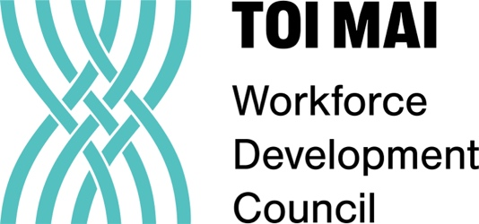

Data source: Ministry of Business, Innovation & Employment – Migration Trend Explorer
www.aucklandmuseum.com

