Torona Kaupekatia

Torona Kaupekatia – Reaching Out
Libraries and Archives Workforce Development plan

Table of Contents
Te kano ki te rau/Summary 1
Tirohanga whānui/Overview 2
Te hōkai wao/Scope 2
Mawhiti wao/Snapshot 2
Mātāpuna māramatanga/Data 4
Whakapakari pūkenga/Training 6
Kua hangaia e te rāngai ōna anō whāinga kei tua o te pūnaha mātauranga hei āki i a ngāi Kanorau/ The sector has developed frameworks outside the formal education system to embed diversity 8
Ngā kaupeka matua/Themes 9
Me whakaarotau e te rāngai te hiranga o te aroā ā-ahurea i te horopaki o te kiritaki me ngā kohikohinga/The sector needs to prioritise the importance of cultural awareness for customers and collections 10
Ka whai painga kē ngā whakangungutangame ngā tohu tauiwi ki ngā tirohanga me ngā pūnaha wāwāhitanga Pākehā/Eurocentric training and qualifications favour Western worldviews and classification systems 11
Ko tā ngā patuitanga ki ngā umanga me ngā hapori he miramira i ngā ara hei takahe rā te wao/Relationships with organisations and communities can highlight the visibility of pathways into the sector 11
Ka whakanuia ana tā te Māori tirohanga, ka tūhono ana hoki ki ngā iwi, mā reira te Māori ngā hua o tēnei wao e kato/Valuing a Māori worldview and partnering with iwi can lead to more Māori pursuing a career in the sector 12
Funding 13
Importance of support for kaimahi Māori 13
Opportunities for iwi 14
Ka whakahohe atu ana, ka tū tahi ana hoki me ngā hapori ngāi Moana, ka tupu ai te ngāi Moana hei purapura tuawhiti/Engaging and partnering with Pacific communities can help grow the Pacific workforce 14
E waiwai ana ngā ara tokonga ā-ara umanga me ngā whaiwāhitanga whanaketanga ki te whakawaiwaia me te purutia o te hunga rangatahi me te hunga whakawhiti/Career pathways support and opportunities for advancement are vital to attracting and retaining young people and career changers 15
Kia pua i te hua/Actions and recommendations 16
Ngā whakamānawatanga/Acknowledgements 17
Te Rua Ngārehu/Contributors 18
Kuputaka/Glossary of terms 21

Te kano ki te rau/Summary

Libraries have evolved from traditional book-lending institutions into community information hubs providing internet access, meeting spaces and social services. Archives are the vital repositories of public and private documents and records, manuscripts and maps, and manage all kinds of information. Together, these institutions play essential roles in preserving and providing access to Aotearoa New Zealand’s taonga, history and knowledge.

However, the workforce in these sectors faces challenges around representation, diversity and retention. While approximately 6,200 people work across public, tertiary and specialty libraries and archives, substantial under-representation persists for Māori (710), Asian (740) and Pacific peoples (340), with numbers below population parity. Compounding this lack of representation is the high turnover of new entrants who leave the workforce within two years of entering.

Several factors contribute to these challenges: career information reaches students too late in their education, and training programmes are largely based on European approaches, making it harder for people from different backgrounds to see themselves in the profession, and affecting members of the workforce seeking to develop cultural knowledge and skills.

This plan addresses these workforce challenges emphasising partnerships with iwi and Pacific communities, improved cultural competency for the general workforce, and visible career pathways from an early age.

Informal discussions across the GLAMMI sector (galleries, libraries, archives, museums, marae and iwi) reveal a growing convergence in skills, capabilities and career paths. This convergence is particularly evident in relation to digitisation and digital access, mātauranga Māori, customer engagement, collection management and description, and highlights the need for a broader workforce planning approach. While this plan holds a cross-sector perspective, it focuses specifically on librarian and archivist roles.

The plan also sits alongside the Māori and Pacific Conservators and Curators Workforce Development Plan, and these two documents should be read together.

Tirohanga whānui/Overview
Torona Kaupekatia/Stretch out like branches.

For this workforce development plan, a sibling of the Māori & Pacific Conservators & Curators Workforce Development Plan, we use the metaphor of seeding new growth in the forest.

When seeds fall on the ground, nutrients and favourable environmental conditions are required to ensure their survival and growth. Fragile shoots emerge out of the soil from which they have built a root structure. With the help of rain, shelter and sunlight, the young plants slowly unfurl, establish and mature.

In the current environment for young librarians and archivists, the soil is lacking nutrients, and the seedlings are unable to establish good foundational growth. Left untended, after a short time they are crowded out by the dense shade of the older trees, never able to establish themselves.

Seedlings must be nourished and tended. Like the recommendations of this workforce plan, this will take time, planning and intention. But this is an investment for the future of the workforce to ensure that the many seedlings of the mahi have the opportunity to stretch up, mature and bear fruit.

Te hōkai wao/Scope

In its Plan Guidance for 2026, the Tertiary Education Commission hascited the “. . . funding available for Vote Tertiary Education will be limited and we will need to reprioritise our investment in a fiscally constrained environment” (6). With this guidance in mind, we recognise that any new initiatives or projects are unlikely to be funded in the short-term. And while there are larger sectoral issues, which this plan touches on, our focus is vocational education and the qualification levels under the remit of Toi Mai on the New Zealand Qualifications Framework (NZQF)levels 1–6.

In undertaking the research for this plan, engagements were conducted with interviewees using a semi- structured interview process, and the insights gathered underpin the actions and recommendations outlined in this plan. The transcription of interviews was supported with the use of Artificial Intelligence transcription software.

Mawhiti wao/Snapshot

“The marae is a pukapuka.”– Librarian
A mixture of local and nationally funded public libraries, school and university libraries, and specialty libraries and archives make up the library and archive sector in Aotearoa.

The role of libraries has changed rapidly in the last twenty years. Libraries were once places focused principally on the lending of books and journals with spaces for newspaper reading and reference areas. Now, if they are public or tertiary provider libraries, they are increasingly community information hubs providing internet and computer access, photocopying and printing services, meeting rooms and event spaces, and access to visual and recorded media. They are also places that organise and host events and campaigns to encourage literacy and the freedom to read. And increasingly, they attend to customers who need a warm, safe space. Public libraries may also house community organisations such as Citizens Advice Bureau, budgeting services and cafes.

In many communities, they have become places for meetings, events and information. In tertiary institutions, libraries are also likely to be hubs for course and qualification information, as well as wellbeing and career advice.

Archives on the other hand are either governed by the Public Records Act 2005 (PRA) or guided by collection policies. The PRA establishes a regulatory framework for information and records management across the public sector. Archives outside the public sector usually have their own kaupapa and purpose, such as Ngā Taonga Sound and Vision, Presbyterian Archives or Ngai Tahu Archives.

For iwi, successive Waitangi Tribunal claims and hearings have unearthed and generated significant documents, maps, photographs and manuscripts that together form important collections.

This growth in material has seen a commensurate growth in iwi aspirations to develop and manage their own archives. Ngai Tahu in Ōtautahi Christchurch, for example, has invested in infrastructure and storage for their significant archives and records after they were severely impacted by the earthquakes in 2011–2012. The iwi shares a building with Archives New Zealand in Wigram, and this example may provide a model that other iwi replicate.

National Library and Archives New Zealand provide leadership in the sector and have developed policy that advocates for and supports communities to look after their own collections. In the future, they expect to see roles developed that enable communities and heritage organisations to hold and preserve their own archives. In addition, they are leading conversations with their communities about archival material available in national collections, and offering support and training to preserve and house material outside of public facilities.

Crucially, both library and archive workforces face funding challenges. In the local body context, cost-cutting from annual and long-term budgets has seen a decline in funding, which in some places undermines the safety of the workforce. Understaffed libraries compromise both safety protocols and employees’ personal safety. When staff are absent without a replacement, decisions must be made to either close the library or put remaining employees in difficult positions.

In the national context, Archives New Zealand Te Rua Mahara o Kāwanatanga and National Library Te Puna Mātauranga o Aotearoa are now housed next door to each other. Communications on this development stress that they will work together to share resources and improve access to their collections.

Mātāpuna māramatanga/Data

Workforce demographics
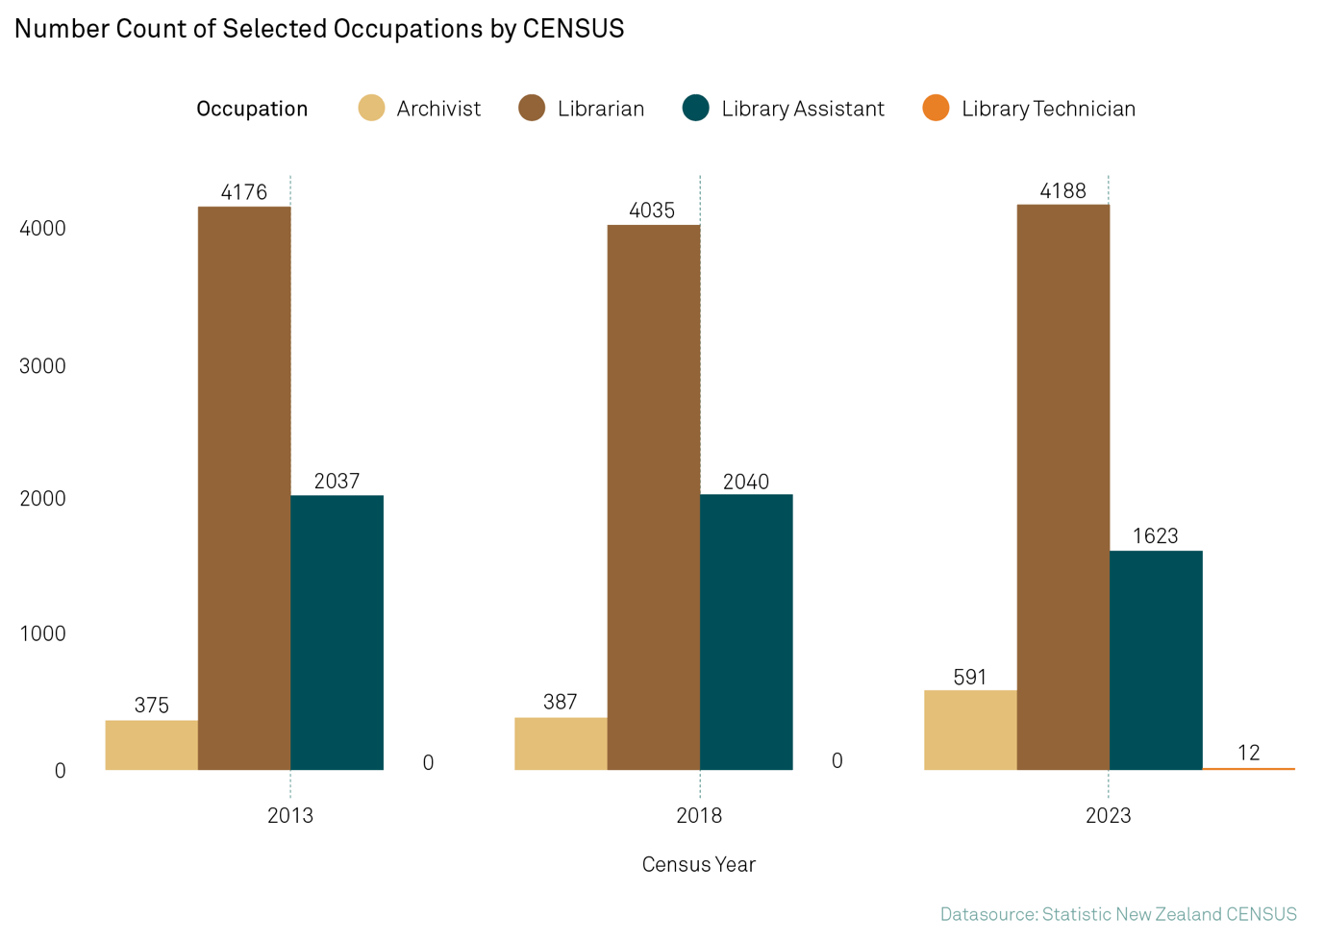
Workforce data from 2015 to 2022 shows a slight increase in diversity; however, there is still a significant underrepresentation of Māori, Asian and Pacific peoples when compared to the wider population. Here are the numbers at the 2023 Census:

- 740 Asian
- 4,100 European
- 710 Māori
- 140 MELAA
- 340 Pacific
- 150 other.

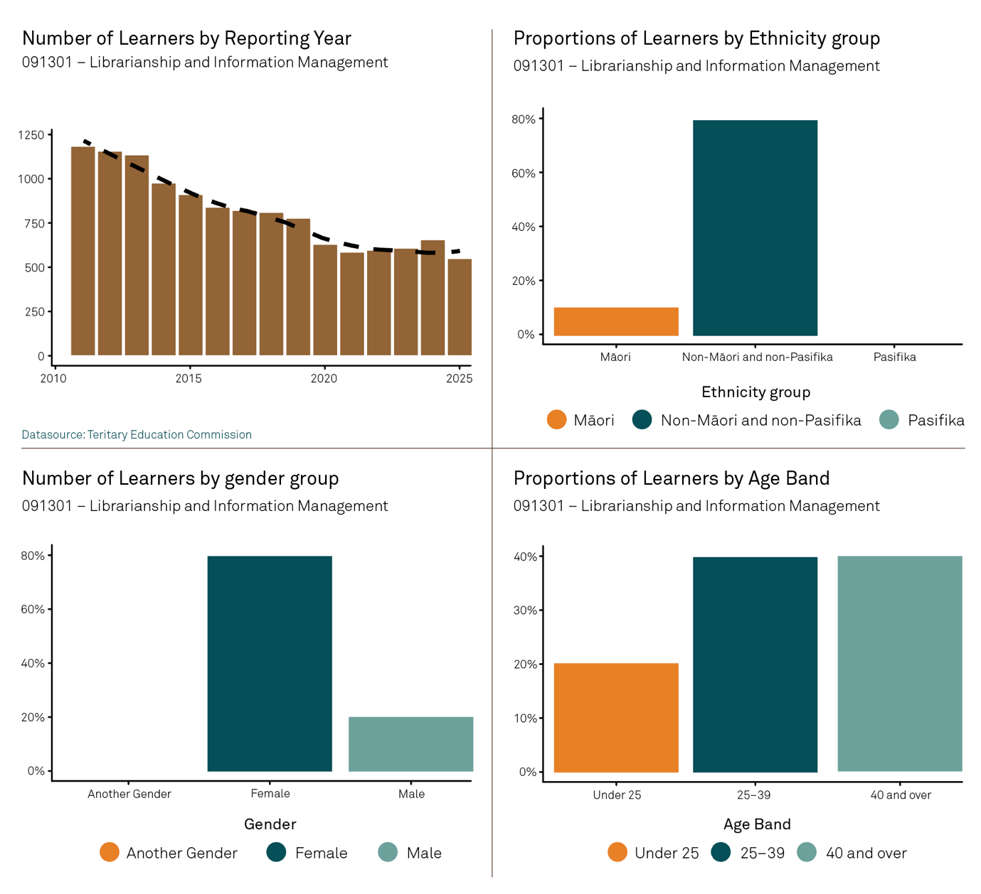

Alongside this data, the other most significant data is the retention rates of new entrants (anyone entering the sector for the first time). Industry tenure data from the end of 2022 shows that in the previous five-year period, over 50% of new entrants had left the sector after two years. Related to this is the high number of people in the workforce who have never changed roles. This issue points to a lack of advancement opportunities in the sector, which – coupled with low payrates and unsociable hours (described below) – explains this high churn rate for new entrants.

Salary bands for the sector according to careers.govt.nz are as follows:

- Library assistants: $49,000–$55,000
- Senior library assistants: $55,000–$65,000
- Graduate librarians and librarians: $49,000–$75,000
- Senior librarians and library managers: $60,000–$125,000
- Archivists with up to 4 years experiences: $49,000–$60,000
- Archivists with 5 or more years experiences: $60,000–$70,000
- Records advisors: $49,000–$58,000
- Records managers: $100,000+.

60% of the workforce is in Auckland, Wellington and Canterbury.

Whakapakari pūkenga/Training
People enter the sector in various ways. Some have skills gained through a range of formal qualifications that offer library and archives-specific training and education from vocational through to postgraduate, or training from other disciplines. Others enter without qualifications especially at the library or archives assistant level, and are trained on the job.

At the vocational level, we heard a number of school librarians, for example, enrol in the NZ Diploma in Library and Information Studies (3466) and the NZ Certificate in Library and Information Services for Children and Teens (3463). The provider of these qualifications, Open Polytechnic, offers a discounted rate for school librarians.

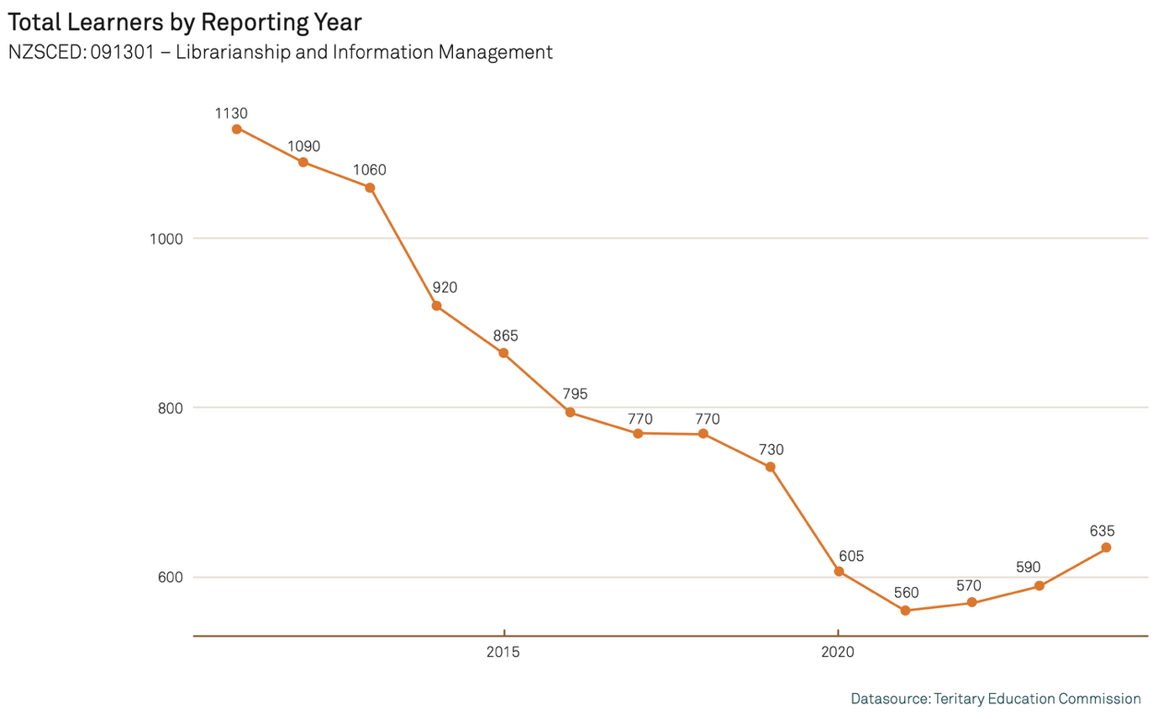

A relatively large proportion of those undertaking this study do it part-time, sometimes doing just a few courses as part of their study. At vocational level, we heard most learners who enrol in library courses successfully complete the courses they enrol in, especially with the goal to upskill, but most learners do not necessarily complete a full qualification as that is not their intent.
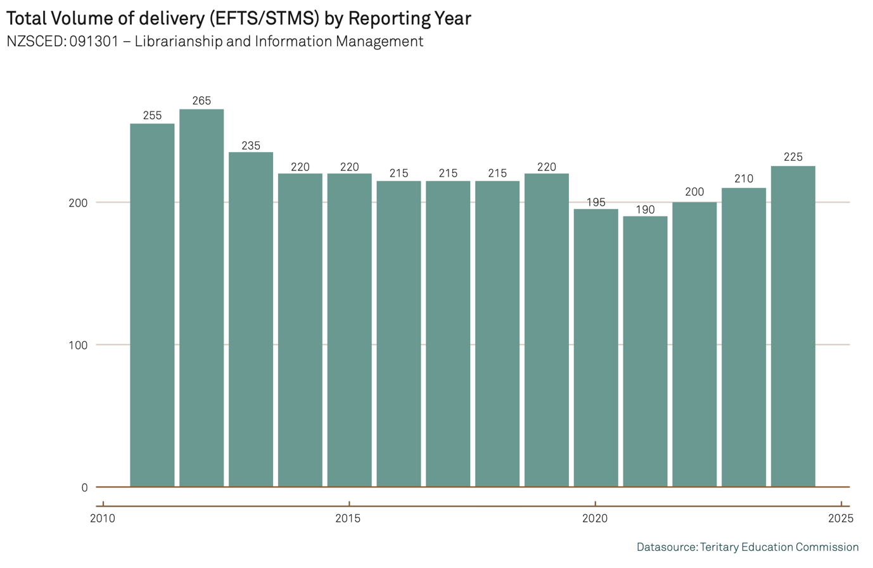

This suggests many of those already in the workforce upskill in specific areas while working.

As a result of the part-time study trends, there is a gap in the numbers between equivalent full-time students (EFTS) recorded as training and those graduating. This can be explained by the part-time learners and learners who only take a few courses in Library Studies or Information Management.

We heard the New Zealand Certificate in Library Practice (3465), Level 3, which is currently not offered by a provider, could be developed for young people entering the workforce in a library position.

It could create a vocational pathway for high school students studying NCEA. Offered with the support of LIANZA’s Te Tōtara capability framework discussed below, this presents an excellent opportunity to introduce high school-level training at NCEA level with a capability framework to assess workplace learning and provide a support structure for the learner.

The Level 6 NZ Diploma in Records and Information Management (3467) is the only qualification dedicated to training for archivists.

Code | Title
3465 | NZ Certificate in Library Practice (level 3), Open Polytechnic
3466 | NZ Diploma in Library and Information Studies (level 5), Open Polytechnic
RK0018 | Heke Puna Maumahara (level 5), Te Wānanga o Raukawa
3463 | NZ Certificate in Library and Information Services for Children and Teens (level 6), Open Polytechnic
3467 | NZ Diploma in Records and Information Management (level 6), Open Polytechnic
RK0052 | Poutuarongo Puna Maumahara (level 7), Te Wānanga o Raukawa
3632 | Graduate Certificate in Library and Information Leadership (level 7), Open Polytechnic
4658 | Graduate Diploma in Library and Information Leadership (level 7), Open Polytechnic
VI00V2 | Postgraduate Certificate in Information Studies (level 8),Victoria University of Wellington
VI00V7 | Postgraduate Diploma in Information Studies (level 8), Victoria University of Wellington
VI00V1 | Master of Information Studies (level 9), Victoria University of Wellington

Kua hangaia e te rāngai ōna anō whāinga kei tua o te pūnaha mātauranga hei āki i a ngāi Kanorau/ The sector has developed frameworks outside the formal education system to embed diversity

Organisations recognise they don’t get a diverse range of applicants applying for roles. They told us they are now taking a more pragmatic approach to recruitment with a skills-first approach to focus on team suitability, ability to collaborate, te reo Māori, mātauranga Māori, customer service and attitude rather than prioritising qualifications. This approach means that job applicants are not screened from the recruitment process if they do not have a qualification – on the understanding that organisational processes and policies and relevant technical skills can be taught on- the-job.

The Library and Information Association of New Zealand (LIANZA) also recognises workforce issues and has developed Te Tōtara Workforce Capability Framework to provide a comprehensive tool for individuals, teams and organisations to understand and fill capability gaps, using the environmental metaphor of the tree as a structure. The framework has been adopted by several libraries throughout New Zealand, and LIANZA continue to promote its uptake and adaptation.

In 2022, Te Ara Tahi: Mātauranga Māori Standards (MMS) were developed by Te Tari Taiwhenua Internal Affairs to meet obligations under the Public Services Act and the Public Records Act 2005, the National Library of New Zealand Act 2003, the Films, Videos and Publications Classification Act 1993, the Royal Commission of Inquiry into Historical Abuse in State Care and in the Care of Faith-based Institutions Order 2018, and te Tiriti o Waitangi principles. These standards provide “holistic descriptions of what high-quality mātauranga Māori practice looks like and what it means to uphold our responsibilities as a Tiriti partner and as key holders of important mātauranga Māori and taonga Māori collections”.MMS is an important resource for the library and archives sector offering guidance and a training framework but has not been widely circulated.

Sector leaders want training to provide skills that are transferable across the wider GLAMMI sector. This approach to the workforce requires a whole-of-sector response.

Ngā kaupeka matua/Themes
“Information is a taonga.” – Provider

This section explores themes that arose during our engagements. It offers a context for the actions, recommendations and strategic objectives proposed.

Me whakaarotau e te rāngai te hiranga o te aroā ā-ahurea i te horopaki o te kiritaki me ngā kohikohinga
The sector needs to prioritise the importance of cultural awareness for customers and collections

Ka whai painga kē ngā whakangungutangame ngā tohu tauiwi ki ngā tirohanga me ngā pūnaha wāwāhitanga Pākehā
Eurocentric training and qualifications favour Western worldviews and classification systems

Ko tā ngā patuitanga ki ngā umanga me ngā hapori he miramira i ngā ara hei takahe rā te wao
Relationships with organisations and communities can highlight the visibility of pathways into the sector

Ka whakanuia ana tā te Māori tirohanga, ka tūhono ana hoki ki ngā iwi, mā reira te Māori ngā hua o tēnei wao e kato
Valuing a Māori worldview and partnering with iwi can lead to more Māori pursuing a career in the sector

Ka whakahohe atu ana, ka tū tahi ana hoki me ngā hapori ngāi Moana, ka tupu ai te ngāi Moana hei purapura tuawhiti
Engaging and partnering with Pacific communities can help grow the Pacific workforce

E waiwai ana ngā ara tokonga ā-ara umanga me ngā whaiwāhitanga whanaketanga ki te whakawaiwaia me te purutia o te hunga rangatahi me te hunga whakawhiti
Career pathways support and opportunities for advancement are vital to attracting and retaining young people and career changers

Me whakaarotau e te rāngai te hiranga o te aroā ā-ahurea i te horopaki o te kiritaki me ngā kohikohinga/The sector needs to prioritise the importance of cultural awareness for customers and collections

We heard that organisational staffing must reflect communities and users to ensure that libraries and archives are accessible to everyone. Customers will be more likely to use a library or archive if they see themselves reflected in the staff.

People also told us that there is growing awareness of the need for cultural knowledge and practices around information and archives. However, they also noted awareness isn’t uniform across the country and can be dependent on the material held by archives or the communities who use a library.

Lack of cultural awareness is one of the consequences of having few Māori and Pacific kaimahi in the workforce. It also impacts the kind of customers that libraries and archives attract, and the valuing and understanding of collections. A growing movement across GLAMMI advocates for developing indigenous and Pacific capabilities and leadership to guide the kind of awareness needed. The appointment of the first Māori Chief Archivist, Anahera Morehu, at Archives New Zealand in 2023 is a step in this direction.

There are also other initiatives in the sector that disrupt Eurocentric approaches. Supported by the National Library, public libraries in metropolitan centres have been at thefore front of changes and innovations to make collections more accessible to their communities. The Wellington Public Library’s recent initiative to create a new classification system with more relevance and meaning for Māori and other customers is an example of this.

Iwi and hapū are taking more ownership and authority over their historical documents and information. They also want to see Māori knowledge systems and tikanga protocols applied in the nationaland regional collections where their taonga are housed. This development highlights the growing importance of te reo and mātauranga Māori for expanding the knowledge base of collections and for engaging with iwi.

“Archives start with people” – Regional archives manager

“. . . the actual parts of the job of being a librarian, those are learned, they’re really easy to learn . . . – Librarian

Ka whai painga kē ngā whakangungutangame ngā tohu tauiwi ki ngā tirohanga me ngā pūnaha wāwāhitanga Pākehā/Eurocentric training and qualifications favour Western worldviews and classification systems

One of reasons that Māori and Pacific people are not attracted to this workforce is that they don’t see themselves in the training or in the workplace. Historically, a Eurocentric qualification and skills framework has been the primary way people train for the workforce. This framework focuses on European ways of doing and knowing – classification and knowledge systems taught in a progressive linear learning structure in English. This largely monocultural approach to library and archive work excludes other worldviews and perspectives.

Yet throughout our engagements we heard about the increasing need for mātauranga and te reo Māori skills as well as relational skills and cultural competency. It also became clear from our conversations with the sector that part of the answer to this problem already exists in the qualifications offered by Te Wānanga o Raukawa – Heke Puna Maumahara | Diploma in Information Management (level 5) – with te reo Māori and iwi studies courses taught alongside the technical skills to enable graduates to work across the GLAMMI sector. This type of programme also fills another need in the sector, that of professional development for kaimahi Māori.

However, research also shows that learners are increasingly finding full-time study difficult to manage. To enable learners in this sector, Open Polytechnic, the provider of most of the sub-degree qualifications, runs a “rolling enrolment” system that allows learners to enrol and start individual courses (or papers) any time during the academic year. This means that people working in archives and libraries are able to access training in library and information management courses while they are on the job.

So while there is no formal work-based training such as apprenticeships, “earning while learning” is normal in the sector and often supported by employers. Promoting this to potential learners could make roles in libraries and archives more attractive.

Ko tā ngā patuitanga ki ngā umanga me ngā hapori he miramira i ngā ara hei takahe rā te wao/Relationships with organisations and communities can highlight the visibility of pathways into the sector

The lack of visible pathways into library and archives careers was something we heard often – that pathways aren’t clear or certain and that they were changing. The most obvious pathways are those provided by the 11 qualifications listed on the NZQA framework. Other pathways include museum studies and heritage studies such as archaeology, history and new qualifications being offered by universities in Indigenous Studies.

People also told us about the importance of relationships with organisations and communities – especially local iwi – to make visible pathways and careers. As an example of this, one of the archives we talked to regularly updates iwi and other stakeholders about its training goals and training opportunities. This maintains the visibility of these career pathways as well as potential opportunities for employment.

We heard public perception of what a librarian does is often misleadingly grounded in popular culture. The sector struggles to represent itself and its myriad roles realistically to prospective employees – particularly high school students, who would otherwise be excellent librarians but choose other careers.

“I can see it with Ngai Tahu, you’ve got all these really passionate young people who are into culture revitalisation and into protecting mātauranga Ngai Tahu and are passionate about that space but never had the training . . . [they] are passionate on a certain kaupapa, rather than the industry.” – Regional archivist

In contrast, careers in archives are largely unknown to young people and new entrants. We heard examples of organisations being proactive in promoting the work of the sector through an interest in ‘heritage’. The University of Canterbury, for example, hosts a ‘Careers in Heritage’ forum once a year, inviting secondary and tertiary students to presentations about careers in the sector. And as the quote above observes, rangatahi can be attracted to the work if it aligns with their interests and kaupapa and if it is presented in the right way.

But we also know that careers need to be highlighted to students from an early age and that library and archives careers need promotion and better articulation to primary and younger secondary students.

“How do we rename the title of a librarian so we shift people’s perceptions of what it is so that they find out what you actually do in the role?” – Librarian

Ka whakanuia ana tā te Māori tirohanga, ka tūhono ana hoki ki ngā iwi, mā reira te Māori ngā hua o tēnei wao e kato/Valuing a Māori worldview and partnering with iwi can lead to more Māori pursuing a career in the sector

“. . . we continue to build communities as a key. Yes. If we don’t have a community . . . it’s a dusty marae . . .” – Archives manager

We heard that the library and archives sector prides itself on being innovative and socially responsive. Yet we also heard about its blind spots – and one of these is te ao Māori. There is a dominant narrative of inclusion and the importance of te ao Māori but little evidence of markers that support this, such as the employment of numbers of kaimahi Māori and trusting relationships with mana whenua. This isn’t true of all libraries and archives, of course, but an overall observation.

Funding

Complicating this, the sector isn’t well resourced and is constantly having budgets adjusted and reduced by city councils and government funders. Projects to support te ao Māori often have finite funding and, like project funding in general, are often the first things to be cut in budget changes.

On the flipside, funding doesn’t always solve the problem of representation. An example of this is the provision of funded scholarships via the Ministry for Culture and Heritage’s Regeneration Fund.

These scholarships were offered for Māori and Pacific applicants to study library and information qualifications from 2022 with final applications closing this year. However, the uptake of these scholarships for this demographic has been relatively low. This problem points to other barriers and complexities rather than being entirely financial. We know that study in general can be more difficult for Māori and Pacific learners because of broader financial constraints, whānau and community commitments.

“We’ve tried different approaches and again it’s really based on the fact that we often don’t have the funding to keep it sustainable. Sustainability is always key, and at the same time interest is always key . . . it is a bit of a struggle.” – Archives manager

Importance of support for kaimahi Māori

People told us that systemic biases and undervaluation of cultural knowledge contribute to stressful and unsupportive work environments for Māori who do work in the sector, and that accessing relevant professional development is also difficult. Where Māori have been successfully recruited, it has been in team situations. We heard how effective the Māori team are at the University of Waikato library, and how being part of a team shares the burden of ‘cultural tax’ commonly faced by kaimahi Māori – that is, the expectation of additional unspecified duties such as mihi whakatau and whanaungatanga that support organisational competencies but under-recognise and undervalue kaimahi Māori who perform this tikanga.

But kaimahi Māori in the sector have organised to remedy some of theseproblems with the establishment of Te Rōpū Whakahau (TRW) in 1992. At first TRW was a special interest group of LIANZA. In 1995 it became an independent incorporated society later entering into a formal agreement with LIANZA to provide cultural advice and feedback. It represents Māori engaged in libraries, culture, knowledge, information, communication and systems technology and has been crucial in supporting kaimahi in the sector and networking nationally and internationally.

Opportunities for iwi

As noted, Waitangi Tribunal hearings have generated large amounts of precious documents, photographs, maps and records. This doesn’t mean they all have to be housed in public archives but it does shift emphasis to empowering iwi to look after their own material. National Library, Archives New Zealand and Ngā Taonga Sound and Vision have all done significant work in this direction. What this also means is that there are opportunities on the horizon for rangatahi and career changers to train in the care and preservation of the taonga tuku iho of their whānau, hapū and iwi and to develop what that looks like for the future.

In the library context, an increasing number of books are being written and translated into te reo Māori and collected by libraries. People told us that the workforce needs people who understand te reo and library systems and can make these accessible to library visitors and communities in knowledgeable and meaningful ways. And finally, te ao Māori and Māori worldviews provide a new and potentially innovative lens through which to consider libraries and archives. We heard that all of the concepts around collecting, systems and preservation are readily available in te reo and the mātauranga provides inclusive and local ways of doing things.

“Managing Pacific taonga requires specific cultural understanding and skills.”– Kaimahi, national organisation

Ka whakahohe atu ana, ka tū tahi ana hoki me ngā hapori ngāi Moana, ka tupu ai te ngāi Moana hei purapura tuawhiti/Engaging and partnering with Pacific communities can help grow the Pacific workforce

The number of Pacific people in library and archives is low, with only 340 (5.5%) of the libraries and archives workforce made up of Pacific people – well below population parity. This number reinforces what we heard from our engagements. Like Māori, Pacific people do not see themselves represented in the workforce, and a lack of diverse mentorship and being the only Pacific person in a workplace discourages Pacific people from pursuing careers in the sector.

Study options are also unattractive, and as for Māori, scholarship initiatives have made little headway in attracting Pacific people. The question was also raised around community consultation: how have Pacific and Māori communities been engaged with about qualifications and training programmes and what meets their needs and cultural values?

The Pasifika community has come up with its own solution for this gap in representation – the Pacific Information Management Network (PIMN) established during the Covid pandemic to connect Pacific kaimahi across the sector. PIMN organises regional gatherings to share information about roles in the sector, to facilitate access and knowledge about Pacific collections held in public collections, as well as mentoring and professional support. It aims to help organisations to recruit more people into the sector but also support those that are there.

We heard that Pacific people have much to offer the sector – not only knowledge of Pacific collections and archives but also cultural values of service and relationality. However, in order to recruit more Pacific people to the workforce, the sector needs to make relationships in Pacific communities to help with recruitment rather than relying on conventional recruitment processes.

In a Pacific context, we heard mentoring is a successful way of retaining and sustaining people in the workforce; more mentoring initiatives targeting Pacific youth would be one way to inspire and support career pathways into the GLAMMI sectors. Initiatives are already being trialled. The Tupu Youth Library in Auckland has been running an after-hours programme to teach life skills to young people in a library setting. The settingis important as it not only introduces young people to the purpose and potential represented by libraries and knowledge, but also to the library as a workplace.

E waiwai ana ngā ara tokonga ā-ara umanga me ngā whaiwāhitanga whanaketanga ki te whakawaiwaia me te purutia o te hunga rangatahi me te hunga whakawhiti/Career pathways support and opportunities for advancement are vital to attracting and retaining young people and career changers

Our data indicates about half of new entrants in the sector leave within two years, whereas those who stay in the sector stay for long periods. We heard that for new librarians, assistant librarians and archivists, career advancement is difficult because of a low turnover of intermediate and senior positions.

The library assistant workforce has historically attracted high numbers of women because of the availability of part-time hours that provide flexibility around childcare responsibilities, so that it is now a female-dominated workforce. We also heard that with women in management there was generous accommodation of the needs of children and childcare in women’s lives.

But in other ways, conditions can be less favourable. The work occurs during unsociable hours, is part-time and capped on a low salary band. Many public and tertiary libraries are open seven days a week and close late. The Wellington City Library for example is open from 8am–8pm during the week and 9.30am–5pm on Saturday and Sunday. University libraries are likely to be open into the middle of the evening, and until midnight during exam time. Furthermore, penal rates are not consistent across the workforce – some libraries may pay extra for Sunday work, others not. These are the roles most likely to be filled by new entrant library assistants.

Additionally, the new entrants we spoke with feel that no one in management is looking out for their professional development interests within the organisation. They told us they looked across to other sectors where management actively mentored young people, but they did not have the same experiences in their workplaces. These factors provide context to the story of high staff turnover seen in the data.

Low salaries are also seen in the story of the two pay equity claims that were set up to seek redress with the Employment Relations Authority. These two pay claims – one for library assistants in the tertiary libraries lodged over two years ago and the other for library assistants in public libraries lodged six years ago – sought to address the low pay rates in this female dominated workforce.

With the change in legislation enacted under urgency prior to the 2025 budget, neither of these pay claims can now progress and will need to be refiled under stricter criteria. This decision will have a significant impact – especially on morale and recruitment, which is already difficult.

But it is important to acknowledge some employers have taken proactive leadership in this space. Christchurch City Council has committed to pay equity for 290 library staff despite the pay equity law change.

“Libraries are run by women . . . so there is more flexibility for mothers and support for neurodiversity and Rainbow staff. Safe and understanding but low paid.” – Library assistant, metropolitan library

Kia pua i te hua/Actions and recommendations

Actions

- Toi Mai will review the existing New Zealand Certificate in Library Practice (Level 3) and consider how the qualification can be updated to provide assessment in the workplace, such as skill standards; and research possible ways of developing vocational NCEA pathways.
- Toi Mai to investigate further options for work-based learning at a sub-degree level in the libraries and archives sector.

- Toi Mai to work with LIANZA and Open Polytechnic to consider how to map Te Tōtara to vocational qualifications to create career pathways and support for high school students and tertiary students interested in pursuing a library career.

Recommendations

Toi Mai recommends

- that Open Polytech partner with SLANZA to explore ways of promoting and providing individual library and archives courses to school librarians

- that library qualifications are developed and/or reviewed to enable them to be eligible for vocational pathways, such as trades academies

- that iwi Māori, hapū and Pacific communities are consulted about their training needs and cultural values during the review of VET qualifications and the development of new qualifications by the future Industry Skills Board to which vocational library and archive qualifications are assigned

- that cultural frameworks for managing Māori and Pacific taonga are based on mātauranga Māori and incorporate te reo Māori and Pacific values and knowledge when relevant VET qualifications are developed or reviewed

- that National Library, Te Rua Mahara o te Kāwanatanga Archives New Zealand, Te Paerangi National Services, Kāhui Kaitiaki, and Museums Aotearoa convene a working group that includes iwi and Pacific representatives to discuss skills needed for the future and agree on common areas of training for the GLAMMI sectors.

Ngā whakamānawatanga/Acknowledgements

This report is mahi tahi in action.

The research, facilitation, analysis, writing and documentation of this workforce development plan has been completed by members of the Mata Herehere team at Toi Mai.

Toi Mai would like to thank those people who helped shape the direction of this WDP by sharing their whakaaro in engagements over the past two years. We’d especially like to thank staff from Te Puna Rāngai Kōrero o Wairarapa; Hocken Library Collections, Otago University; New Zealand Law Librarians Association; Open Polytech Advisory Group; University of Waikato Library; Te Herenga Waka Victoria University of Wellington; National Library; Wellington City Council Archives; University of Auckland; Archives and Records Association of New Zealand; Auckland City Library; Arataki Library Wellington City Libraries; University of Otago Library; Library and Information Advisory Commission; and Archive of Māori and Pacific Sound Auckland University.

Te Rua Ngārehu/Contributors

Toi Mai would like to acknowledge the time and contribution of the following people:

Toi Mai would like to acknowledge the time and contribution of the following people:
Research Participants
Annabel Armstrong Clarke
Christchurch City Council Archives

James Armstrong
Auckland City Council Archives

Tessa Bowler
Wellington City Libraries / PSA

Jeanette Bullen
Ngā Taonga Sound & Vision

Maria Collier
Te Wānanga o Raukawa

Rachel Esson
National Library

Claire Hall
Ngā Taonga Sound & Vision

Jennie Hood
Freelance archivist

Rachel Hurd
Presbyterian Church Archives

Carla Jefferey
Massey University Library / Te Rōpū Whakahau

Cellia Joe-Olsen
National Library / Te Rōpū Whakahau

Erin Kimber
MacMillan Brown Library, University of Canterbury

Bronwyn Larkins
Tertiary Education Union

Honiana Love
Ngā Taonga Sound & Vision

Laura Marshall
LIANZA

Paul Meredith
Ngā Taonga Sound & Vision

Jason Montalau
Auckland City Council Archives

Megan Morris
Tertiary Education Union

Takerei Norton
Ngai Tahu

Kristen Ramsdale
Canterbury Museum

Kamala Roberts
Christchurch City Council Libraries / PSA

Sana Saleem
Unitec / Pacific Information Management Network

Talia Roth
Archives New Zealand

Trina Schuster
Selwyn District Council / Pacific Information Management Network

Sarah Tester
Christchurch City Archives

Annemarie Thomas
LIANZA

Libraries and Archives Workforce Development Project team
Graeme Cowie
Te Pā Hōtaka | Workforce Planning Advisor

Tim Croft
Mata-tika | Workforce Lead

Caitlin Dever
Te Pā Auaha | Graphic Designer

Mary-Jane Duffy
Te Uru o Toi Puaki |Mata Herehere | Relationship Manager

Stephen Lai
Te Whatu Rarau | Data Analyst

Tumuilotoa Flaui Muaulu
Mata Herehere | Relationship Manager

Toi Mai Workforce Development Council Contributors

Hinepounamu Apanui-Barr
(Ngāi Tahu, Ngāti Porou)
Te Whatu Ohooho | Senior Advisor

Tinaka Birch (Tūhoe)
Te Kahu Ahurea ā-Tāngata Rite Tahi| Diversity & Inclusion Partnership Lead

Josh Bowen
Te Pā Ohoreo | Communications Advisor

Grace Campbell (Ngāti Ruanui)
Te Taungarau | Corporate Services Coordinator

Aretha Ngawaka (Ngāti Wai, Ngāti Rehua, Waikato Tainui, Ngāti Rangiteaorere, Ngāti Rākaipaaka)
Te Taungarau | Corporate Services Coordinator

Makea Pokere (Ngāti Ruanui, Ngāti Toa)
Te Pā Rere Ataata | Marketing Advisor

Teara Leaupepe Timoteo
Te Pā Rere Hua | Communication and Marketing Lead

Steven Youngblood
Te Poururuku Rāngai Taumata Tirotiro | GM Strategy and Industry Development

Consultants
Anton Matthews (Te Rarawa)
Director, Hustle Group

Kuputaka/Glossary of terms

Hapū
Subtribe

Hui
Meeting

Iwi
Tribe

Kaupapa
Topic, agenda, purpose, plan, issue

Mahi
Work

Mahi tahi
Working together

Manaakitanga
Hospitality, generosity, kindness, support or the process of showing these things to others

Mātauranga
Knowledge, understanding, skills

Motu/ngā motu
Islands, our islands

Pou
Support/pole

Rangatahi
Young person

Tangata whaikaha
A person with a disability

Te Ao Māori
The Māori world

Tikanga
Correct procedure, custom, practice

Taonga tuku iho
Ancestral treasures
Whakapapa
Genealogy

Whakaaro
Thoughts, views, opinions

Whānau
Extended family, family group, a familiar term of address to a number of people – the primary economic unit of traditional Māori society. In the modern context the term is sometimes used to include friends who may not have any kinship ties to other members.

About the statistics used in this plan

Access to the data used in this study was provided by Stats NZ under conditions designed to give effect to the security and confidentiality provisions of the Data and Statistics Act 2022. The results presented in this study are the work of the author, not Stats NZ or individual data suppliers.

These results are not official statistics. They have been created for research purposes from the Integrated Data Infrastructure (IDI) and Longitudinal Business Database (LBD), which are carefully managed by Stats NZ. For more information about the IDI and LBD please visithttps://www.stats.govt.nz/integrated-data/

The results are based in part on tax data supplied by Inland Revenue to Stats NZ under the Tax Administration Act 1994 for statistical purposes. Any discussion of data limitations or weaknesses is in thecontext of using the IDI for statistical purposes, and is not related to the data’s ability to support Inland Revenue’s core operational requirements.

For more information contact:
wdpfeedback@toimai.nz

Toi Mai Workforce Development Council
toimai.nz
P O Box 445
Te Whanganui-a-Tara Wellington

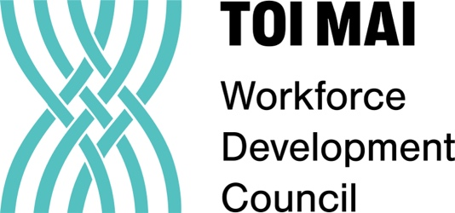

These ‘difficult positions’ may mean that there is one person on their own closing the library at the end of the day or someone who has to stay at the library during their unpaid lunch hour to support the staff member of duty.
See Te Tari Taiwhenua Department of Internal Affairs press release
See careers.govt.nz
Link to the Framework https://www.lianza.org.nz/te-totara-workforce-capability/
Te Ara Tahi: Mātauranga Māori Standards, Te Tari Taiwhenua Internal Affairs, p. 5.
We have used the dictionary.com definition for Eurocentric: “Considering Europe and Europeans as focal to world culture, history, economics, etc., or viewing everything through the lens of European values, attitudes, and interests.”
See article on this initiative: https://wellington.govt.nz/news-and-events/news-and-information/our-wellington/2025/03/te-awe-library-trials-new-shelving-system-for-a-more-meaningful-Māori-experience
See Te Rito Part One, Te Pūkenga, 2021, https://www.xn--tepkenga-szb.ac.nz/assets/Our-Pathway/Learner-Journey/Te-Rito-Insights-from-learners-Part-One-Final-Digital.pdf
Student Perspectives on Leaving School Pathways and Careers , Ministry of Education, 2008
See insights on this subject from Te Rito reports, Te Pukenga, 2022
This is the link to the first of three videos created as a webinar series for mana whenua on Rēkohu Chatham Islands to share information held by Archives NZ, and also to inspire them to think about their own archives. Short-term project funding and budget cuts made this project difficult to sustain.
Newsroom article by Mandy Henk on the pay equity changes and the impact for librarians https://newsroom.co.nz/2025/05/14/im-a-librarian-and-youre-right-mr-luxon-but-not-for-the-reasons-you-think/

