Skills in the creative sector

A thriving sector despite training mismatch

Report to Toi Mai Workforce Development Council
Shamubeel Eaqub, Rosie Collins and Nihal Sohanpal
14 August 2025

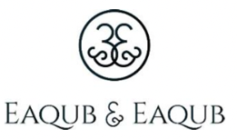

Key Points

Culture is a foundational driver of production, innovation, and prosperity.

Culture is made up of shared symbols, practices, and meanings, and it plays a key role in politics, social unity, and collective action. People working in creative fields like the arts, media, and design, help shape society by offering unique ideas and skills and talents. They influence how we live and work together and often lead the way in innovation.

This contribution also has a systemic role in value creation: cultures shape and stabilise the "rules of the game" that support justice, social cohesion, and long-term societal well-being. Although economic conceptions of value frequently dominate public discourse and policy, ideas of value are not hegemonic but rooted in diverse cultural worldviews, reflecting that cultural attributes mean different things to different people.

Sharp tensions can emerge between Western rationalist cultures (typical of NZ European Pākehā) and Indigenous Māori worldviews, which emphasise relationality through whakapapa and carry a sense of intergenerational responsibility embedded in a networked understanding of time and place. Other migrant perspectives, such as those of Asian and Pasifika communities, bring further cultural breadth and variation to ethical understandings of social value.

As Acemoglu, Johnson, and Robinson’s body of work argues, inclusive institutions (particularly education and training in this case) are essential for realising this value in economic terms. They create the conditions for ease of doing business and ensure long-term stability – what we might think of as the conditions for economic viability.

Deliberate investment in creative capacities (as the basis for the sustained formation of talent), especially among younger generations, is essential to ensure this creative potential is actively cultivated and organised to support productivity, rather than left to emerge by chance.

The creative sector may be bigger than you think

The creative sector (creative industries and occupations) contributed $12.9 billion to New Zealand’s economy in 2022, equivalent to 4% of total GDP. Using a broader measure, which includes the ‘non market’ value generated via the consumption of creative services and volunteer time, the total sector’s contribution rises to $19.1 billion, or 5.8% of GDP.

There were 90,000 creative sector jobs (creative industries and occupations) in 2022, 3% of all jobs. Labour share is smaller than GDP share because the sector is relatively high in productivity.

There was also hidden labour: volunteer time was equivalent to another 16,000 jobs. There are close to 110,000 people with creative qualifications who work outside the sector – who may be creative but are not formally part of the creative ‘sector’.

Creative exports were valued at $3.6 billion in 2023. This makes creative exports Aotearoa New Zealand’s fourth-largest export industry, larger than fruit, and behind the three dominant commodity exports: dairy, meat, and forestry.

A note of caution: the creative sector is not easily captured by the current official classification system, which are better designed for the old economy of making things for industry classification and doing tasks. As a result, some parts of the creative sector are captured in industry, some are captured in occupation (e.g. design), and some are invisible (e.g. Ngā Toi Māori). We are reliant on what is available in the data, and there are still gaps that cannot be easily remedied.

The creative sector is highly productive

There is a persistent myth that the creative sector is low in productivity. While this appears true when measured by GDP per worker, it largely reflects inconsistent and irregular work patterns rather than low value per hour worked. When adjusted for hours worked, productivity in the sector is approximately $346,000, comparable to the agriculture sector at $317,000, and well above the economy-wide average of $197,000 per full-time equivalent worker.

Although economic productivity, measured through returns such as wages and profits relative to labour inputs, is a useful metric, it does not capture the creative sector’s broader social and cultural contributions. Nonetheless, improving productivity within each creative subsector is a practical and necessary focus for improving value creation. Such improvements typically arise from the interplay of capital, labour, and skills, reinforcing the need for policies that promote both sustainable growth and wider societal impact.

Increases in productivity stem from improvements in both capitals, such as technology, tools, and infrastructure, and in the skills and capabilities of the workforce. In the creative sector, where outputs are often intangible or non-standardised, these factors are especially interdependent.

Skills in the creative industries are developed in diverse ways and often follow non-linear paths.

While formal qualifications can provide a foundation, evidence shows that the most effective upskilling occurs through practice: on-the-job learning, mentoring, and peer exchange These experiential forms of training typically depend on informal networks and project-based work and build on early investments in school training, making them difficult to quantify but no less critical to productivity and value creation. It is this sustained and continuous investment in education that precedes the formation of talent. However, the current funding system does not adequately support these modes of skills development in New Zealand, limiting the sector’s capacity to realise its full social, economic, and cultural potential.

Our education and training system produces creatives, but not people who work in creative jobs

As Mazzucato argues, public value is generally realised not at the point of market exchange, but downstream when people’s lives are meaningfully improved through better systems and services.

This longer-term, outcome-oriented perspective makes measuring the creative sector’s impact more complex. It especially highlights the need to address precarious work through coordinating policies that align skills with long-term measures of public value: creating the conditions for sustained creative labour and innovation which meets social objectives. For this sector, the viability of creative work remains an important focus.

Currently, funding for creative training is (predictably) comparable to the share of workers with creative qualifications.

However, funding appears to be backward looking. The key question then is not simply how much funding and support exists for creative training, but whether it is well-designed to meet the specific needs of viable creative industries and occupations. Evidence suggests that current training provision is not well aligned with industry needs, as around 80% of those working in creative industries and occupations do not hold formal creative qualifications – they are self-taught or taught in ways that are not coherent to the formal system of education.

While current education and training funding may succeed in developing some creative skills, it is not consistently aligned with what the sector needs for employability and innovation. It is clear that informal, work-based, and practice-led learning (e.g., like mentoring, peer feedback, and on-the-job experience) are central to how skills are actually formed in creative work.

This points to a larger challenge: the assumption that more or different qualifications automatically lead to better jobs or innovation

Evidence from both New Zealand and international contexts (such as the UK’s New Labour-era reforms) shows that simply expanding micro-credentials and qualifications, without addressing job quality, power dynamics, and real labour market demand, often leads to credential inflation.

That is, more certificates but little improvements in wages, job security, or career progression. In this context, qualifications are more symbolic than substantive.

Despite rising numbers of creatively educated people, there is little evidence of corresponding economic returns specifically linked to these qualifications, largely due to unresolved structural issues in the labour market, such as high levels of precarious work in the sector and a persistent mismatch between how people actually learn in creative fields and the long-form qualifications typically offered.

New Zealand needs a learning system that evolves through strong feedback loops between industry, creative workers, education providers, funders, and policymakers, anchored in the country’s social, economic, and cultural context.

However, instead of adopting a coordinated, whole-of-system approach, current policy risks reverting to outdated, top-down models of skills development focused narrowly on addressing present-day input gaps. This overlooks the real dynamics of the creative sector, such as the wider economic context that produces talented creatives and/or prevents them from undertaking creative occupations due to structural limitations on their contribution (i.e. it is too expensive to train or live as a creative worker).

To understand these dynamics, what is needed is a co-designed system; one that is adaptive, grounded in real-world conditions, and guided by long-term public value. Clearer coordination mechanisms are needed to incorporate feedback from those actively working in creative occupations.

With the disestablishment of Toi Mai, it remains unclear who will carry forward the essential role of coordinating industrial policy and convening stakeholders for creative sectors.

The danger is that, in its absence, government systems will default to simply expanding or condensing formal qualifications as an ostensible fix to ‘input quality’, rather than building the broader ecosystem needed to support viable creative occupations.

International models offer helpful lessons. For instance, in the UK, Skills England brings together government and industry to align skills policy with sector needs.

Australia’s National Skills Agreement similarly provides a framework to coordinate training and workforce development across jurisdictions, fostering responsive and collaborative planning. Both approaches highlight the importance of cross-sector coordination and targeted industrial policies to support the creative economy.

Notably, the UK has recently appointed a Creative Freelance Champion to represent freelance workers on the Creative Industries Council, ensuring that the perspectives of precarious workers inform national policy.

In contrast, New Zealand is dismantling the very coordination functions that were most likely to underpin strategic, long-term planning.

The work started by Toi Mai in 2021 was incomplete as a coordination mechanism. It focused predominantly on linking industry views with TEC funding decisions, but even as a partial mechanism, it provided a unique form of feedback loop between creative sectors and training institutions.

However, the recent decision to disestablish the Workforce Development Councils risks shifting industrial policy away from the early, formative stages of value creation (those focused on shaping public value through system-wide collaboration) and toward a narrower emphasis on reforming the vocational education system. These systems are often siloed, with limited feedback mechanisms to inform or adapt the broader strategic vision. Yet there is little evidence that the need for more integrated, value-shaping approaches has diminished.

With this in mind, our work examines the current state of skills development in the creative industries and highlights the need for future governments and businesses to pursue industrial policy which:

- Recognises creative skills as essential to long-term public value. Industrial policy should explicitly acknowledge the long-term contribution of creative skills to institutional stability, social cohesion, and sustainable economic growth. These are not peripheral outcomes, but core public values that those with creative skills help to uphold. This aligns closely with businesses’ desire for stable operating environments and policy predictability, highlighting the important role of government in shaping and sustaining these outcomes.
- Reforms the training system to reflect real creative pathways – thinking beyond just long-form qualifications. Current funding structures heavily favour long-form, formal qualifications at the expense of flexible, short-term, and practice-based learning which are more aligned with how people in the industry actually progress and hone creative skills. A rebalanced system would recognise and support the non-linear, often informal pathways through which creatives build skills, such as on-the-job learning, mentoring, and project-based work. Businesses have a clear interest in advocating for a shift in focus, as redundant qualifications and over-indebted workers do not benefit them either.

- Re-establishes coordination mechanisms grounded in real conditions. Reinstate cross-sector coordination that takes seriously the cultural and socio-economic realities of creative work, especially its precarity. A training system built from this perspective should support broader goals like the Making Work Pay priority identified by the UK, ensuring creative occupations are viable, valued, and integrated into holistic policy frameworks. The focus should be on improving outcomes, such as decent, sustainable creative work, rather than simply increasing the number of qualifications in the system. This will take specifying roles and responsibilities in the system and creating clearer feedback loops between institutions; and organising government functions towards common goals.

Disclaimer:

Access to the data used in this study was provided by Stats NZ under conditions designed to give effect to the security and confidentiality provisions of the Data and Statistics Act 2022. The results presented in this study are the work of the author, not Stats NZ or individual data suppliers.

These results are not official statistics. They have been created for research purposes from the Integrated Data Infrastructure (IDI) and Longitudinal Business Database (LBD) which are carefully managed by Stats NZ. For more information about the IDI or LBD please visit https://www.stats.govt.nz/integrated-data/ .

The results are based in part on tax data supplied by Inland Revenue to Stats NZ under the Tax Administration Act 1994 for statistical purposes. Any discussion of data limitations or weaknesses is in the context of using the IDI for statistical purposes, and is not related to the data’s ability to support Inland Revenue’s core operational requirements.

Table of Contents

1. Introduction 7
2. Creatives shape both culture and prosperity 9
3. The creative sector’s economic contribution is big 11
Box 1: Creative skills as a driver of innovation 12
Box 2: Creative exports fourth largest commodity 14
4. 90k creative jobs; but most trained creatives work elsewhere 15
5. The creative sector is highly productive 18
6. Skills development is more nuanced than qualifications 22
7. Creative training is currently missing the mark 25
8. It’s not the funding, but how it is used 25
Box 3: Funding is biased towards longer-form provider-based learning 26
Box 4: Student loan and student allowance eligibility criteria create barriers 27
9. No coherent long-term skills strategy 28
10. Industry policy is not just problem fixing, but system shaping 30
Box 5: UK case study of joined-up decision making across government in skills 33
11. Recommendations 35
Appendix A: Definitions 36
Table 1: Creative sectors industry mix 36
Table 2: Occupation mix 37
Table 3: Qualification mix 38
Appendix B: Who works in creative jobs? Highlights 39
Appendix C: Government as a System framework 43

Table of Figures

Figure 1: Economic contribution of creatives is hampered by how we measure activity 13
Figure 2: Creative industries and occupations broadly comprise 90k people in creative jobs 17
Figure 3: Creative employment map: Qualifications, Occupations & Industries 18
Figure 4: Creative occupation jobs have increased more than creative industries – the industry of creative jobs is changing over time 19
Figure 5: There is a myth of low productivity in creative industries 20
Figure 6: There is wide productivity variation withing creative industries 21
Figure 7: Proximate factors affecting productivity outcomes 22
Figure 8: Income by age of qualification 24
Figure 9: Age of creative qualification and income – 2023 25
Figure 10: Preferred form of professional learning 26
Figure 11: Types of training best suited for employees/contractors 26
Figure 12: Overlap of Creative Jobs & Qualifications 27
Figure 13: Fragmented responsibilities, no system steward 31
Figure 14: Governance systems involve a wide-range of value-shaping functions 32
Figure 15: Examples of governance functions that can coordinate and align skills systems with long-term value goals if delegated, devolved, or directed 34
Figure 16: UK's description of Skills England as a feedback loop 35
Figure 17: The creative sector workforce is younger than agriculture and NZ workforce 41
Figure 18: The creative sector workforce has under-presentation of Māori, Pacific, and Asian 42
Figure 19The creative sector is largely made up of self-employed/employer 42
Figure 20: The creative sector struggles to retain new sector entrants 43
Figure 21: People don’t leave creative jobs for higher pay 43
Figure 22: New entrants into creative industries are largely coming from other industries, including those with second jobs (this is further complicated by self-employment) 44
Figure 23: Exits mainly to services industries, retail and hospitality 44

Introduction

Toi Mai commissioned this research to understand the broader economic narrative of creative skills development in Aotearoa New Zealand and how people (especially skills and qualifications) fit with and enable this system.

Toi Mai was set up in 2021 as a Work Development Council to give industry greater control over all aspects of vocational education, working with employers, independent earners and volunteers to understand the current and future skills needs for the creative, cultural, recreation and technology industries.

We took a mixed methods approach for this research, reviewing literature on cultural frameworks, international creative strategies, work done in the sector and other skills related bodies, as well as primary data analysis of the New Zealand Creative sector.

Our analysis shows the creative sector is both sizeable (measured by its contribution to GDP and exports) and highly productive, challenging common misconceptions.

It is also growing rapidly, making its success central to New Zealand’s future prosperity.

A vibrant creative sector drives productivity, boosts global competitiveness, and supports higher-value jobs.

Beyond economic impact, creative work also enriches cultural life and wellbeing, acting as a dual engine of economic and social value. However, current modes of creative training are not hitting the mark. While 86% of creative-qualified people work outside the creative sector, only 20% of creative roles are filled by those with creative qualifications. The issue is not the level of funding, but whether what is being funded aligns with real industry needs and the needs of those seeking training.

Current policy too easily equates skills primarily with formal qualifications, overlooking that creative skills tend to be developed through a mix of formal and informal learning and on-the-job experience. In the creative sector, most workers do not need specific creative qualifications. Yet funding tends to favour long-form qualifications and large education providers, rather than the diverse types of training (formal or informal) that actually boost employability and productivity for these groups (e.g. shorter courses or skills-based classes).

The disconnect between funding and industry outcomes reflects a broader systems failure seen across multiple sectors, where training and skills development lack effective industry feedback. Toi Mai was created to address this gap and has been maturing over three years, providing a platform for industry input to shape training. However, with the recent disestablishment of Workforce Development Councils (WDCs), the future of such coordination mechanisms is uncertain, risking a return to siloed, top-down decision-making.

In the future, prioritising the development and maintenance of dynamic feedback loops within the creative sector will remain essential. Ensuring that funding, training, and qualifications are continuously aligned with the evolving needs of the industry can drive meaningful productivity and innovation in and beyond the sector. This will take the deliberate use of government functions in influencing, engaging, and designing for public value. Efforts should help ensure the creative sector becomes a viable, rewarding space to build a livelihood.

Creatives shape both culture and prosperity

This section situates creative attributes in an economic context, drawing on Acemoglu and Robinson’s work on culture, institutions, and social equilibria. It explores how economic value is created at two levels, from:

- Proximate drivers of value – seen in visible and measurable outcomes such as jobs, wages, and creative output (e.g., performances, content, exhibitions) from the use of various capitals, labour, and technology; as well as from
- Fundamental drivers of value – the underlying, often less visible, drivers of long-term economic wellbeing such as culture, geography, luck, and institutions.

Traditional growth theory identifies capital, labour, and technology as the proximate drivers of prosperity. While these factors help describe how economies grow, they don’t fully explain why similar inputs yield different outcomes.

Of the fundamental drivers of value, only luck is beyond influence. Meanwhile, geography can be shaped through investment (e.g. in better transport networks) or softer measures (e.g. trade agreements, cultural diplomacy). However, institutions, shaped by culture, are the most enduring and adaptable foundations for long-term prosperity.

Building on this work, Acemoglu and Robinson (2023)’s cultural-institutional theories help us to understand culture not as a fixed set of values, but as a repertoire of shared attributes, such as a set of norms, practices, and everyday symbols. As elements combine and recombine in various configurations that help people make sense of the world and navigate decision-making, they garner shared meaning and symbolic value. Over time, as these patterns shape and are shaped by institutions, they result in social equilibria: the stable arrangements that define how societies operate and evolve.

A key concept in their model is cultural fluidity, the ability of a society’s cultural attributes to be reconfigured in response to new challenges or opportunities. Cultural changes can happen gradually or sometimes all at once, creating discontinuous jumps or feelings of tearing or rupture in the social fabric. Societies with more fluid cultures and strong creative skills might be better equipped to innovate, adapt, and reimagine institutional forms, while in contrast, rigid or exclusionary cultural systems may entrench inequality or resist necessary change. But at the same time, if culture becomes too fragmented and too hollowed out of shared meaning, rapid change can weaken the collective trust that institutions rely on.

In sum, all economic and social actors shape and are shaped by culture. Those with creative skills are unique in that their cultural contribution is intentional and explicit. Culture is not only their output, but also their function and method. Productions tend to hold intrinsic value outside of market exchange.

This means the value of creative occupations needs to be considered at both:
- The proximate level, creative skills directly create employment, contribute to GDP, and generate exportable goods and experiences.
- The fundamental level, where creative skills build the cultural capabilities that underpin trust, identity, inclusion, and innovation, factors essential to institutional stability and long-run prosperity.

In this report, we define the creative sector narrowly using New Zealand’s official industry classifications (ANZSIC codes), which include sectors such as book and other publishing, film and video production, music recording and publishing, television broadcasting, internet publishing, libraries and archives, museums, performing arts, creative artists and performers, and jewellery manufacturing.

However, when considering the sector’s contribution and the function of creative skills in value creation, we take a broader conceptual view that extends beyond these classifications.

The creative sector’s economic contribution is big

Defining the creative sector is complicated by two factors: the sector is not easily defined, as creative work is spread across creative industries and occupations; and there are non-monetary benefits which are not easily or consistently measured.

As cultural value often accrues over long timeframes and manifests in diffuse, non-market ways, standard tools like "willingness to pay" or GDP contribution fail to capture concepts of public and intrinsic value, especially where creative outputs have collective and symbolic significance.

Figure 1: Economic contribution of creatives is hampered by how we measure activity
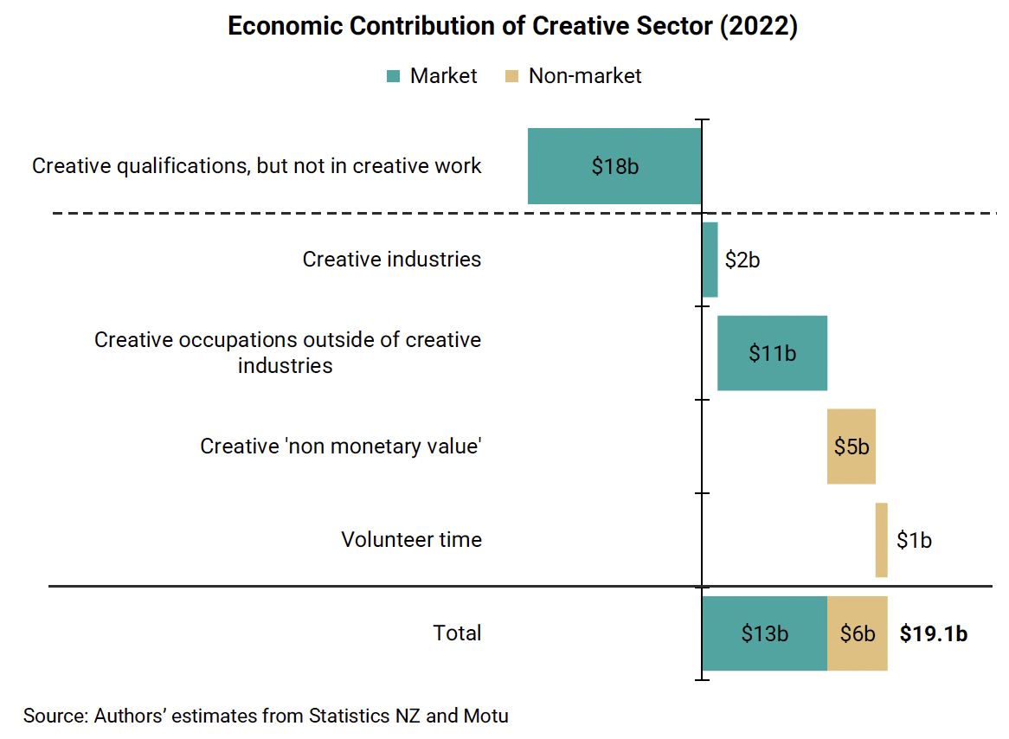

The chart above presents a narrow measure of sector value based on actual financial flows (represented as market values), as well as unmeasured contributions, representing estimated social and economic impacts that are less visible but still significant, shown as non-market values.

For market measures we estimate gross value added, which is wages and gross profit – _or the returns to labour and capital. Please note:

- The term ‘creative industry’ reflects the traditional way economic value is measured (like for the construction or manufacturing or farming sectors)
- But creative work happens outside of creative industries too. Our use of creative ‘occupations’ reflects more value than in a narrower definition of creative industries.
- Our third framing is an even broader definition, where the economic value created by those who have creative qualifications but do not work in a creative occupation or a creative industry is added in. This measure reflects a lot of people – they are the ‘hidden’ creatives that are working in a range of industries and occupations. This cohort is a critical reminder that not all qualifications lead to employability in dedicated sector; there is value in training that can be applied in other industries and occupations. We have not included this in our definition of the creative sector, as these are creatively trained people who are applying those (and other) skills in “non-creative” jobs.

As to the hard to monetise non-market or social benefits of the creative sector, there are two obvious metrics that we have supplied:
- Volunteer time which uses creative skills, equivalent to 16,300 jobs, is worth $1.3b at the 2024 average wage per year.
- The non-monetary value of participation and consumption of the arts (beyond ticket prices) was estimated by Motu at 6-20% of the income of those who attend or participate (70% of New Zealanders), which is equivalent to at least $4.9b (and gives us a top end estimate of $21.2b of public value).

This gives us a broad measure of economic contribution of the creative sector, based on both market-based approaches of GDP contributions (broadly the wages and gross profits generated in creative industries and creative occupations), and the monetary equivalent of non-measured benefits of creative arts participation and consumption, and volunteer time. But notably, even this does not reflect the long-term stabilising function of cultural productions as a democratic value, which is more challenging to measure.

Box 1 explains more about the importance of understanding creative skills outside of market-measures, as a driver of public value through innovation potential and the derivation of shared meaning. Box 2 compares the export output of the creative sector (based on UN data), which shows that it is a significant export at $3.6b, behind our major exports of dairy, meat and forestry (and tourism at $17b), but larger than notable exports such as fruit, wine and seafood.

Box 1: Creative skills as a driver of innovation

Understanding creative industries (and occupations) as a production system helps reconcile its contribution and interdependence with other production systems in the economy. But there is another way to look at it: the value of creative skills.

Creative skills contribute directly to productivity and innovation in firms (an economic value output) but also form the basis of social fabric and trust (a longer-term, social values outcome). It is increasingly recognised that the potential of creative skills is maximised in collaboration with other actors, as a dynamic of systems structure.

If value is created collectively a key question becomes what capabilities, resources and capacities are needed for this value to be created across different sectors? If cultural innovation is shaped by “controversial ideas, fitful beginnings, and contestable practices”; resourcing and capability should reasonably be planned over a long-term horizon. The risk of focusing predominantly ‘on the new and now’ is it bolsters a ‘thin notion of cultural value’ overlooking the decline in cultural sectors and embracing ‘a crude version of innovation, which conflates it with novelty'.’

Mazzucato’s framework for public value instead focuses on measures of progress towards the achievement of broad and widely accepted societal goals, such as creative innovation. These goals are achieved through collaboration between both private and public sectors, which together, via the process of innovation, co-create and co-shape markets.

Creativity as a skill has been linked to jobs which are more likely to grow as a percentage of the workforce by 2030, and the value of these attributes is not limited to creative occupations.8 In the UK, for instance, creativity has been identified as the most significant predictor of occupation growth up to 2030.

Box 2: Creative exports fourth largest commodity

If creative exports were a commodity, it would be the fourth largest after dairy, meat, and forestry. It is larger than fruit and wine. It is clearly a large and important export sector.
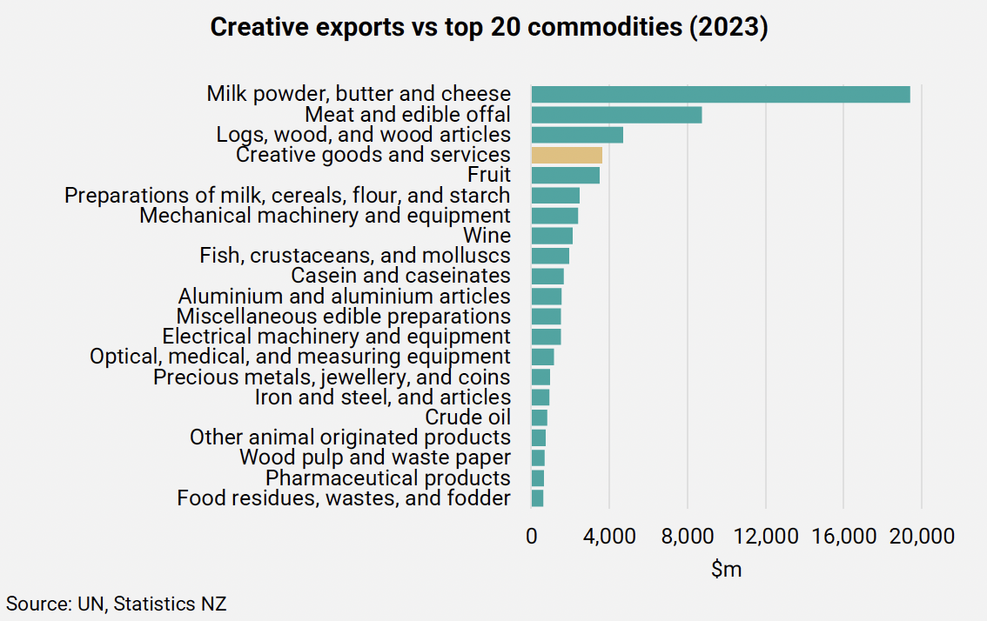

The contribution of creative exports as a share of GDP is not as high as some countries like Sweden, Denmark and Canada. But it is larger than Norway and Australia. These are countries we typically look at for their industrial strategies.

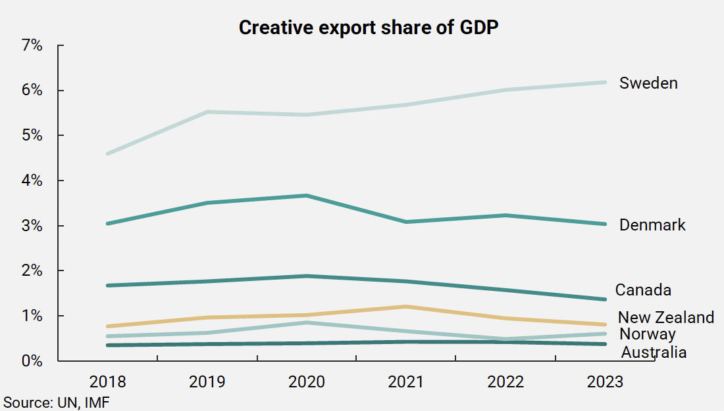

90k creative jobs; but most trained creatives work elsewhere

For our quantitative analysis we define creative jobs as those which are in creative industries or occupations. There is an overlap between the two, shown in Figure 2 (Figure 3 includes those with creative qualifications). We There are around 90,000 people working in creative jobs in New Zealand. This doesn’t include the additional 16,300 full time equivalent volunteering spent in the creative sector each year.

Figure 2: Creative industries and occupations broadly comprise 90k people in creative jobs
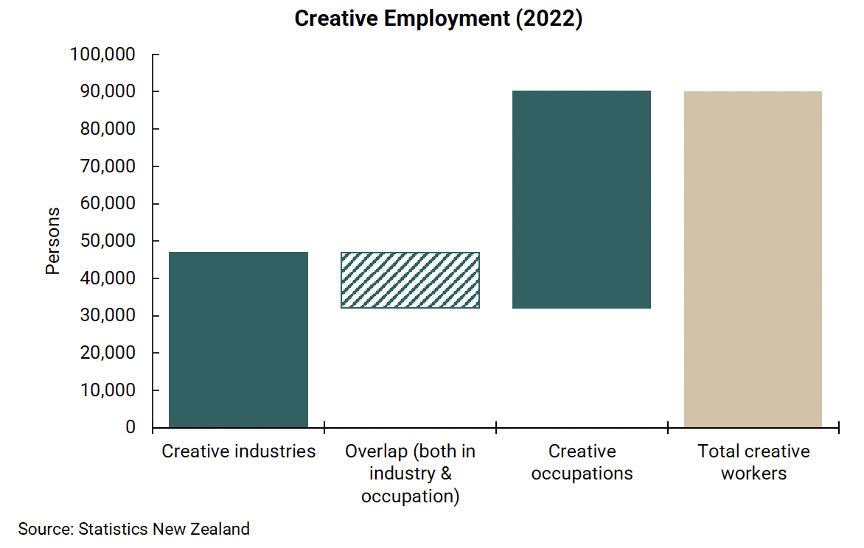

The makeup of how many people work in these various parts is shown in the Venn diagram below, which maps those who work in creative industries, those who work in creative occupations, and those with creative qualifications. Those with creative industry and creative occupation jobs are what we define as creative jobs. Those with creative qualifications working in non-creative jobs outside of the sector are out of scope for this work. However, as we highlighted in Box 1, creative attributes are an important contributor to broader innovation and social stability outcomes.

Figure 3: Creative employment map: Qualifications, Occupations & Industries

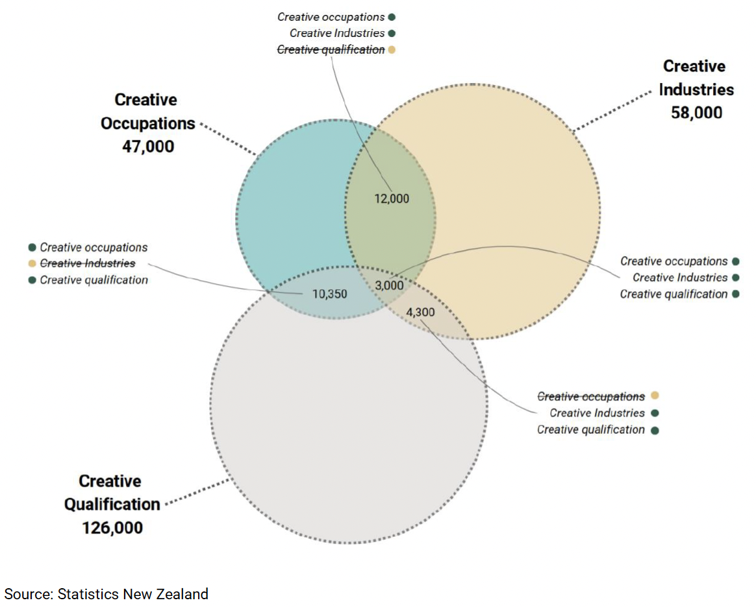

Why we invest in creative training is an important question

If it is for creative skills to fuel innovation, that may very well be happening. But if it is to increase employability in creative jobs – to make this type of work viable - then the government’s funding has been much less successful.

As Figure 4 below shows, there has been significant growth in the number of people with creative qualifications over the past decade, reflecting substantial investment in long-form training. However, the growth in creative jobs has been much more modest, with just 5,600 more jobs in creative industries and 19,000 more in creative occupations. While the share of creative qualification holders working in creative jobs has increased slightly (from 10% to 14%), the vast majority remain employed in other sectors.

This disconnect points to a broader issue: a systemic bias toward long-form qualifications, reinforced by static funding models and weak feedback loops between education providers and employment outcomes. As a result, education systems continue to prioritise formal credentials even when clear career pathways into creative roles are limited. Despite rising educational attainment, this approach has not translated into stable employment or meaningful career progression within the creative industries, with persistent barriers to sustained, quality work.

At the same time, this emphasis on lengthy qualifications does not fully reflect how the creative sector operates in practice, where shorter, flexible forms of training (such as micro-credentials or project-based learning) are frequently more aligned with rapidly changing skill demands (or traditions of informal apprenticeships). A more dynamic, responsive approach to training could better support both creative work pathways and the wider application of creative skills across the economy.

Figure 4: Creative occupation jobs have increased more than creative industries – the industry of creative jobs is changing over time
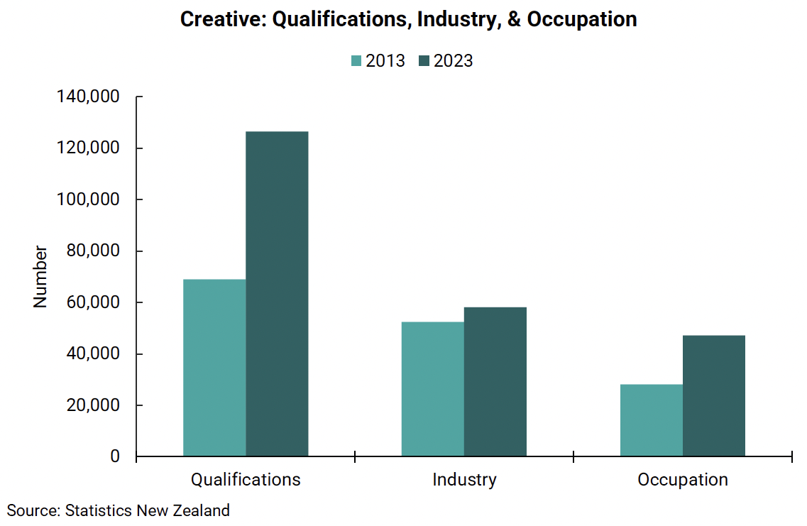

The creative sector is highly productive
There is a prevailing perception of low productivity in the creative sector. It is true on a GDP per worker basis. But that reflects inconsistent work. When we adjust for hours in 2022, the productivity of creative industries sits at $346,000 and creative occupations at $353,000, comparable to agriculture at $317,000, and much higher than the national average of $197,000. These metrics are based on our analysis of FTE workers based on paid hours.

This measure looks narrowly at creative industries, rather than the wider definitions to include occupations. This is because the data then becomes conceptually incompatible for comparison purposes. This has the effect of missing out some are included under other industry codes that are not fully representative (e.g. game development), and some are invisible (e.g. Ngā Toi Māori).

Emerging industries, like game development is another example of where a sectors contribution is unidentifiable as a result of the current classification system. In 2024, the New Zealand game development industry generated $548m in revenue, an increase of 26% from 2023, and equating to approximately $500k revenue per employee.

Figure 5: There is a myth of low productivity in creative industries
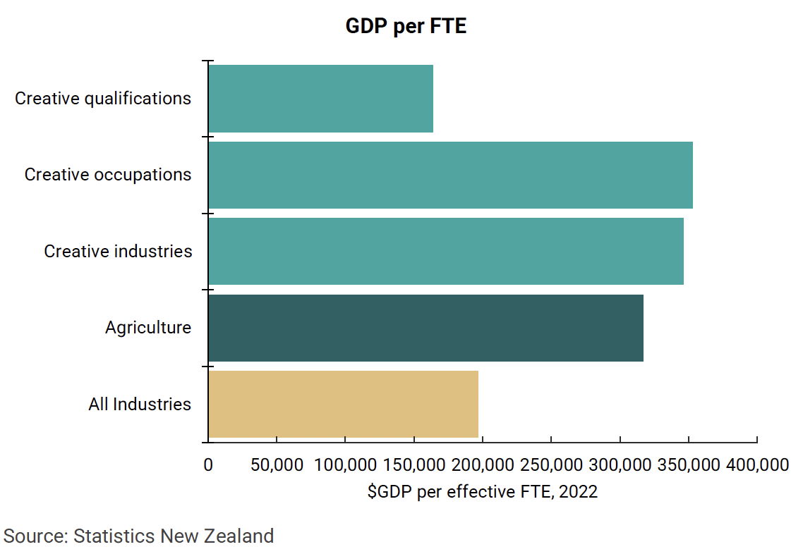

Error! Reference source not found. shows that productivity varies a lot across the creative sub-industries. Movie and music related industries are high productive (while the sector shows most of the returns as profits, for self-employed and many employers_’ _profits are equivalent to labour income).

Remaining industries tend to be lower productivity, often in performance and publishing industries. Some, such as performing arts may have a larger non-monetised societal benefit. Others face wider structural pressures globally, such as book publishing.

Figure 6: There is wide productivity variation withing creative industries
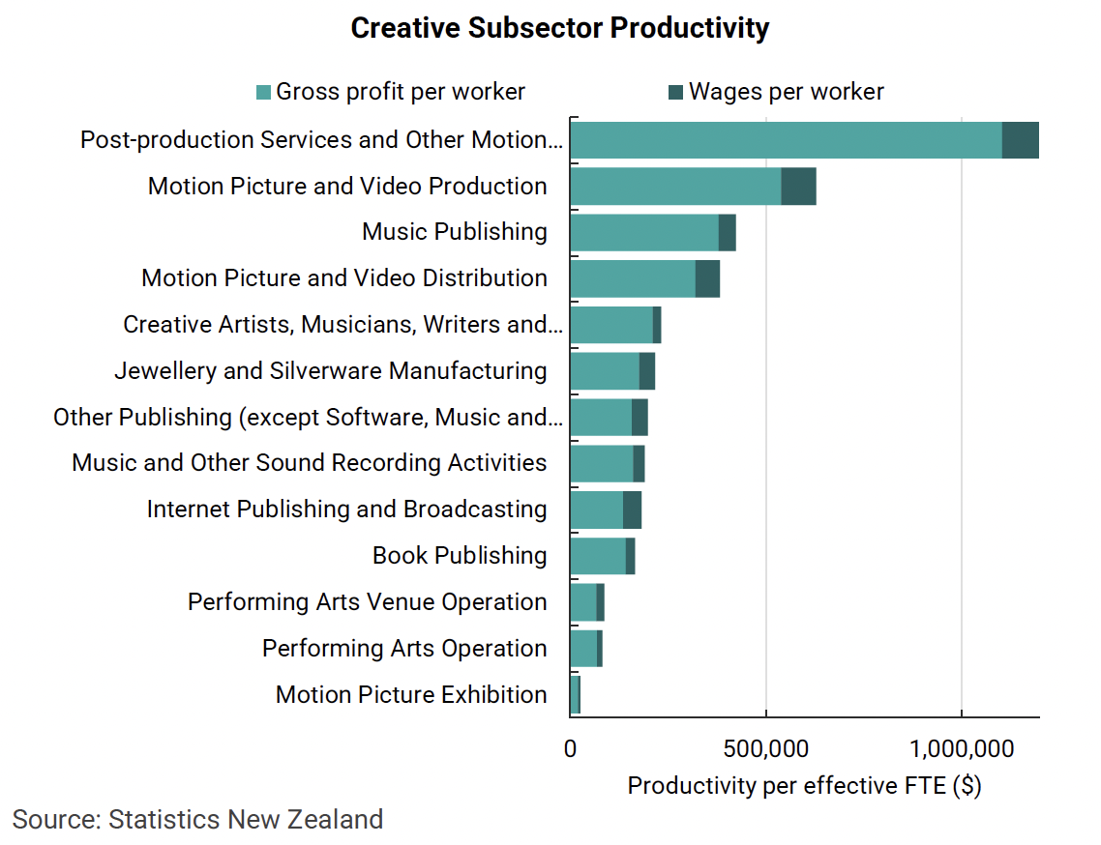

Within sector heterogeneity is not surprising. What matters for each sub-industry is to focus on progressive improvement in productivity (generating better returns from its work, for workers and owners) relative to baseline performance.

Productivity is a function of many things, but skills are a critical component

Productivity is the visible and measurable outcome of how effectively an economy or organisation transforms inputs into outputs. It is widely used as a key performance indicator in both government and business.

Economically, it typically refers to the return on inputs, particularly labour and capital, and is measured as outputs (such as wages or profits) relative to those inputs. Skills are a key factor influencing the quality of interaction between key inputs, alongside access to capital (see Figure 7 below).

Figure 7: Proximate factors affecting productivity outcomes
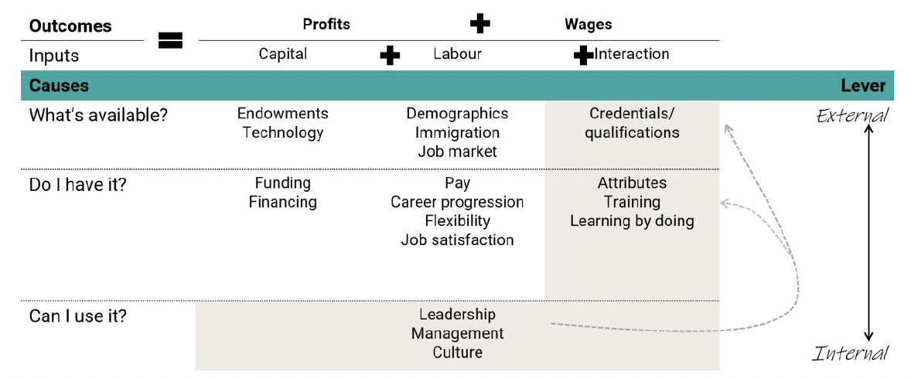

The goal for an economy tends towards achieving a positive dynamic where returns to both capital and labour are increasing over time. Achieving this depends on a complex mix of internal and external factors that affect both capital, labour, and the relationship between them, including the fundamental drivers of growth we identified in the earlier section.

To understand what drives productivity, we can ask three broad questions:

- What resources and capabilities are available?
For capital, this includes the availability of physical resources (like land and water) and access to appropriate technologies (e.g. using a tractor instead of a horse). For labour, it involves understanding demographic trends, workforce participation, and labour market conditions. At the intersection of labour and capital, it means considering what qualifications and training systems are in place to enable people to use available capital efficiently. This includes access to education, vocational pathways, and industry-specific training.
- Do we have the right inputs in place?
Having a good understanding of what is available is only part of the equation: the next step is acquiring the right resources. For businesses, this means investing in productive capital, which may be limited by financial constraints. For labour, it involves attracting and retaining people with the right skills, qualifications, and attributes. It’s not just about formal credentials, but also about soft skills like communication, teamwork, adaptability, and sound judgement. Businesses also need effective systems to support learning, such as on-the-job training, mentoring, and continuous professional development.

- Are we using these inputs well?
Even with high-quality capital and a skilled workforce, productivity gains only materialise when the interaction between the two is well managed. This is where leadership, management, and culture become critical foundations. Effective leadership aligns people and resources with strategic goals; good management ensures that systems and processes work smoothly; a strong workplace culture supports collaboration, innovation, and continuous improvement. Industry stakeholders have noted that continuous and sustained educational investment precedes the emergence of strong talent and creative capacity, especially when support is consistent from early schooling through to adulthood. When these elements are in place, an organisation is more likely to turn potential into performance.

In reality, this is the big overarching set of attributes necessary for a successful business. Ultimately, productivity reflects not just assets or headcount, but how well people and systems work together to generate value.

Skills development is more nuanced than qualifications
The formation of talent is not a static or linear thing. Rather, it includes a range of formal training, informal training, learning by doing, and mentoring access to name a few. The process of gaining skills is a continuous journey rather than something that should be viewed as static. As skill demands change, and what is socially valued changes, the workforce needs to be able to adapt.

Evidence shows new hires learn rapidly on the job. This is consistent with earnings data that shows rapid increase in incomes soon after gaining qualifications.

Literature also suggests that combination of formal and informal learning works best. The creative sector is no different in this regard: mentoring, short-form courses, and various forms of on-the-job learning tend to be the most effective mechanisms for skills development.

As noted, a formal qualification can be important, but it is only one part of a skills development process. This contrasts from traditional funding models for training, which tends to conflate acquisition of formal qualifications with learning.

Figure 8: Income by age of qualification
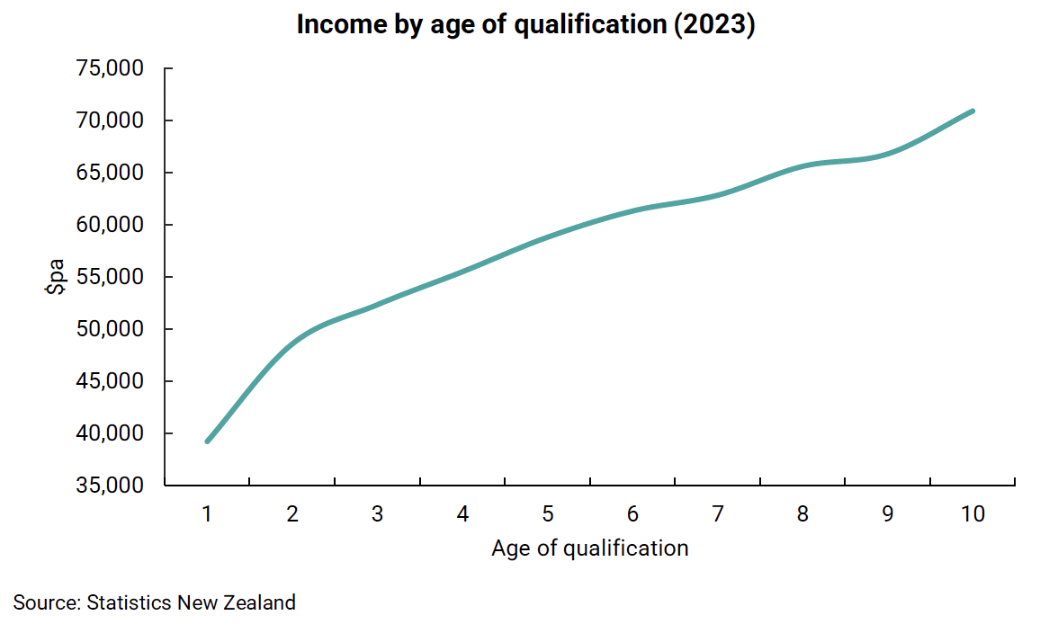
Figure 9: Age of creative qualification and income – 2023
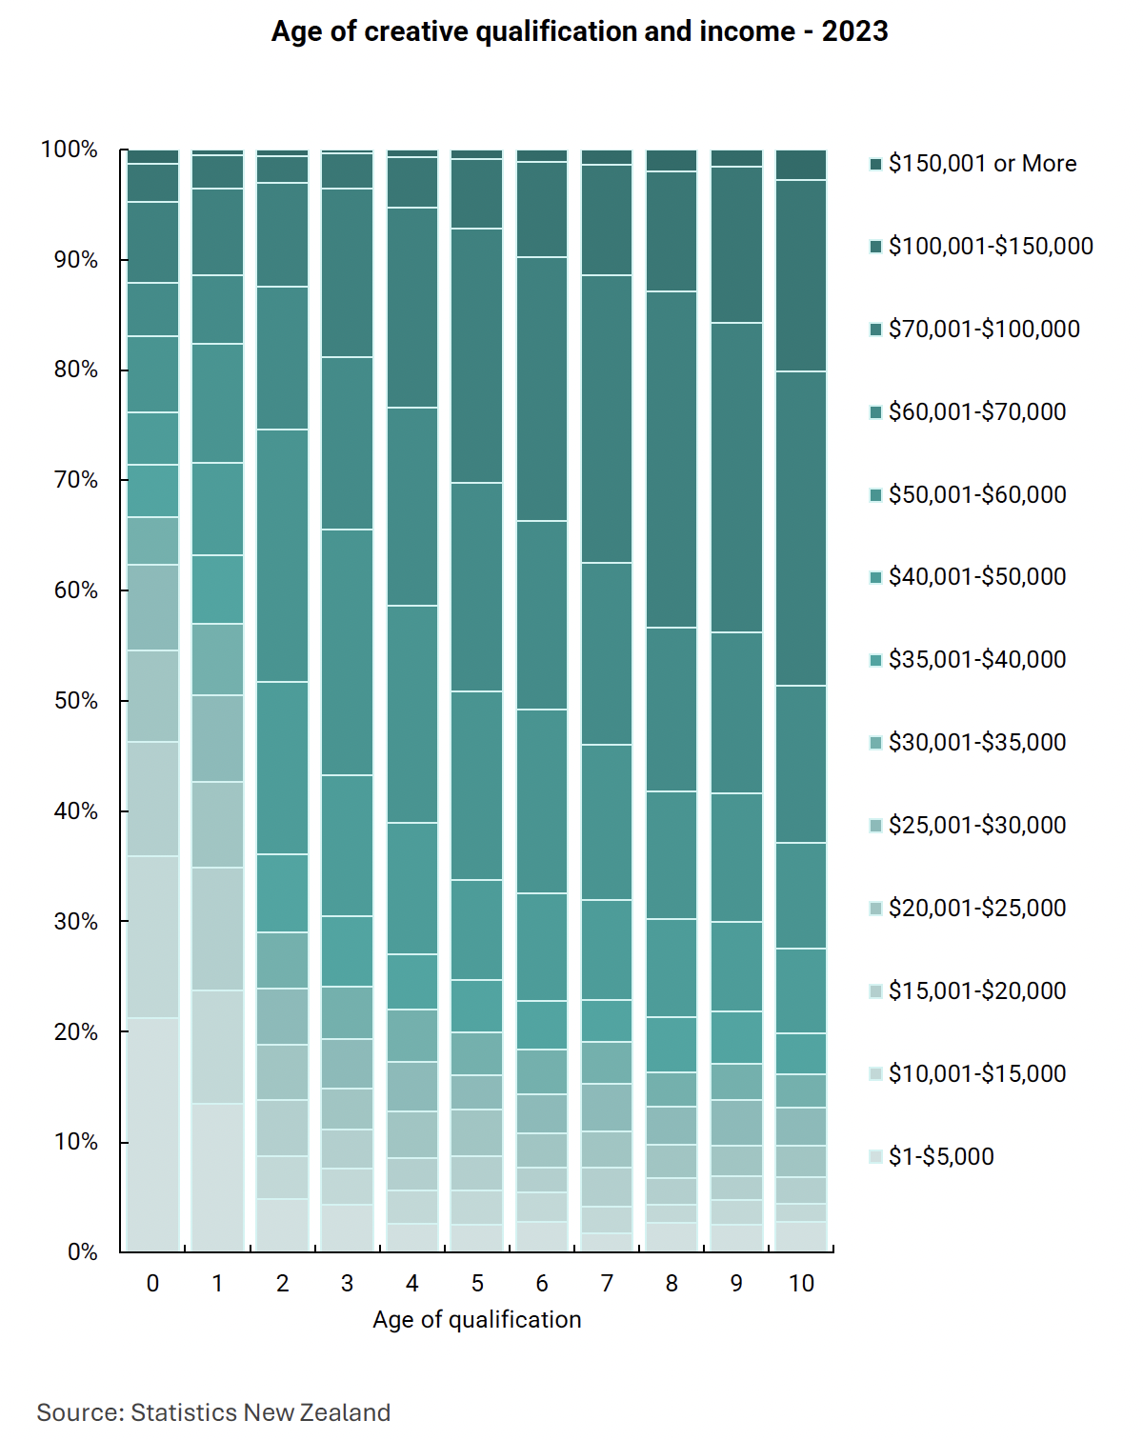

Figure 10: Preferred form of professional learning
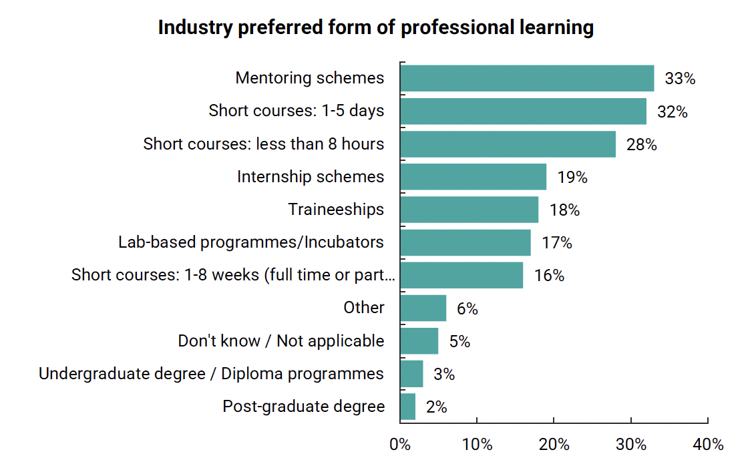
Source: New Zealand Film Commission and Toi Mai Workforce Development Council

Figure 11: Types of training best suited for employees/contractors
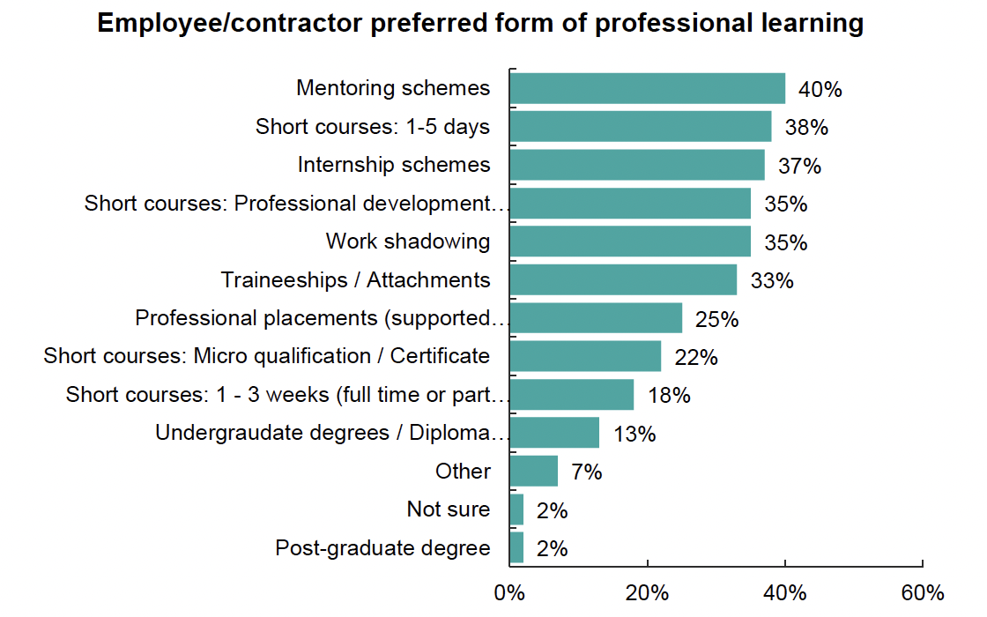
Source: New Zealand Film Commission and Toi Mai Workforce Development Council

Creative training is currently missing the mark
Most people working in New Zealand’s creative industries or creative occupations currently do not hold creative qualifications.

While funding for creative training appears proportionate to the economic size of the sector (creative arts make up about 5% of all tertiary education funding based on TEC data, matching the share of workers in the broader creative economy), these qualifications are not widely represented among people actually employed in creative roles. Only around 20% of creative workers hold a related qualification.

This suggests that, while creative training may provide valuable skills, it is not translating into improved employability within the creative sector itself. Funding, in other words, is not the issue – it is how that funding is being deployed, and whether creative occupations are viable for those who take out the heavy debt load that long-form qualifications tend to require for most groups.

Figure 12: Overlap of Creative Jobs & Qualifications
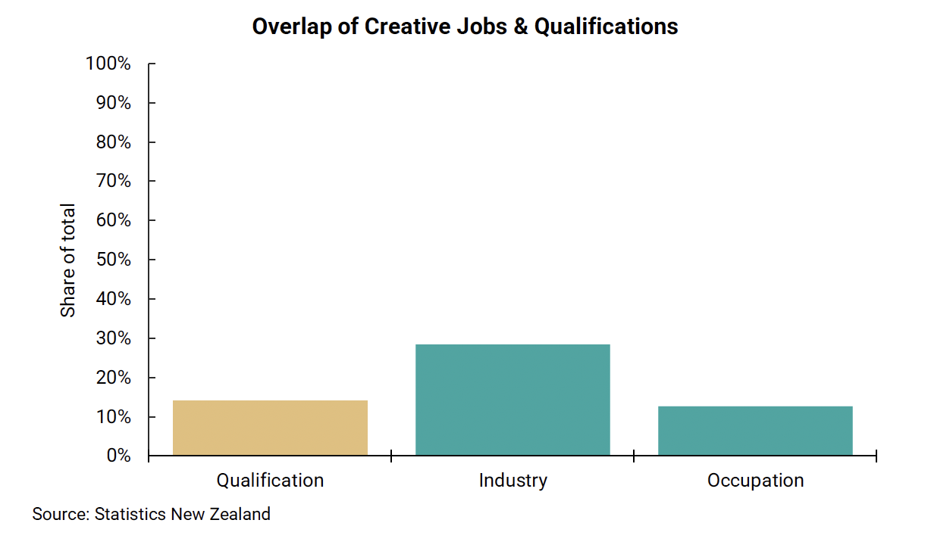

It’s not the funding, but how it is used
This disconnect appears to stem from a misalignment between the training system and labour market realities in the creative sector. Our interviews with a small group of creative businesses highlighted several persistent challenges related to this challenge, including:
- A system bias toward longer-form, provider-based qualifications (see Box 3)
- Limited support or uptake for more agile training models like micro-credentials
- Access to student loans and allowances heavily shapes training decisions by setting social norms, often in ways that don’t reflect industry needs (see Box 4).

These issues point to a lack of coordination between key stakeholders (including funders, providers, regulators, employers, and learners) in designing training that leads to meaningfully improved employment outcomes.

Box 3: Funding is biased towards longer-form provider-based learning

When discussing with creative industry stakeholders, we heard there has been a desire for training and education to be shorter-form and work-based. Despite this, funding continues to incentivise longer-form provider-based training and education.

An example is the Creative Arts delivery classification in the table below. It shows that provider-based funding is 25% higher than for work-based learning (even though the literature suggests there is often higher effectiveness in the latter). Funding increases at higher levels of training, creating a strong incentive for providers to favour their own provider-based learning pathways.

We also heard that funding can be harder for niche training that may have few learners at higher cost, but better employment and income outcomes. Funding takes a broader cost per trainee perspective, which can miss these nuances.

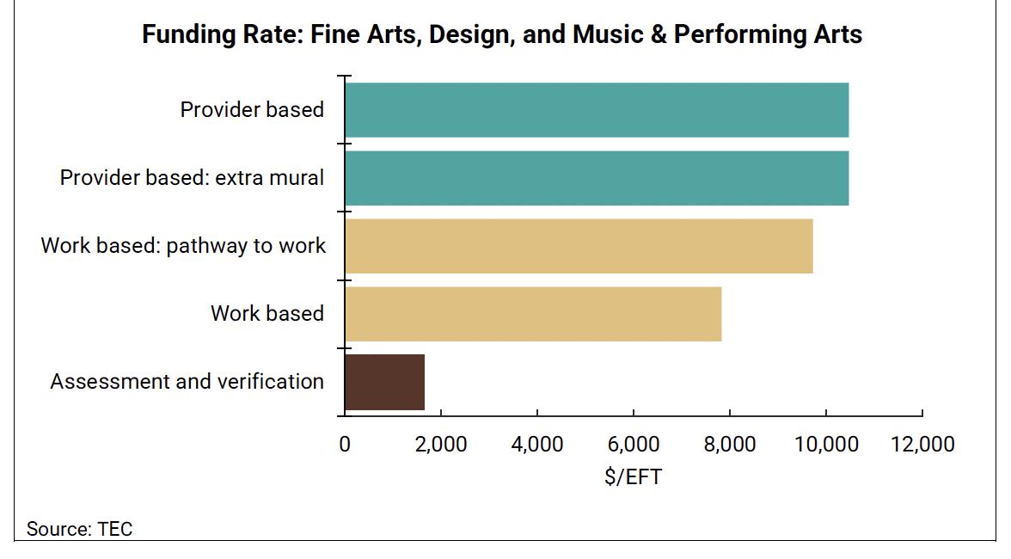

Box 4: Student loan and student allowance eligibility criteria create barriers

Another important enabler for training and education is connecting access to student loans and allowances to cover training. Group training organisations (GTOs) have highlighted that learners are currently not eligible for student loans or allowances (through MSD) as they are classified as in work, yet they still have to pay substantial course fees (for some trades fees are around $4000/year). During this time, trainees will only earn a training wage but need to live, buy tools and travel to work/learning venues. That is, they still incur study and opportunity costs. In this dynamic, for many it is unworkable to train.

Another issue our interviews raised relates to the exclusion of micro-credentials from the funded/funding-enabled training system. Currently, learners wanting to enrol in micro-credentials are not eligible for student loans and allowances. Yet in some cases, micro-credentials are worth 40 credits, which equates to approximately 400 hours of learning and could take months to complete.

No coherent long-term skills strategy

New Zealand lacks a coordinated, long-term industrial strategy for developing creative skills: one that addresses not only current workforce needs but also helps shape the future economy we aspire to build.

At present, investment is focused on inputs (such as formal training and human capital development), rather than being organised around long-term value outcomes. This reflects a siloed system, lacking a unifying purpose and a clear understanding of how its parts interact. Multiple government and sector agencies, such as the Ministry of Education (MoE), Ministry of Business, Innovation and Employment (MBIE), Tertiary Education Commission (TEC), Workforce Development Councils (WDCs, such as Toi Mai), NZQA, education providers, and employers, play important roles in the development of creative skills.

Yet they often operate in parallel rather than in concert, with no overarching strategy to align their efforts. While each actor has its own mandate and motivations, their actions are deeply interdependent. The result is a fragmented, often reactive policy landscape which lacks the coherence needed to steer the economy toward more inclusive and future-focused outcomes.

Within this system:
- MoE provides strategic leadership across the education sector and oversees funding mechanisms but has limited contact with industry or creative workers.
- MBIE sets labour market policy through documents like the Employment Action Plan (2024), but this is not sector specific or oriented to a collaborative long-term vision.
- Immigration policy is adjusted on an ad hoc basis in response to current domestic skills shortages, rather than anticipating and planning for future needs. There is limited integrated planning to build the institutional capacity required to support migrants effectively or to address the impacts that high immigration levels can have on social cohesion.
- TEC allocates funding and monitors TEO performance.
- WDCs offer vocational education advice but have limited levers to drive change directly. Whilst they have stepped in to play an advisory function, the main coordination mechanism for creating change within their remit is through qualifications and advice on vocational training to TEC – _they do not have permission to advise on whole-of-system outcomes.

Diffusion of responsibility means no single body is accountable for aligning the skills system with wider economic, industrial, and social goals. Past investments in coordination mechanisms (such as through Toi Mai) have been limited and mainly focused on TEC funding, rather than on broader efforts to influence, engage, and design creative systems for long-term value creation.

Figure 13: Fragmented responsibilities, no system steward
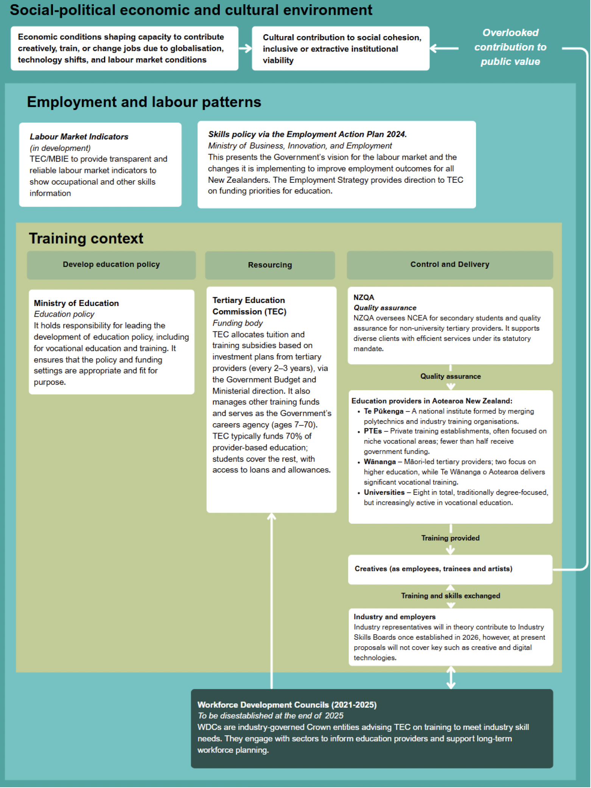

10. Industry policy is not just problem fixing, but system shaping

Too often, industry policy and skills strategies are treated as quick fixes for visible input problems like skill shortages, mismatches, or underemployment, by focusing mainly on improving access to inputs such as education or immigration. However, government functions have a far more fundamental role: they should support inclusive institutions and the entire process of value creation, shaping markets and expanding opportunities with a long-term perspective rather than reacting narrowly to immediate skills gaps.

Figure 14: Governance systems involve a wide-range of value-shaping functions

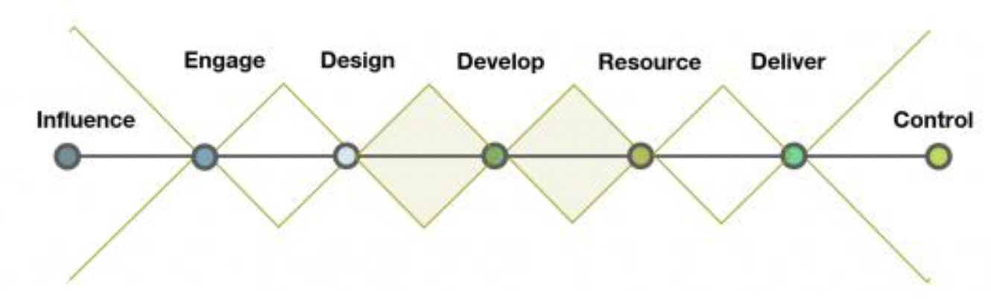

A narrow focus risks misdiagnosing the barriers creatives face in building viable careers, concentrating on proximate factors instead of addressing deeper structural issues, such as extractive institutions that contribute to challenges like excessive indebtedness from poorly designed education pathways and high housing costs.

Government has a unique role as a steward of the public interest, not only to respond to labour market demand, but to enable new markets, build future capabilities, and support sectors whose value is long-term, cross-cutting, and typically under-recognised in traditional economic models.

Within this system:

- MoE provides strategic leadership across the education sector and oversees funding mechanisms but has limited contact with industry or creative workers.

- MBIE sets labour market policy through documents like the Employment Action Plan (2024), but this is not sector specific or oriented to a collaborative long-term vision.

- Immigration policy is adjusted on an ad hoc basis in response to current domestic skills shortages, rather than anticipating and planning for future
- needs. There is limited integrated planning to build the institutional capacity required to support migrants effectively or to address the impacts that high immigration levels can have on social cohesion.

- TEC allocates funding and monitors TEO performance.

- WDCs offer vocational education advice but have limited levers to drive change directly. Whilst they have stepped in to play an advisory function, the main coordination mechanism for creating change within their remit is through qualifications and advice on vocational training to TEC – _they do not have permission to advise on whole-of-system outcomes.

Diffusion of responsibility means no single body is accountable for aligning the skills system with wider economic, industrial, and social goals. Past investments in coordination mechanisms (such as through Toi Mai) have been limited and mainly focused on TEC funding, rather than on broader efforts to influence, engage, and design creative systems for long-term value creation.

Figure 13: Fragmented responsibilities, no system steward shows that the current focus is predominantly on improving input quality through skills development. However, stakeholders are not organised around the broader influencing, engagement, and design functions of government (some of which are outlined below and detailed further in Appendix C’s Government as a System framework). Efforts remain narrowly focused on education policy, funding, delivery, and regulation.

To date, Toi Mai has served as a partial coordinating mechanism linking industry with TEC funding, but it lacks the delegated authority to convene stakeholders for developing a whole-of-system vision. This means that while it can identify skills mismatches in education pathways, it has limited capacity to advise other parts of government; for example, on how economic precarity restricts the ability of people with creative skills to participate fully in creative occupations.

Some examples of functions that governments can undertake in early stages of system shaping are specified in Figure 15 below:

Figure 15: Examples of governance functions that can coordinate and align skills systems with long-term value goals if delegated, devolved, or directed
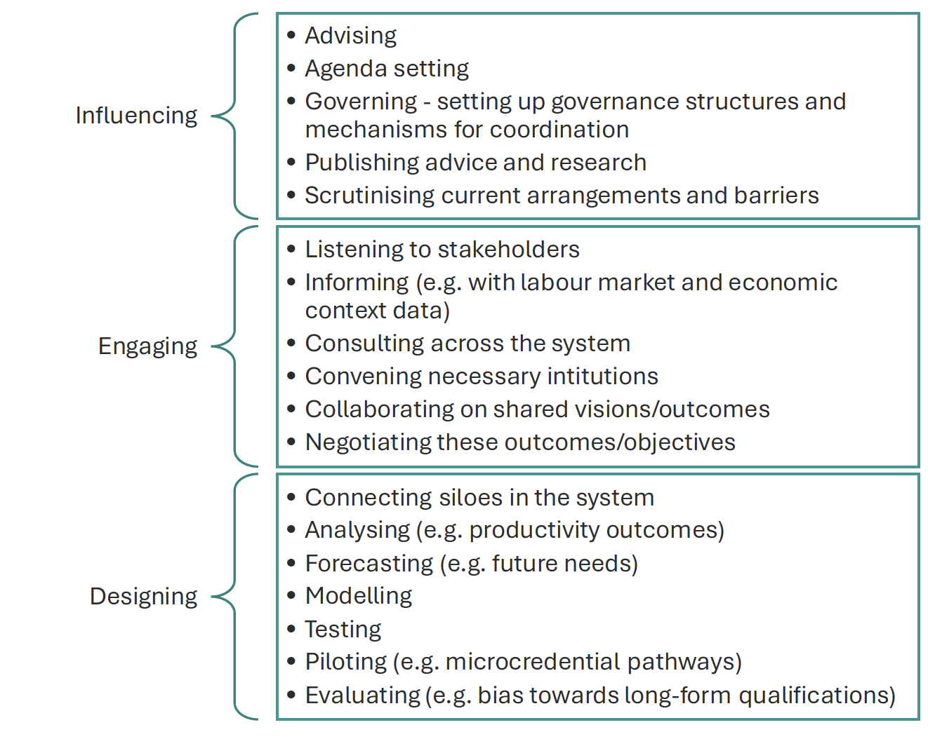

Other jurisdictions are moving toward a whole-of-system approach, embedding future-focused, evidence-based feedback mechanisms into their education and training systems. These mechanisms connect labour market intelligence, employer

needs, societal priorities, and learner outcomes with funding, qualifications, and system settings. For example:
- Australia’s 2024 National Skills Agreement has introduced a shared stewardship model, led by the Skills and Workforce Ministerial Council, to align national priorities with regional needs.17
- The UK’s Skills England is being positioned as a single feedback loop back into government, informing funding and policy decisions with real-time intelligence from industry and educators (see Box 5 for further detail).

Figure 16: UK's description of Skills England as a feedback loop

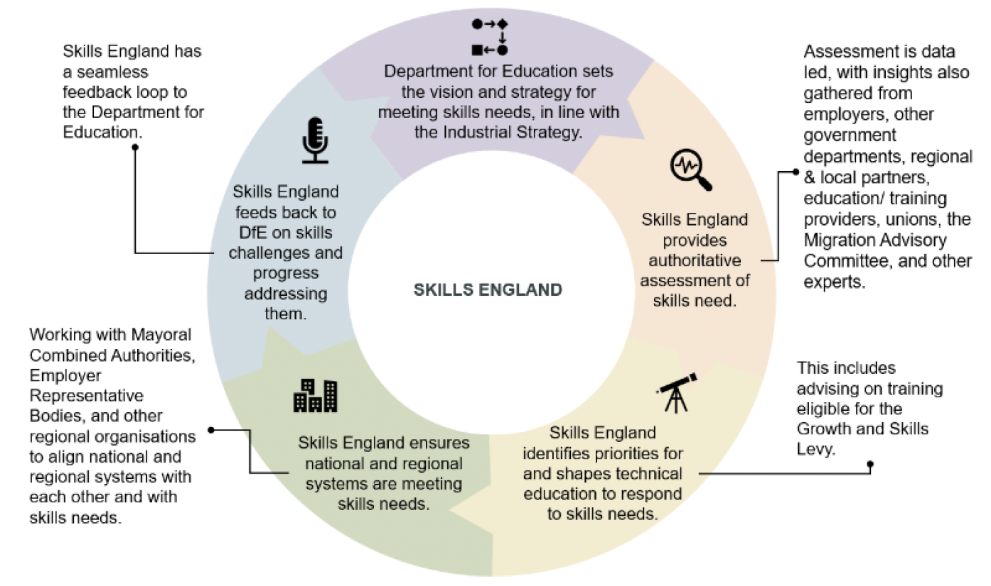

Crucially, neither model required a wholesale structural overhaul. Both invested in governance and system feedback capacity that worked across existing institutions. Our interviews and analysis of the creative sector reinforce this need locally. Rather than continuing to manage a decentralised and reactive system, New Zealand can benefit from investing in a coordinated, long-term creative skills strategy with:

- Clear stewardship functions, to align actors toward shared economic and social goals, based on the wider social-economic and cultural context which is likely to prevent creative occupation uptake (e.g. such as high costs of training, job precarity, and high costs of living);

- Designated and active feedback loops based on close relationships with industry and creative workers, including those freelancing in the gig economy, to ensure learning, adaptation, and accountability within the system, aligned with the actual training needs of the sector (e.g., for shorter-form, decentralised modes of training at lower cost).

- Representation from across sectors, including the cultural and creative industries, to reflect the evolving shape of work and opportunity.

Box 5: UK case study of joined-up decision making across government in skills

The UK has recognised the need for an agency that is dedicated to the collation of data and insights, and which uses these to convene stakeholders and collaborate effectively across a range of government functions. In the creative sector, Skills England is delegated responsibility for working with a number of agencies, including:

- The Industrial Strategy Council: To develop a skilled workforce needed to deliver a clear, long-term plan for the future of the economy

- Department for Business and Trade: To support businesses and investors in navigating, participation in, and developing UK skills landscape

- Department for Work and Pensions: to support the UK Treasury on understanding labour market trends

- Migration Advisory Committee: to ensure a domestic skills pipeline that reduces reliance on overseas workers

The intent is to create a single feedback loop into Government to help inform funding and policy decisions, as per the diagram below:
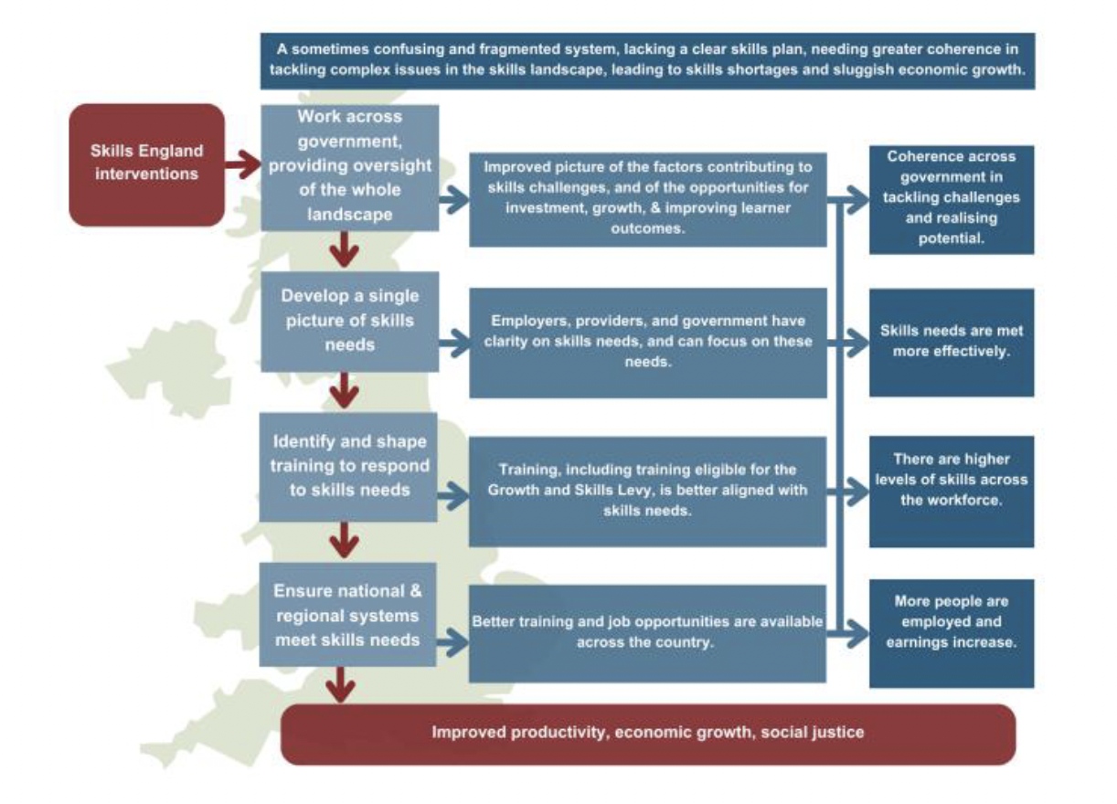

Recommendations

New Zealand’s creative industries are highly productive and strategically important, yet their potential is significantly constrained by structural weaknesses in the skills and training system and the absence of a clear industrial policy aimed at improving the viability of creative work and careers.
Fixing this requires targeted, coordinated action across government, business, and individuals – we make some recommendations below:

- Recognise creative skills as essential to long-term public value. Industrial policy should explicitly acknowledge the long-term contribution of creative skills to institutional stability, social cohesion, and sustainable economic growth. These are not peripheral outcomes, but core public values that those with creative skills help to uphold. This aligns closely with businesses’ desire for stable operating environments and policy predictability, highlighting the important role of government in shaping and sustaining these outcomes.

- Reform the training system to reflect real creative pathways. Current funding structures favour long-form, formal qualifications at the expense of flexible, short-term, and practice-based learning which are more aligned with how people in the industry actually progress and hone creative skills. A rebalanced system should recognise and support the non-linear, often informal pathways through which creatives build skills, such as on-the-job learning, mentoring, and project-based work. Businesses have a clear interest in advocating for this shift, as redundant qualifications and over-indebted workers do not benefit them either.

- Re-establish and embed active coordination mechanisms grounded in real conditions. Reinstate cross-sector coordination that takes seriously the cultural and socio-economic realities of creative work, especially its precarity. A training system built from this perspective should support broader goals like the Making Work Pay priority identified by the UK, ensuring creative occupations are viable, valued, and integrated into holistic policy frameworks. The focus should be on outcomes, such as decent, sustainable creative work, rather than simply increasing the number of qualifications in the system.

Appendix A: Definitions

We use the following definitions for the creative sector: creative industries, creative occupations and creative qualifications. These different measures do not overlap neatly, but each are important to consider in understand the sector and skills related to it. Two examples illustrate this well. Graphic design is captured in occupations, but not in industry. Ngā Toi Māori is not captured in either. Official classification systems aren’t well suited to capturing the creative sector in its entirety.

Table 1: Creative sectors industry mix

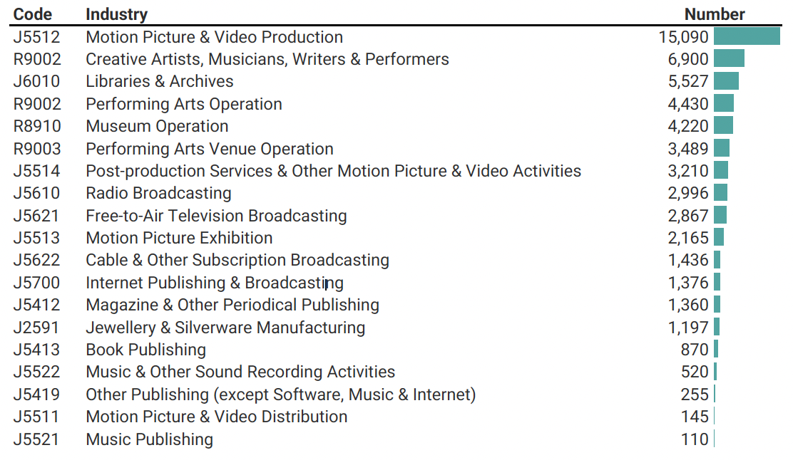

Table 2: Occupation mix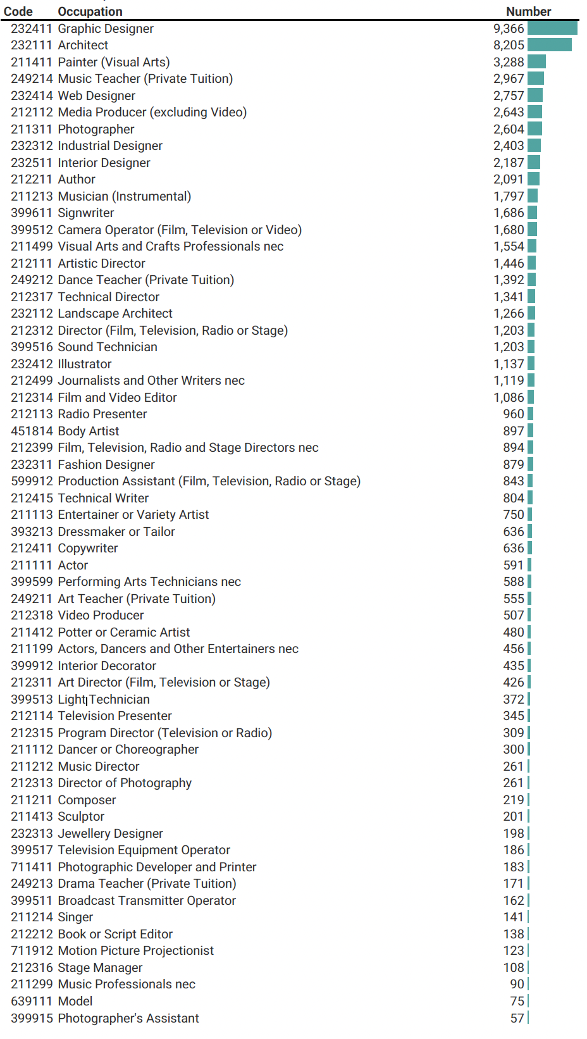

Table 3: Qualification mix

Performing Arts | Music
Performing Arts | Drama and Theatre Studies
Performing Arts | Dance
Performing Arts | Ngā Mahi a Rēhia (Māori Performing Arts)
Performing Arts | Performing Arts not elsewhere classified
Visual Arts and Crafts | Fine Arts
Visual Arts and Crafts | Photography
Visual Arts and Crafts | Crafts
Visual Arts and Crafts | Mana Whakairo (Māori Carving)
Visual Arts and Crafts | Jewellery Making
Visual Arts and Crafts | Floristry
Visual Arts and Crafts | Visual Arts and Crafts not elsewhere classified
Graphic and Design Studies | Graphic Arts and Design Studies
Graphic and Design Studies | Textile Design
Graphic and Design Studies | Fashion Design
Graphic and Design Studies | Ngā Mahi a te Whare Pora (Māori Weaving)
Graphic and Design Studies | Graphic and Design Studies not elsewhere classified
Communication and Media Studies | Audio Visual Studies
Communication and Media Studies | Journalism, Communication and Media Studies
Communication and Media Studies | Written Communication
Communication and Media Studies | Verbal Communication
Communication and Media Studies | Multimedia studies
Communication and Media Studies | Communication and Media Studies not elsewhere classified
Other Creative Arts | Creative Arts not elsewhere classified

Appendix B: Who works in creative jobs? Highlights
The make-up of who works in the creative sector brings out some clear trends, particularly when compared against the NZ workforce and the agriculture sector.

The creative workforce is younger. 44% of the workforce in the creative sector are aged between 15 to 34, this is compared to 39% for the NZ workforce, and 38% for agriculture. It also shows that older people are less likely to work in the sector. While some of it may be voluntary, interviews revealed a common theme: lack of security of work and income. This could become a significant issue as the population ages, which will mean increased competition for young workers.

Figure 17: The creative sector workforce is younger than agriculture and NZ workforce

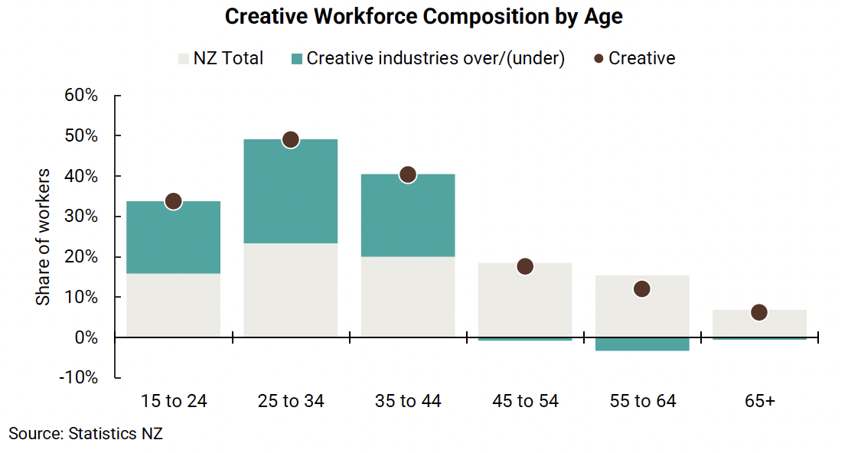

Looking through the creative occupation lens, these occupations have an under-representation of Māori, Pasifika and Asian ethnicities. The data does not explain why this is the case, but given future population growth will be largely in minority ethnic groups (i.e. non-Pakeha), it is important to consider the potential changes required to create better pathways for other ethnicities/

Of those in creative occupations, 4% are Māori, 2% Pacific, 14% Asian, and 68% European. This contrasts significantly with the NZ workforce where 13% are Māori, 7% Pacific, 16% Asian, and 59% European.

Creatives are more likely to be self-employed (but without staff), who typically have less secure income and fewer protections. Around 40% are in paid employment, half of the New Zealand norm of over 80%. The experience of working in the sector is entirely different to most other industries in New Zealand.

With this feature of the sector comes a number of issues, particularly around the levels of precarious work. Of the creative sector workforce, 25% either work in more than one job in the same industry or work across more than one industry.

The precarious nature of work in the creative sector creates issues with long-term workforce planning, with retention rates of new entrants into the sector being low.

Figure 18: The creative sector workforce has under-presentation of Māori, Pacific, and Asian
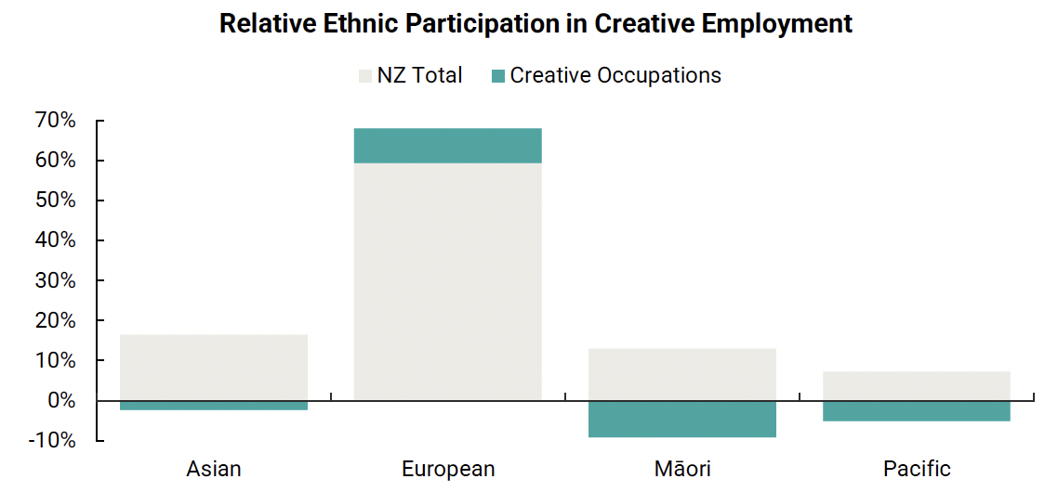

Figure 19The creative sector is largely made up of self-employed/employer
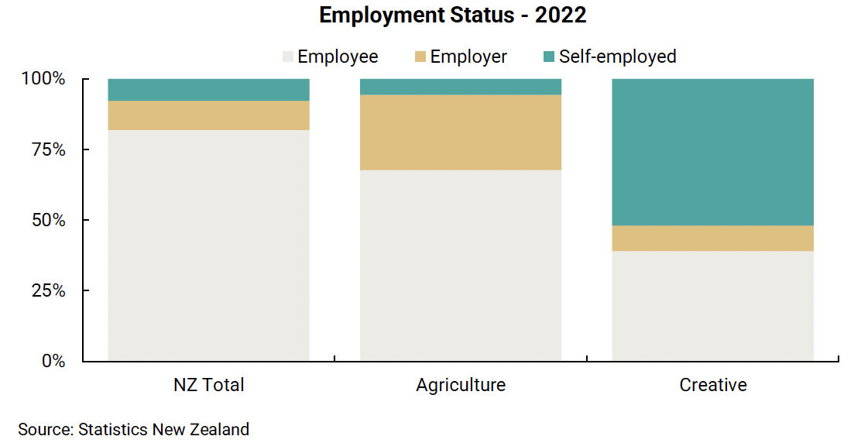

Very low retention of workers can be seen in the following figure. Of those who started work in the creative sector in 2015, a staggering 82% had exited after 1 year (compared with 68% in agriculture), and 90% after 2 years. This means skills learnt on the job are easily lost.

Leaving work from the sector early on makes sense. But our analysis shows that staying longer can mean higher incomes in the industry, and the majority who leave after 1 year are on average likely to earn less because of the move. For example, of those who left after 3-5 years of experience in the sector, 41% earnt more after leaving, but 59% earnt less. This means that there is a cost to leaving the industry after building up experience and skills.

Figure 20: The creative sector struggles to retain new sector entrants

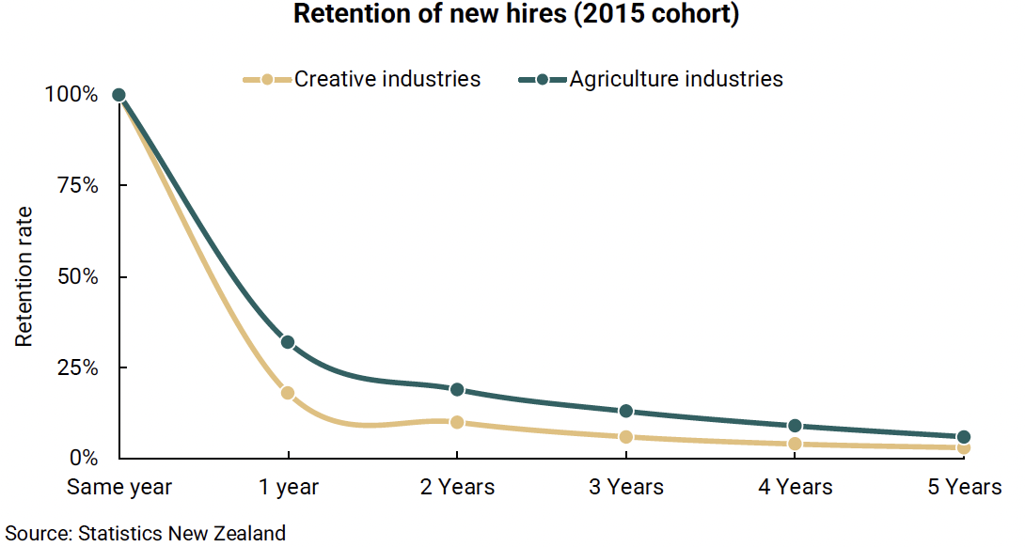

Figure 21: People don’t leave creative jobs for higher pay
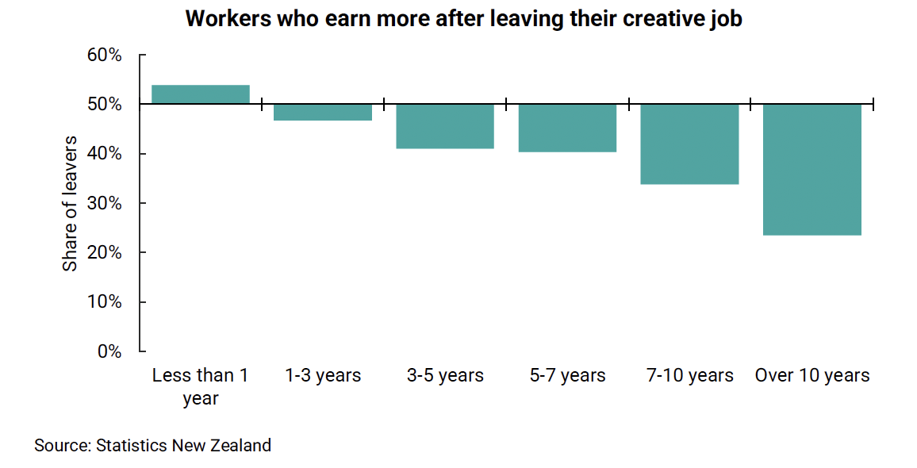
The following charts show industries where creative workers come from, and where they go to. The exits are predominantly to services sector jobs, which are often lower pay.

Figure 22: New entrants into creative industries are largely coming from other industries, including those with second jobs (this is further complicated by self-employment)

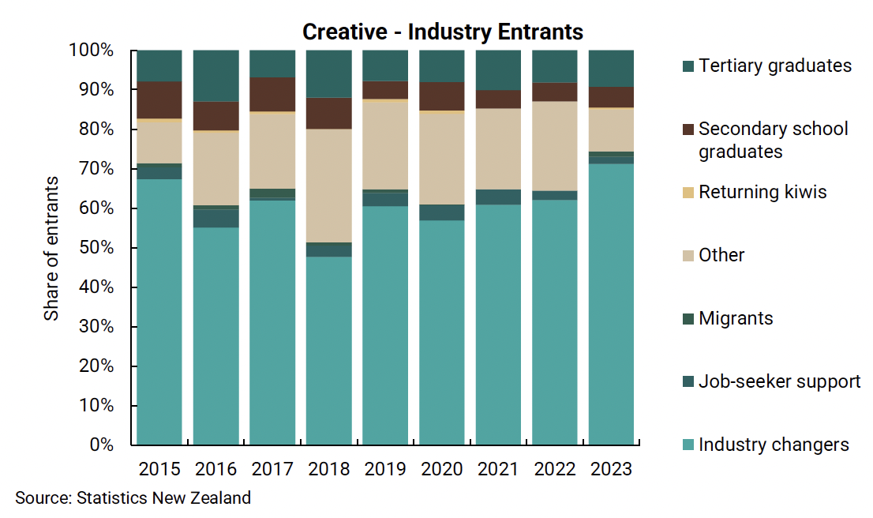

Figure 23: Exits mainly to services industries, retail and hospitality

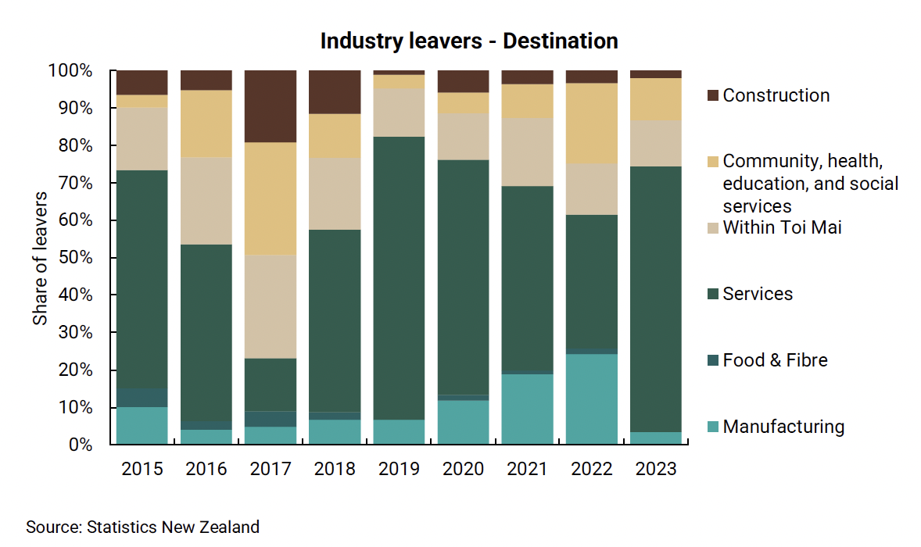

Appendix C: Government as a System framework

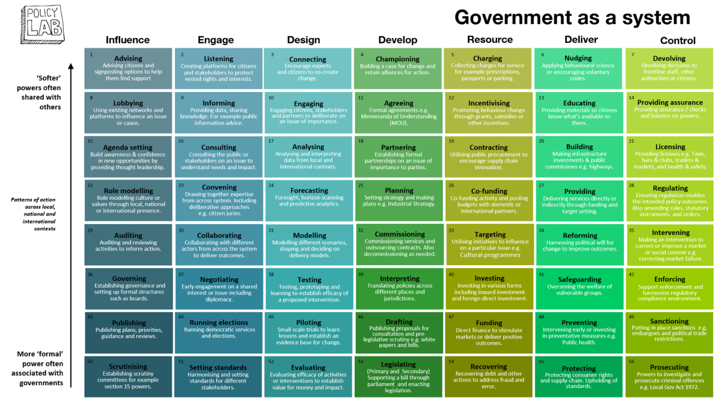
Source: UK Policy Lab, 2020. https://openpolicy.blog.gov.uk/2020/03/06/introducing-a-government-as-a-system-toolkit/

Simon Johnson, “Nobel Lecture: The Institutional Origins of Shared Prosperity,” American Economic Review 115, no. 6 (2025): 1749–1786, https://doi.org/10.1257/aer.115.6.1749.
This differs to the Manatū Taonga, Ministry for Culture and Heritage GDP estimate of $16.8m for 2022 due to different industry coverage.
Assuming 2080 hours worked per full time equivalent person per year.
Daron Acemoglu, Simon Johnson, and James A. Robinson, “Institutions as the Fundamental Cause of Long-Run Growth,” NBER Working Paper No. 10481 (Cambridge, MA: National Bureau of Economic Research, May 2004; revised August 22, 2022).; Daron Acemoglu and James A. Robinson, "Culture, Institutions, and Social Equilibria: A Framework," Journal of Economic Literature 63, no. 2 (2025): 637–692.
Sica, Giusy, Maria Palazzo, Alessandra Micozzi, and Maria Antonella Ferri. "Leveraging on Cultural and Creative Industries to Foster Social Innovation: A Bibliometric Analysis." Journal of Innovation & Knowledge 10, no. 1 (January–February 2025): 100649. https://doi.org/10.1016/j.jik.2024.100649.
Oakley, Kate. “The Disappearing Arts: Creativity and Innovation after the Creative Industries.” International Journal of Cultural Policy 15, no. 4 (2009): 403–14.
Mariana Mazzucato and Josh Ryan-Collins, Putting Value Creation Back into ‘Public Value’: From Market-Fixing to Market-Shaping (UCL Institute for Innovation and Public Purpose, 2019), https://www.ucl.ac.uk/bartlett/public-purpose/sites/public-purpose/files/public_value_final_30_may_2019_web_0.pdf.
Creative Industries Policy & Evidence Centre. Creativity and the Future of Skills (London: Nesta, November 2018). https://pec.ac.uk/wp-content/uploads/2023/12/Creativity-and-the-Future-of-Skills-report.pdf.
Creative Industries Policy and Evidence Centre (PEC), “New Research Shows Creativity Will Become Even More Important to the Growth of Jobs Between Now and 2030,” Nesta, November 13, 2018.
NZGDA, 2024 Industry Survey Results
de Grip, Andries. 2024. The Importance of Informal Learning at Work. IZA World of Labor, March. https://doi.org/10.15185/izawol.162.v2.
European Centre for the Development of Vocational Training (Cedefop), Skills in Transition: The Way to 2035 (Luxembourg: Publications Office of the European Union, 1 September 2023), accessed 20 June 2025, https://www.cedefop.europa.eu/files/5563_en_0.pdf.
https://toimai.nz/wp-content/uploads/2023/06/Screen-Workforce-Survey-Draft-Report-2022-Company.pdf
https://toimai.nz/wp-content/uploads/2023/06/Screen-Workforce-Survey-Draft-Report-2022-Individual.pdf
Group training organisations act as intermediaries between employers and apprentices or trainees. They employ apprentices and trainees, then place them with host businesses for on-the-job training.
Tertiary Education Commission, Funding mechanisms and delegations, “Unified Funding System,” accessed June 20, 2025, https://www.tec.govt.nz/funding/funding-and-performance/funding/mechanisms.

