Te Pūaotanga | The New Dawn

Te Pūaotanga – The New Dawn represents the Toi Mai vision for an intentional future for creative industries (including createch). It draws inspiration from Te Wao Nui a Tāne (the Great Forest of Tāne) and describes our creative sectors as Te Wao Nui o Toi – a diverse, thriving and creative ecosystem.

“Kia tū ai, kia kōrihi ai ngā manu o Te Wao Nui o Toi”. In its mahi, Toi Mai aims to give the birds of the Great Forest of Toi a place to stand and sing in chorus and capture the essence of collective renewal. Just as the dawn chorus heralds a new day and requires a healthy ecosystem to sustain it, our creative sectors need strong foundations to thrive and enrich society. This metaphor celebrates how individual voices create harmony through their unique contributions. We now call on all parts of the creative sector to activate, coordinate and unite in renewing this shared vision.

Foreword
The numbers are staggering. New Zealand’s creative sectors, people in creative roles and industries already contribute $12.9 billion to GDP and up to $19 billion when considering non-market value. They are our fourth largest commodity export – bigger than fruit, wine and seafood. Creative sectors are highly productive, generating the equivalent of $346,000 per person per year.

Yet we are systematically destroying this competitive advantage through broken policy and fragmented thinking. Our governments treat the creative industries as cultural hobbies or, in the case of Ngā Toi Māori, gifts to the nation. Meanwhile, our competitors perceive creative industries as infrastructure and systematically build creative economies that drive innovation across all sectors. The productivity per creative worker in New Zealand is on par with agriculture; yet only agriculture is something our politicians will die on a hill for. Creative industries – yeah, nah.

While our primary industries are impressive, they can only feed 40 million people annually. Even if the current Government’s ambition to double exports is realised, that’s only 80 million people, or 0.01% of the world’s population. Compare that to the creative sector, which can reach 5.3 billion global consumers (66% of the world’s population) through digital screens and platforms. At the time of writing, New Zealand artist Lorde’s recently released album Virgin was approaching 250 million streams on Spotify in just 24 days.

We’re not saying it’s ‘either or’. It should be ‘and and’. If we are more ambitious for the creative sector, we can accelerate national productivity while building the cultural and institutional capabilities that underpin long-term economic resilience and innovation across all industries. We could then leverage the increased economic growth to afford our future with enough left over to support farmers during the next drought, flood or trade war.

The transformation roadmap exists. Three years of Toi Mai research provides proven pathways to get there, including recognising creative industries as strategic economic infrastructure, restructuring incentives through smart resource reallocation, and creating dynamic information systems.

The international evidence is compelling. The implementation is tested. This is the inflection point.

Toi Mai will be disestablished on 31 December 2025, as part of the current coalition Government’s vocational education and training reforms, and our mahi will come to an end. In this report we’re outlining three strategic pathways to activate New Zealand’s transformation towards a creative economy, for activation by government, industry and business.

The creative birds of Te Wao Nui o Toi are ready to sing their economic dawn chorus. The question isn’t whether we have the capability – it’s whether we have the courage to act on what we already know.

Other nations are planting the forests we should be growing. The fertile ground exists. The seedlings are ready. The only question remaining is whether we’ll plant the ecosystem that announces New Zealand’s creative leadership to the world or continue managing decline while explaining why transformation was too difficult.

The window is closing fast. Other nations are capturing the creative economy opportunities that we are fumbling. We can either act on the evidence we have or watch our competitors build the future we should be leading.

The opportunity is significant. The timing is crucial. The decision is yours.

Dr. Claire Robinson
Te Tumu o Toi | CEO, Toi Mai Workforce Development Council

The challenge and opportunity
When Toi Mai was created in 2021, it was the first time the creative sector had ever been acknowledged as an ‘industry’ in New Zealand legislation. Prior to the global pandemic, the previous Government had indicated its intention to create an industry transformation plan for the creative industries. This was shelved following the additional Budget 2020 investment made by Government to support the arts, culture and heritage sector through its recovery from COVID-19.

The vocational education and training system Toi Mai encountered in 2021 had scant understanding of the skills and workforce needs of the creative industries. There was poor data coverage and invisibility of many creative occupations, industries and pathways.

Neither Ngā Toi Māori nor game development were officially recognised as an industry or an occupation.

Most creative industries did not have apprenticeships. The vocational education system was not geared up to meet the work-based learning needs of the gig-based, self-employed workforces that dominate the sector.

Toi Mai was well behind the back foot compared to traditional or legacy industries like agriculture and construction that have been supported for a hundred years – by government policies, ministerial portfolios, legislation, infrastructure, investment, purchasing contracts, science research, dedicated agencies and funded apprenticeships.

Toi Mai has spent the past three years building the evidence base, developing industry partnerships and working out ways to facilitate work-based learning within the current system constraints. We’ve proved that industry-led, evidence-based coordination works. When creative industries have a voice in their own workforce development, real progress happens.

In late 2024, the Government released Amplify: A Creative and Cultural Strategy for New Zealand for public consultation. One of its ambitions is for the creative sector to drive economic growth and exports.

We share this ambition and have identified evidence-backed opportunities to make the ambition real. Had Toi Mai continued to exist, our work would have supported its second strategic pillar: Nurturing Talent.

It is unclear whether the Industry Skills Boards (ISBs) that will replace WDCs in 2026 will be able to pick up this mahi. They have a more restricted mandate than WDCs and less than half the funding.

Because of this limitation, we’re passing the baton to wider industry leaders, organisations and changemakers to continue the important work that Toi Mai has been unable to complete in our short time.

This is our call to move beyond well-intentioned words to coordinated action – to create the conditions where the birds of Te Wao Nui o Toi can stand together and project their economic dawn chorus to the world.

Purpose
This document is a wero or challenge that Toi Mai leaves to government and business – a strategic roadmap for transforming New Zealand’s creative industries from fragmented cultural activities into integrated economic infrastructure that drives innovation across our entire economy.

What the economics tell us
The companion Skills in the creative sector report reveals that New Zealand’s creative industries are far more economically significant than most people realise, but they are being severely undermined by a broken skills and training system.

Key findings are outlined below.

Scale and impact: The creative sector contributes approximately $13–19 billion to GDP (up to 5.8% of our economy) and, when compared to other commodities, was our fourth largest export at $3.6 billion in 2023 – bigger than commodities from fruit, wine and seafood, sitting behind only dairy, meat and forestry.

Productivity myth busted: When properly measured (adjusting for hours worked), creative and occupations are highly productive at $346,000 a year versus the national average of $197,000. This is slightly higher than agriculture at $317,000.

Massive training disconnect: Here’s the surprising part: most people working in creative industries or occupations don’t have “creative qualifications” (80%), and most people with creative qualifications (86%) don’t do “creative work”.

While it benefits the economy for creatively trained people to work in all sectors and across industries (they can drive innovation and be great problem solvers, for example), the fact that most of our creative workforce do not hold any creative qualifications demonstrates fundamental issues with our training system.

Bottom line: New Zealand has a significant competitive advantage in creative industries that is being squandered by funding and policy settings designed for traditional industries, not the way creativity and innovation work.

Government is critical in realising economic potential
In both the creation of the Amplify strategy and the establishment of Toi Mai (and subsequent Industry Skills Boards), the Government has recognised there is potential in this space it is missing out on. But the Government doesn’t have a clear idea of why and how it can intervene to support creative industry growth.

The current economic constraints place firm limits on new government spending. But there is reallocation (and reform) that can be implemented within current funding constraints. Those reforms can be targeted at repairing broken system settings – the areas government is currently investing in but are not working as they should, leading to wasted resources and misallocation of capital. These system settings are outlined below.

Education–industry misalignment

The education system produces creative graduates with credentials that don’t necessarily translate into creative industry-relevant or ready-made skills, largely due to an overreliance on qualifications as a proxy for skills.

Government funding incentivises educational providers to focus on long-form (formal degree) qualifications rather than workforce-ready skills and capabilities, creating a skills mismatch that undermines sector productivity and setting industry and learners up to struggle.

Market failure in skills development

There is no comprehensive plan for meeting our current and future skills requirements for the creative industries and people in creative roles. Relying solely on market mechanisms has resulted in inefficient “double handling” where industries must find resources to re-train formally qualified graduates. This confusion between efficiency (minimising costs) and effectiveness (achieving desired outcomes) has created a gap between educational output and industry needs.

In the absence of a national skills strategy, investment is not targeted at sectors that have potential for higher economic growth. Toi Mai has advocated for better coordination between government agencies, sector bodies and providers, and now there is an even bigger role for the creative sector to ensure this continues.

Investment ceiling effect

Government has a pivotal role in fostering innovation, entrepreneurship and co-creating market value.

While specific interventions (like film rebates) demonstrate the potential to increase sector activity, the absence of data on market and demand potential means we’re making investment decisions without the fundamental data needed to know what works. This leads to under-investment or waste.

The system lacks feedback mechanisms to identify upper limits and growth potential.
There is opportunity to adjust current interventions to create a more cohesive ecosystem – for example, incorporating stronger training requirements into screen rebates to enable longer-term skills development and build a more stable workforce.

Pipeline fragmentation and lack of feedback loop(s)

The ongoing decline in creative education enrolment from secondary through vocational levels suggests a systemic breakdown in the talent pipeline and the lack of a feedback loop. Meanwhile, each education and policy stage operates in isolation rather than as part of a coordinated pathway:
- Creative and cultural education is viewed as “nice to have” rather than essential.
- Piecemeal policies have failed to create coherent career progression.
- Lack of clear pathways forces talent overseas.

Three Horizons – what’s needed?
We’ve used the Three Horizons framework6 to structure our thinking and map out what’s possible. It’s a practical way to understand where we are today (Ināianei – Horizon 1), where we need to get to (Te Pae Tawhiti – Horizon 3) and the messy but crucial bit between where transformation happens (Te Pae Tata – Horizon 2).

Ināianei – Horizon 1: The present system – the forest at dusk
Fragmented governance, disconnected education systems and reactive funding create an environment where voices are isolated, overworked or unsupported. Many birds sing alone, some cannot be heard at all and the full potential of our dawn chorus remains unrealised. The ecosystem is losing strategic “fit”, and there is a need to consider what must end to enable regrowth.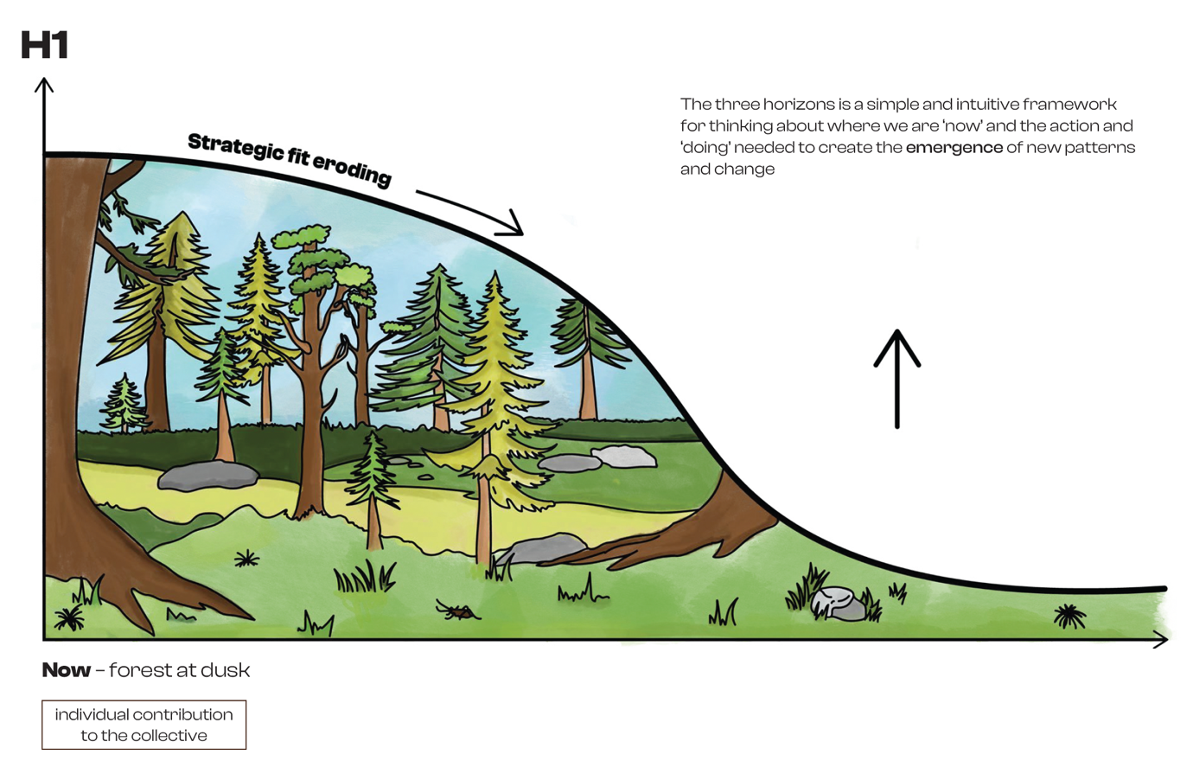

Te Pae Tawhiti – Horizon 3: The emerging future – te pūaotanga, the full dawn chorus

While the future cannot be entirely predicted or planned, its emergence can be supported by creating conditions for our industries to thrive. Through our ‘great forest’ metaphor, this thriving ecosystem features:

- a connected forest where creative sectors and skills are recognised as central to our economy and catalysts for innovation across all industries
- strong branches of integrated policy linking education, innovation and development
- rich soil of sustainable career pathways nurturing creative talent and providing regenerative financial and entrepreneurial resourcing
- diverse trees providing varied perches for different creative voices
- a chorus that projects powerfully beyond our shores into global markets.

This vision represents not incremental improvement but fundamental transformation in how creative industries are understood, supported and integrated into New Zealand’s economic identity.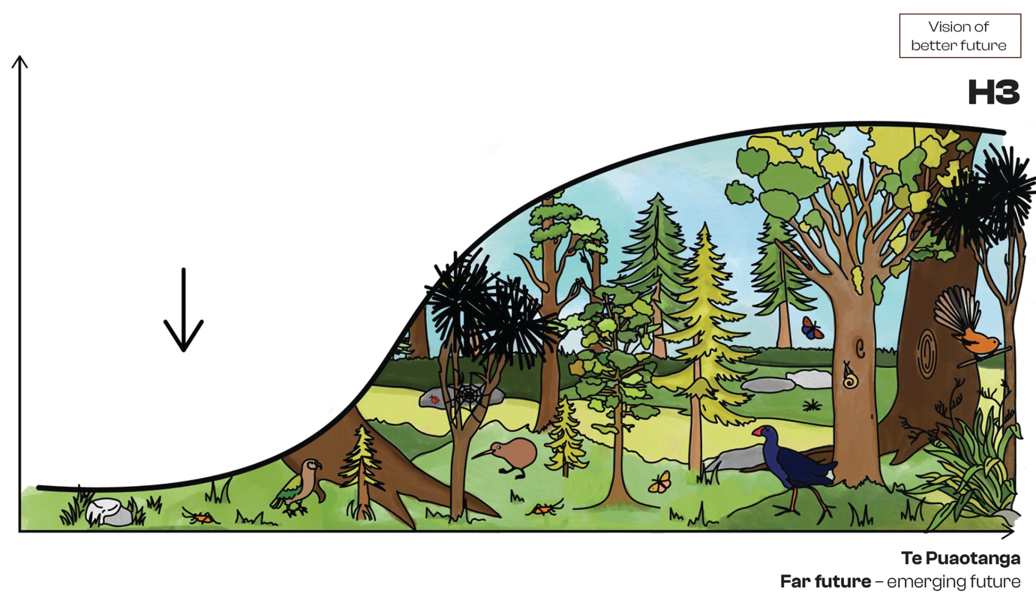

Te Pae Tata – Horizon 2: The critical transition – the first birdsong

The transition to the future we want requires deliberate interventions that bridge the current reality (H1) and our desired future (H3).

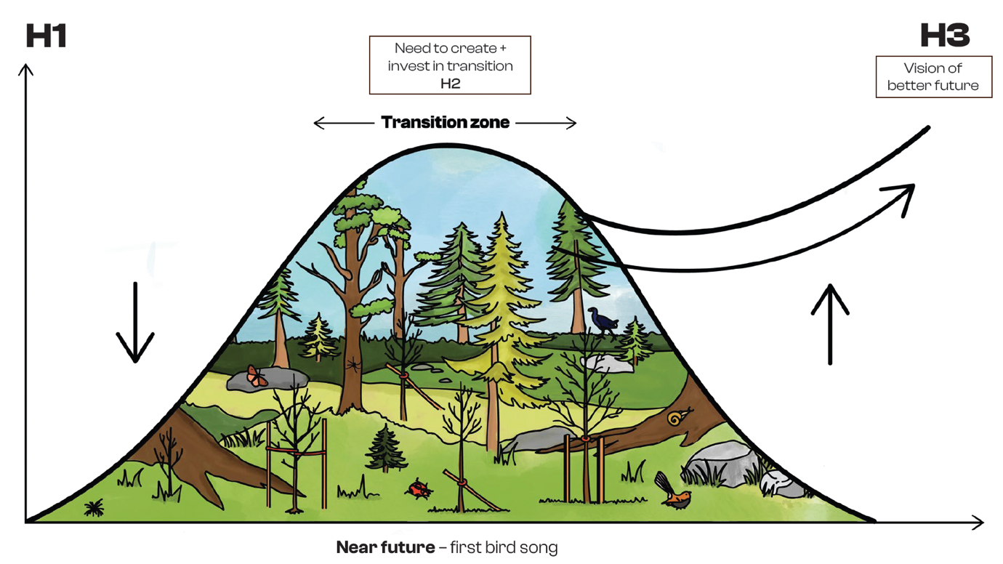

New Zealand’s education system faces the classic Three Horizons dilemma of continued investment in Horizon 1 approaches (reactive interventions, traditional credential-focused education and work-based learning models), which diverts resources from Horizon 3 development while providing diminishing returns. Meanwhile, Horizon 2 thinking can appear threatening to those invested in current systems. Our ambition is to recognise the creative and digital technology sectors as strategic economic drivers for our society.

Getting to Te Pae Tata requires us to:
- manage the decline of Horizon 1 approaches with care but determination
- invest substantially in Horizon 2 innovations as bridges to the future
- maintain a clear vision of Horizon 3 transformation to guide transition efforts.

International landscape

We don’t need to reinvent the wheel. Our analysis of the international landscape reveals four high-impact approaches that successfully transformed creative economies. We should adapt these to boost our creative economy.

1. Industry policy and intentional investment

If there is an industrial policy today, it is the myth of “not picking winners”, focusing instead on providing benefits to all businesses while government gets out of the way. Except our governments do pick winners, on a daily basis, from setting up a National Space Agency to support space business development, to encouraging STEM education in schools, to prime ministers leading trade missions to countries that take our agricultural exports, to the funding of large infrastructure projects like state highways, schools, hospitals and state housing developments. Only last month (July 2025), the Ministers for Economic Growth and Infrastructure announced billions of dollars’ worth of infrastructure projects that they said would drive economic activity and create thousands of jobs across the country.

Other advanced and competitor economies have developed industrial policies that are deliberately positioning creative industries as core economic drivers rather than peripheral sectors.

By pretending that it doesn’t pick winners, New Zealand is missing out on the benefits those economies are gaining from those policies. As the Swedish Minister for Culture noted, creative industries are now viewed as “a new type of Swedish primary industry”, signifying a fundamental shift in economic perspective. This positioning is supported by structured, data-driven investment approaches with carefully tracked outcomes.

Key examples include the following:
- Creative State Victoria (Australia): Strategic $288 million investment has helped creative sectors contribute $40.5 billion to Victoria’s economy, growing at 4.8% annually.
- UK Creative Clusters Programme: £56 million investment created over 5,500 jobs and supported 460 startups across nine regional clusters.
- The recently published United Kingdom Skills Strategy (under new agency Skills England) has identified creativity as one of the top five drivers of job growth to 2030.

2. Partnerships with other industries for whole-economy growth

The most innovative approaches refuse to isolate creative industries, instead integrating them strategically as “whole economy” outcomes, interwoven with tourism, export, sustainability and technology sectors to create powerful multiplier effects.

Key examples include the following:

- Indonesia’s Ministry for Tourism and Creative Economy: Integration increased the creative sector’s GDP contribution from $81.6 billion in 2022 to $90.4 billion in 2023.
- Australia’s Cultural Tourism Accelerator: Recognised that 57% of first-time visitors to regional areas attend festivals or cultural events as their primary motivation.
- Canada’s Creative Export Strategy: $125 million investment supported over 1,900 creative businesses in accessing international markets.

3. Creative skills as systems catalysts

There’s an evolution from viewing creativity as sector-specific to recognising it as a catalyst for innovation across all industries.

Key examples include the following:

- Creative Denmark positions creativity as an economy-wide innovation driver through a public–private partnership model. This approach has helped Danish creative industries contribute approximately 6% of the country’s GDP and employ over 100,000 people.
- Ireland’s Creative Climate Action Fund (€5.8 million for 43 projects) uses creative approaches to address climate change and inspire behavioural change.

4. Better recognising value and impact

New models are being developed overseas that change the way economies and businesses think about “value”.

As outlined in the Skills in the creative sector report (2025), creative industries produce value differently than traditional industries. While conventional economic value is typically measurable at the point of purchase, creative value manifests primarily as long-term outcomes rather than immediate outputs.

Standard economic thinking typically frames creative industries’ contributions narrowly as “worth $2bn to the economy” or similar quantifications that prioritise immediate market transactions.

This approach is problematic, as it:
- inadequately captures long-term productivity gains, knowledge spillovers and structural ecosystem development
- creates inefficient resource allocation and systemic underinvestment in creative sectors
- fails to recognise creative organisations as market shapers rather than just market participants.
This approach is insufficient for sectors that actively shape new markets rather than simply participating in existing ones.

Why traditional economic measurements miss the point

Standard economic thinking measures creative industries like any other business – count the jobs, add up the sales, done. But this misses how creative value actually works.

Creative industries are different because they:

- Create ripple effects – when a film crew trains local technicians, those skills stay in New Zealand long after filming wraps. The benefits spread far beyond the original investment.
- Build future opportunities – training game developers today doesn’t just fill current jobs; it positions us to compete in markets that don’t even exist yet. These are economic doors that stay open for decades.
- Get stronger together – creative businesses benefit each other by leveraging access to talent, suppliers and markets.
- Work as investments, not just consumption – when you buy a car, that’s it: transaction complete. But creative work keeps generating value for years. A successful film builds our reputation, develops our skills, contributes to participant wellbeing, attracts tourists, spins out new companies and creates cultural capital that benefitsthe whole economy.
- Have built-in cultural value – you can’t separate the “economic” part of creative work from its “cultural” part. They’re the same thing.

This is why measuring creative industries like traditional industries misses most of their actual contribution to our economy. We need measurement frameworks that capture long-term value creation, not just immediate transactions.

Designing a spectrum of value

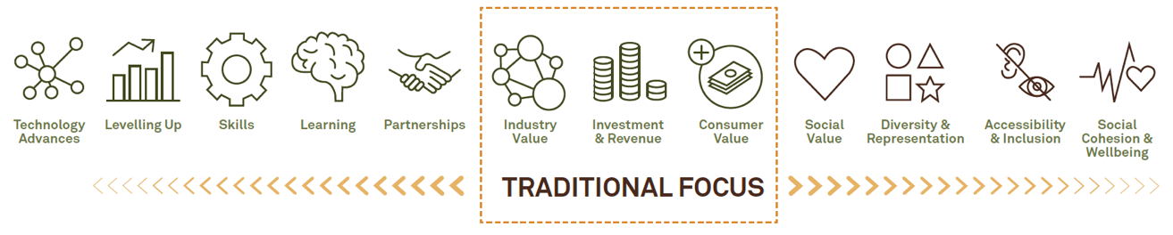
Diagram: Modified from Mazzucato et al (2020)

Pathways to transformation

This roadmap outlines three strategic pathways required to activate our transformation towards a creative economy.

Pathway 1: Treat creative industries like the economic engines they are

We can’t transform to a creative economy doing what we’re doing now. Rather, we need to recognise creativity as foundational infrastructure in our economy – essential for economic growth and social progress.

a. Active government leadership through strategic integration with whole-economy development

- Develop industry policy and a national skills strategy that looks out 20–30 years.
- Position creative industries as strategic economic assets and catalysts for tourism, export, sustainability and technology growth.
- Create a Minister for Creative Industries portfolio in Cabinet.

b. Establish a national skills agency for all vocational skills

Realising the economic potential of our creative industries requires a flexible, responsive and adaptive skills system to ensure industry can continue to adapt and innovate.

The current vocational education and training system is not consistently delivering a skilled workforce for the creative industries, and the Government’s reforms will not deliver the responsive and adaptive system these industries will require.

This issue is not unique to the creative industries, and a more deliberate and coordinated approach to vocational skills development would benefit the entire economy.

New Zealand should rationalise core functions of the vocational education and training system into a single skills agency, much like Skills England. This agency could include:
- funding providers to deliver qualifications (classroom or work-based)

- funding employers and wider industry to deliver on-the-job skills (including non-credentialed skills)
- qualification development and registration on the framework
- developing and embedding different work-based learning approaches that work for each industry
- identifying current and future skills needs
- quality assurance.

Productivity impact: Creates multiplier effects where creative investment drives growth across multiple sectors.

Pathway 2: Make current investment work smarter

Redirect existing investments without requiring new funding through smarter deployment of current resources.

a. Strategic investment through the International Visitor Levy

With 25% of international visitors engaging with “creative tourism” (such as visiting film, events and experiences), a portion of the International Visitor Levy could be hypothecated (allocated) to boost these experiences and develop new ones. This would produce a creative investment feedback loop, generating greater returns from creative tourism.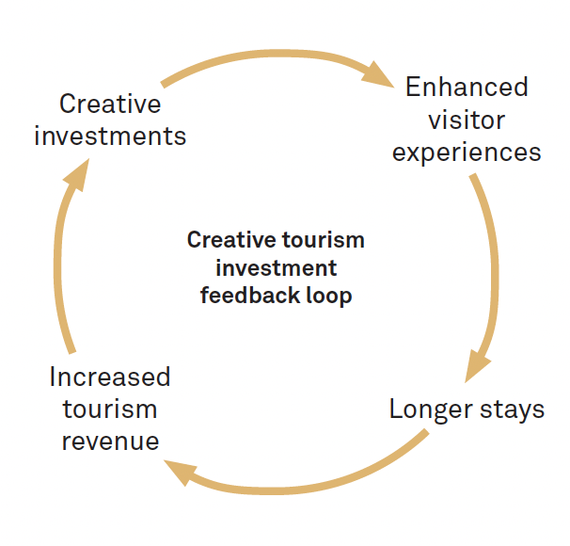

b. Reform education and industry incentives

- Reform education funding to reward skills-based outcomes rather than credential completion (addresses “double handling” where industry retrains graduates).
- Strengthen and integrate training expectations into existing incentives (such as screen or game development rebates) to create self-sustaining workforce development.

Productivity impact: Creates self-reinforcing cycles where education responds to industry needs and investment flows to highest-return activities.

Pathway 3: Change how we measure and shape impact

Standard economic frameworks fail to capture creative industries’ full contribution, creating systematic underinvestment and inefficient resource allocation. There is a need to address the issue of ‘invisible sectors’, critical data gaps and absence of feedback loops.

a. Move beyond traditional metrics
We need a way of capturing the broader value and impact of investment beyond GDP. Industry and government should explore and adopt more dynamic approaches to understanding and measuring value creation that reflects the lingering economic and wider social impacts of investment and activity.

b. Establish a creative industries policy coordination and evidence centre

We need more reliable and consistent data about our creative industries. The absence of this data hides their economic and productive potential from public and political view and limits the Government’s ability to make deliberate investments in training and productivity.

A dedicated and well-resourced evidence centre similar to the UK model (could sit within an existing agency such as Ministry of Business, Innovation, and Employment or Ministry for Culture & Heritage, for example) would enable all stakeholders to access shared, reliable data for coordinated action and investment decisions.

The evidence centre would track meaningful metrics including creative exports growth, high-value job creation, talent retention rates and cross-sector economic multiplier effects to provide a comprehensive view of the creative economy’s contribution.

This high-level coordination mechanism would enable the system to adapt, innovate and self-correct in response to changing conditions, reducing dependency on top-down directives while ensuring aligned action toward shared goals.

Productivity impact: Enables evidence-based investment decisions, improved industry coordination and prevents skills mismatches through early warning systems.

As we approach our new dawn…

To achieve a pro-creative (and creative technology) legislative, regulatory and leadership ecosystem that enables Te Pūaotanga, the birds of Te Wao Nui o Toi can begin gathering now – rather than wait for government reform or the political winds to change.

Their voices emerge from an entire living ecosystem where native and exotic trees provide canopy structure, understory plants create shelter and pathways, insects and bees enable pollination and connection, and fertile detritus nourishes new growth. Each layer – from forest floor to emergent giants – creates the conditions where creative voices can harmonise into something greater than the sum of their parts.

While systemic transformation requires government leadership (as described above), the creative ecosystem’s health depends equally on what sector and business leaders choose to do today. The most thriving creative economies emerge when industry creates its own coordination mechanisms rather than waiting for external solutions.

Actions for business and sector leaders

The transformation requires both immediate action and longer-term systemic change.

While advocating for government paradigm shifts and resource reallocation, creative leaders can simultaneously build the collaborative infrastructure that makes those changes birds of Te Wao Nui o Toi need not wait for permission to begin gathering. Industry leaders can start creating the evidence, partnerships and coordination that demonstrate creative industries’ economic value while building toward the policy transformation that recognises and supports this reality.

Create and use dynamic value frameworks

Rather than accepting traditional “worth $X to the economy” measurements, creative organisations can lead the way by developing and implementing their own dynamic value frameworks that capture knowledge spillovers, option value and network effects.

Use these frameworks in annual reporting and internally for investment decisions while advocating for policy systems to adopt similar approaches that recognise creative industries as market shapers rather than just market participants.

Be the exemplars for other industries to develop dynamic models that suit their specific sector contexts.

The last call before the chorus

The path forward is clear, and the window for action is narrowing.

While we’ve been debating whether creative industries deserve strategic investment, our competitors have been building creative economies.

Singapore, Ireland and Indonesia have demonstrated what coordinated creative policy achieves through measurable economic transformation.

The evidence doesn’t lie. We have a major export industry that we’re treating as a cultural hobby. We have highly productive workers yet only traditional industries get treated as economically essential. We have significant creative tourism activity, yet none of our tourism levy supports creative infrastructure.

This isn’t about choosing between economic pragmatism and cultural values. It’s about recognising that our creative sectors are economic infrastructure.

The dawn chorus is not just symbolic. It is strategic. This is our economic moment, and it won’t wait. You have the blueprint. The only question left is – will you act, or let the silence settle?

The dawn is breaking

https://legislation.govt.nz/regulation/public/2021/0098/20.0/LMS490757.html
Includes sectors such as book and other publishing, film and video production, music recording and publishing, television broadcasting, internet publishing, libraries and archives, museums, performing arts, creative artists and performers, and jewellery manufacturing.
https://www.mch.govt.nz/sites/default/files/2025-09/Amplify-A_Creative_and_Cultural_Strategy_for_New_Zealand_2025-2030.pdf
For the purposes of this document, we include digital technologies within our definition of ‘creative industries’.
Eaqub et al (June 2025) Skills in the creative sector – A thriving sector despite training mismatch.
Bill Sharpe (2013) “Three Horizons: The Patterning of Hope” (book) or Sharpe, B., Hodgson, A., Leicester, G., Lyon, A., & Fazey, I. (2016). Three horizons: A pathways practice for transformation. Ecology and Society, 21(2), Article 47. https://doi.org/10.5751/ES-08388-210247
New strategy for businesses in the cultural and creative industries – Government.se
Budget delivers $288 million boost to the creative state | Creative Victoria.
Clusters-Booklet-Story-So-Far-V12-web.pdf Two major UKRI investments continue to boost creative industries – UKRI
https://skillsengland.education.gov.uk/
Welcome to website Ministry of Tourism and Creative Economy
RAF-Cultural-Tourism-Accelerator-Program-Guidelines-2021.pdf $7 Million Regional Arts Tourism package announced – Regional Arts NSW
Creative Export Strategy – Canada.ca Helping Canada’s creative industries succeed in global markets – Canada.ca
White Papers
gov.ie - €5.8 million funding announced for creative, cultural and artistic initiatives under the new Creative Climate Action Fund II
Center for Economic and Business Research (April 2025) Spillover impacts in the publicly funded arts and culture sector. London 2025., Thabit, S, Sancino, A and L. Mora (2023) Strategic Public Value(s) governance : A systematic literature review and framework for analysis. Public Admin Rev 2025: 85 : 885 - 906, DPMC (2017) Understanding Public Value : Leaders Roundtable with Professor Mark Moore, The Policy Project, Moore. M (2013) Recognising Public Value, Harvard University Press. USA, Moore. M (2010) Creating Public Value, Harvard University Press, USA.
https://www.ucl.ac.uk/bartlett/sites/bartlett/files/final-bbc-report-8_dec.pdf
Creative Industries Policy and Evidence Centre | Nesta
DPMC (2017) https://www.dpmc.govt.nz/sites/default/files/2022-12/understanding-public-value-mark-moore.pdf
IIPP (2020) https://www.ucl.ac.uk/bartlett/research-projects/2020/jan/re-imagining-public-value-bbc
https://www.hks.harvard.edu/publications/creating-public-value-core-idea-strategic-management-government

